

**American International University-Bangladesh**

Faculty of Science & Technology (CSE)

ADVANCE DATABASE MANAGEMENT SYSTEM

Summer 2024-25

Section: A

**Swimming Pool Management System**

Supervised by

**JUENA AHMED NOSHIN**

|  |  |  |
| --- | --- | --- |
| **Group Members** | **ID** | **Contribution** |
| **MD. SAZZAD KHAN** | **22-49172-3** | **35% -** Normalization, Table Creation Using SQL, Data Insertion Using SQL, Basic PL/SQL, Advanced PL/SQL. |
| **MD KAIS RAFAT BIN RABBI KOMOL** | **23-52332-2** | **23% -** Introduction, Project Proposal, Schema Diagram, Conclusion |
| **ABHISAK DAS AMIT** | **22-49207-3** | **20% -** User Interface Planning |
| **AVISHEK CHANDA PRATYAY** | **21-45489-3** | **22% -** Scenario Description, ER Diagram |

**Table of Contents**

|  |  |  |
| --- | --- | --- |
| **Content** | **Title** | **Page No.** |
| **1** | **Introduction** | **3** |
| **2** | **Project Proposal** | **3 – 4** |
| **3** | **User Interface Planning** | **4 – 9** |
| **4** | **Scenario Description** | **10** |
| **5** | **ER Diagram** | **11** |
| **6** | **Normalization** | **12 – 19** |
| **7** | **Schema Diagram** | **20** |
| **8** | **Table Creation Using SQL** | **21 – 35** |
| **9** | **Data Insertion Using SQL** | **35 – 53** |
| **10** | **Basic PL/SQL** | **54 – 69** |
| **11** | **Advanced PL/SQL** | **70 – 86** |
| **12** | **Conclusion** | **87** |

**Introduction**

We created a simple management system called the Swimming Pool Management System to simplify a swimming pool facility's daily activities. To maintain a well-organized Swimming Pool its management regularly face situations where they need to write down or update any kind information whether it is customer, employee related or items for the swimming pool itself related in a hand written paper or in an excel sheet. Both are time consuming and not great for privacy of the Swimming Pools Management System. So rather than relying on spreadsheets, difficult processing, and paper-based records, this management system will save all important data in one safe, well-organized digital spot.

**Project Proposal**

1. Problem Statement:   
Managing a swimming pool facility involves managing a complex amount of entities: members, trainers, staff, pool resources, bookings, events, and financial transactions. Relying on manual methods, as paper-based records or spreadsheets that are not consistent are inaccurate, easy to make human error, and lack data security and accuracy. This makes it difficult and time-consuming to complete tasks like scheduling without conflicts, precise financial tracking, and individualized member services.

2. Proposed Solution:   
We used Oracle 10g to develop and set up a reliable, normalized relational database management system (RDBMS). All-important processes will be automated and simplified by the SPMS, which will serve as a unified, integrated data center. The system is designed around key entities—Member, Trainer, Staff, Pool, Booking, Event, and Transaction—and their relationships, ensuring data consistency and removing errors.

3. System Overview & Key Features:  
Based on our analysis and design, the system will manage the following core functions:

* Member Management: Handles member profiles, contact information, and membership types.
* Trainer & Staff Management: Maintains detailed records of trainers (including their specialties) and staff (including their roles), ensuring the right personnel are assigned to activities.
* Pool Resource Management: Tracks pool locations and capacities to prevent overbooking and ensure safety.
* Booking System: The core operation, facilitating the reservation of pools and trainers by members for specific dates and times.
* Event Management: Organizes and schedules events at specific pools, managed by staff and bookable by members.
* Transaction & Payment Processing: Records all financial transactions linked to bookings and events, supporting multiple payment methods for flexibility.

4. Expected Outcome:  
The completed SPMS will determine a fully functional, normalized database that efficiently handles all defined operations. It will serve as a verification to the practical application of advanced database principles, including entity-relationship modeling, normalization up to 3NF, and programmable SQL, providing a solid base for future GUI development.

**User Interface Planning**

Sign Up Page

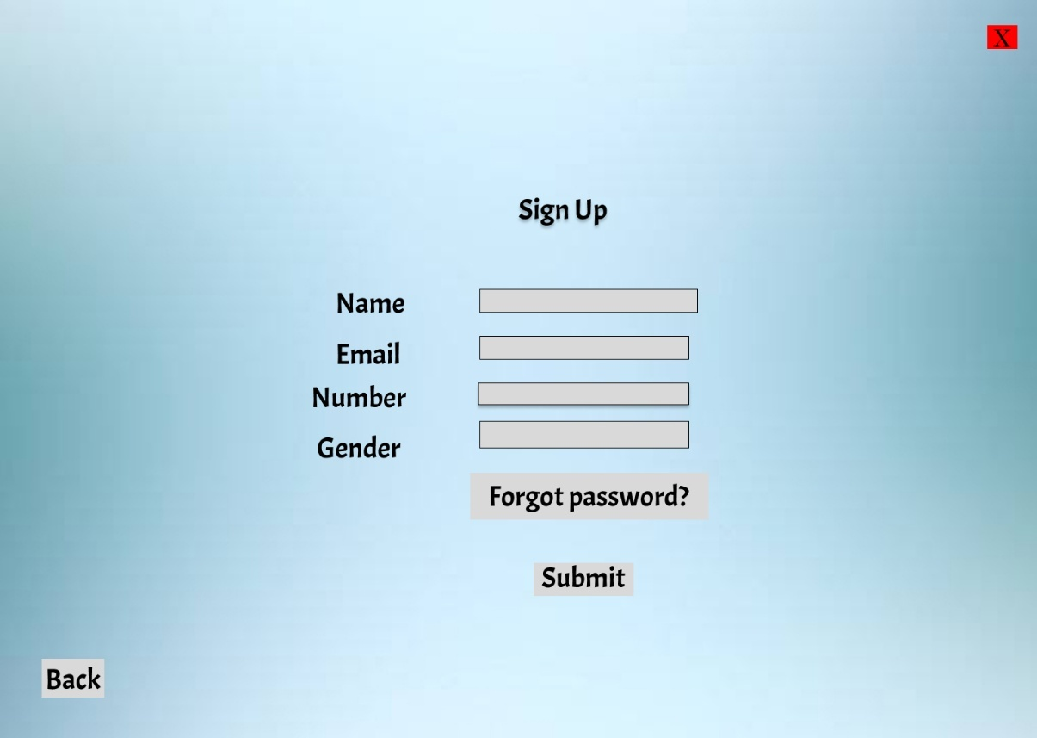

LogIn Page

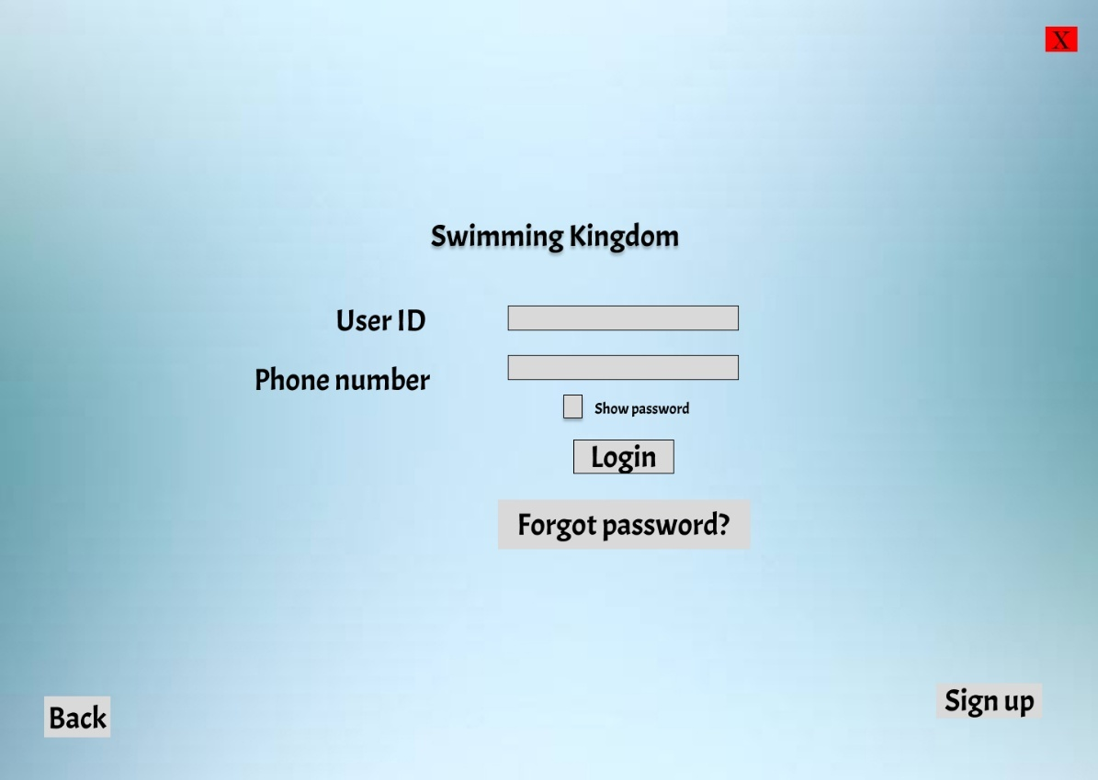

Admin Dashboard Page

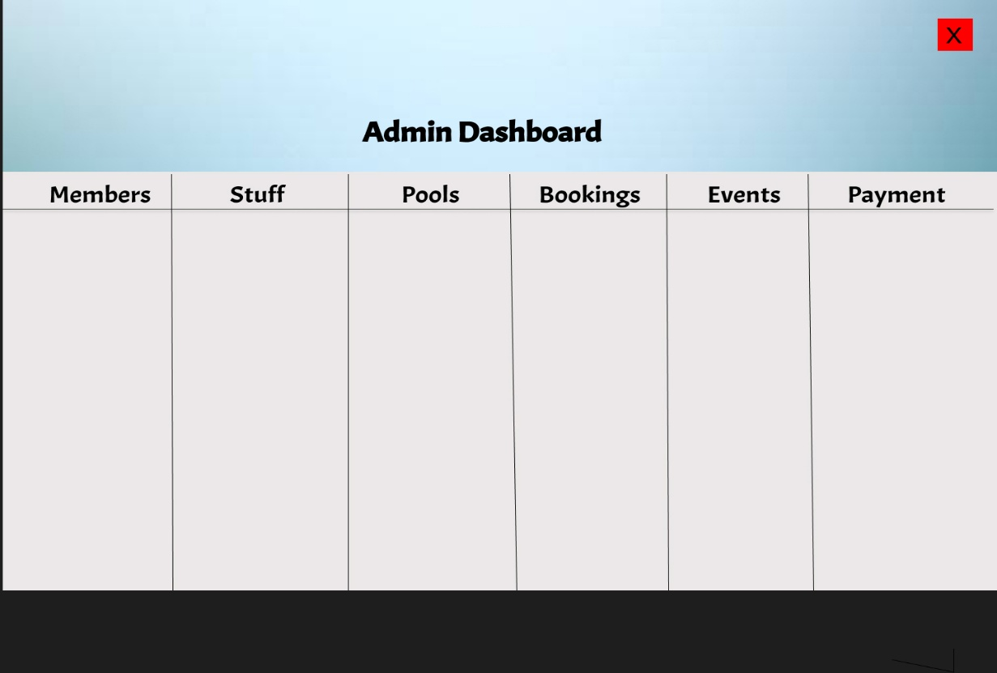

Event Dashboard Page

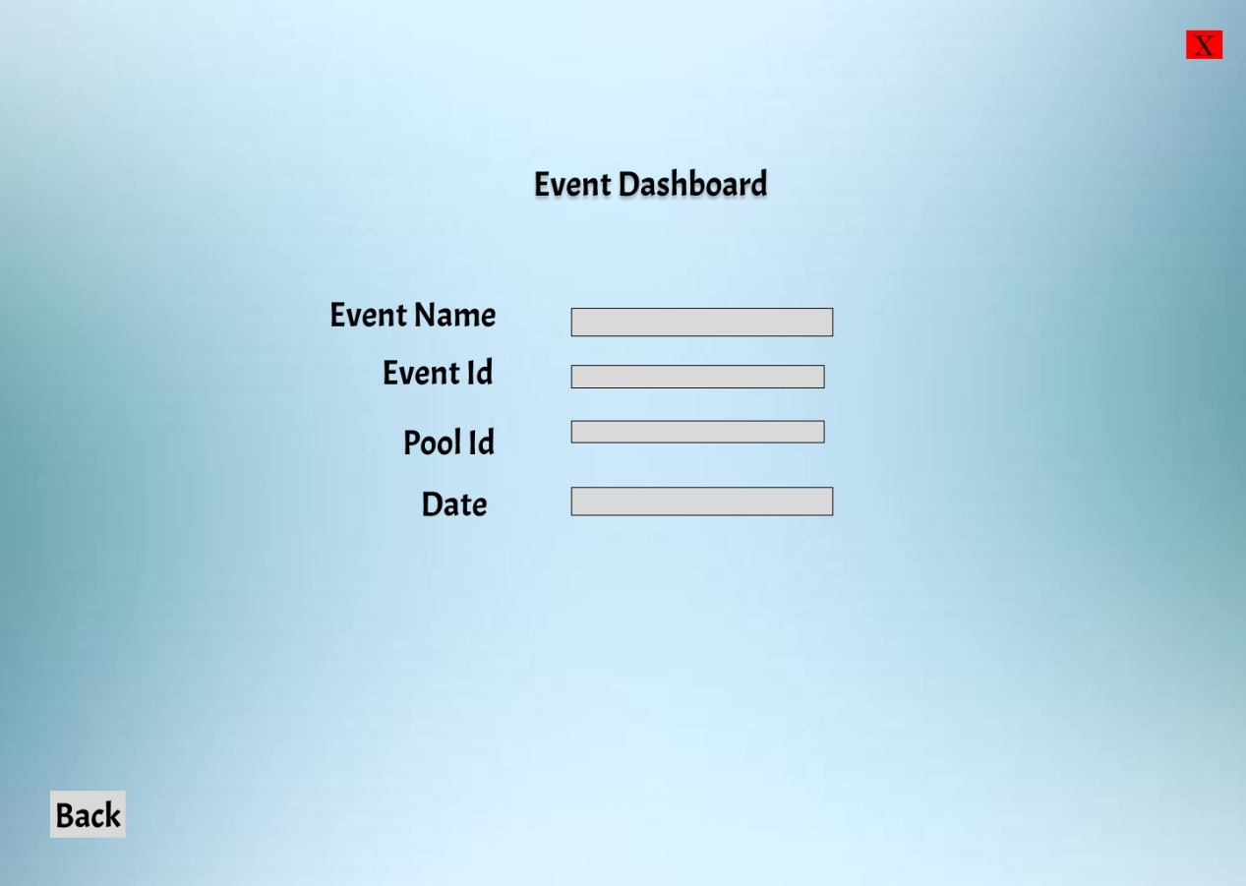

Pool Dashboard Page

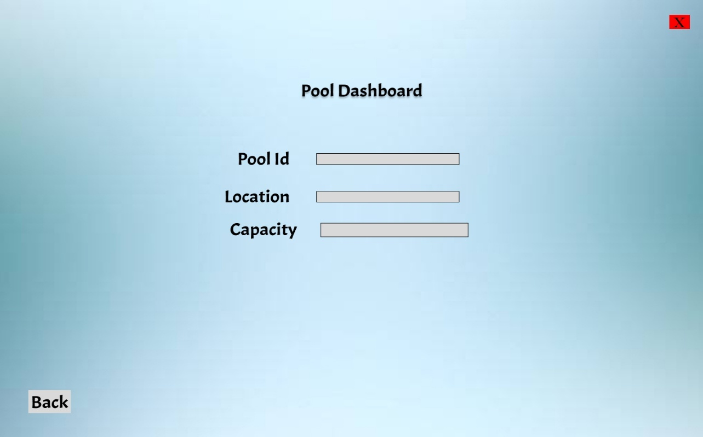

Staff Dashboard Page

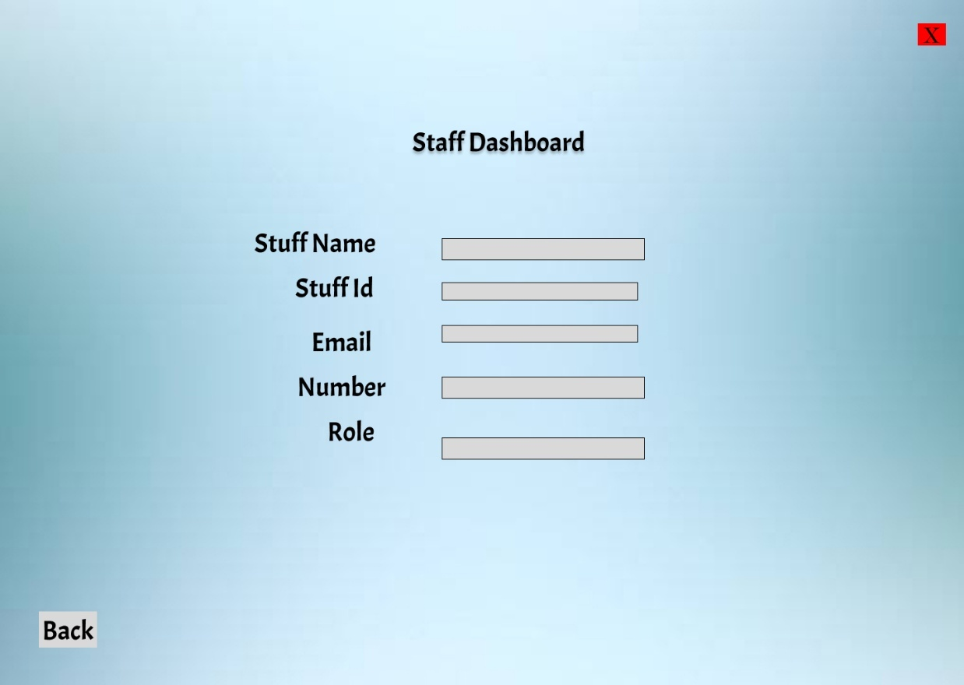

Trainer Dashboard Page

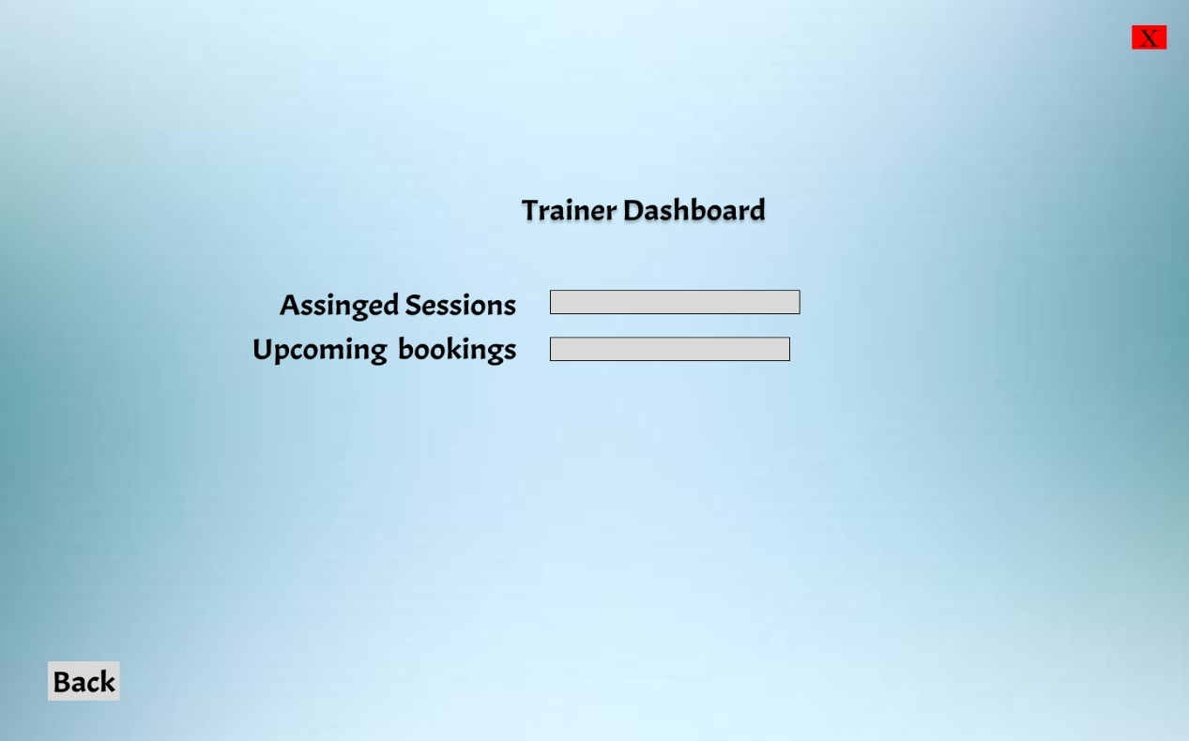

Member Dashboard Page

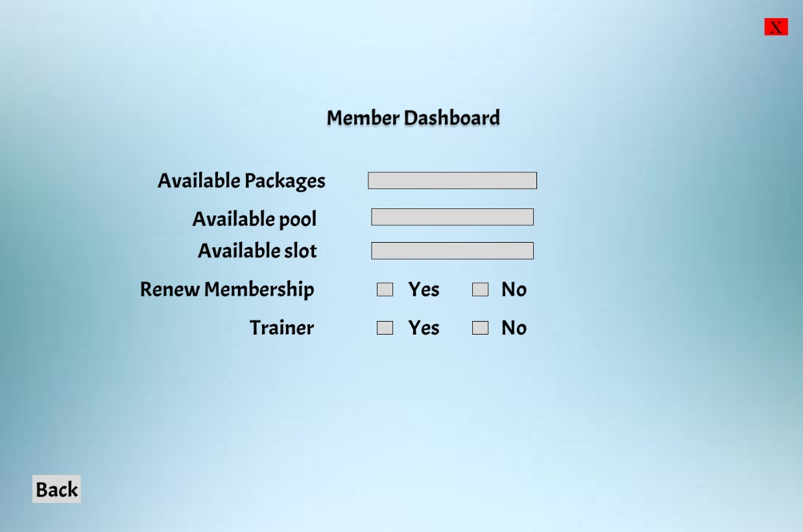

New User Page

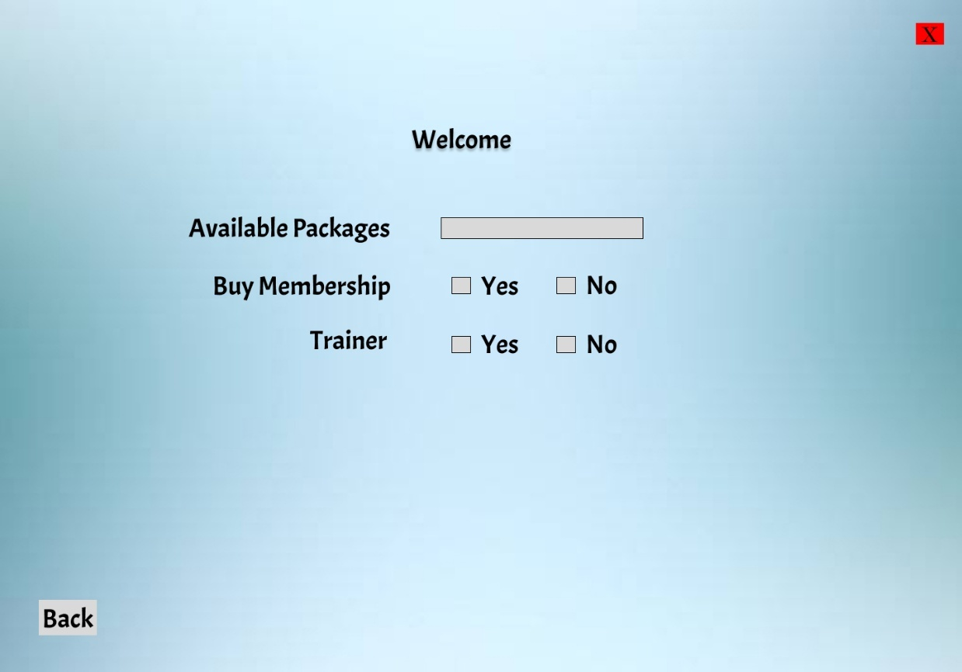

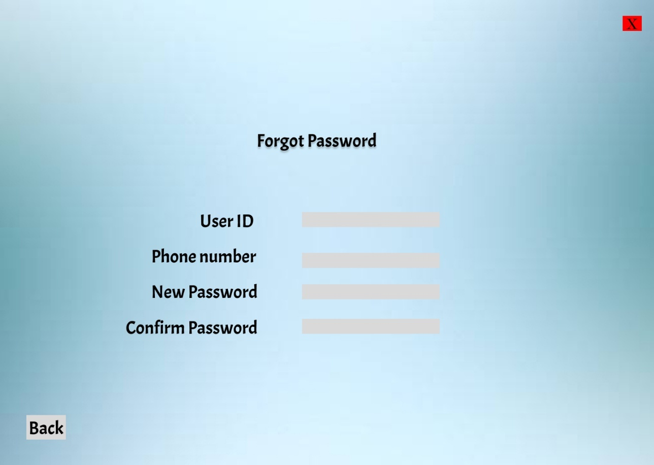Forget Password Page

**Scenario Description**

The Swimming Pool Management System is designed to efficiently manage the activities, resources, and services offered by a swimming pool facility through an integrated approach. At the core of the system are the members, each identified by a unique MemberID, with complete profiles containing details such as name, email, phone, join date, membership type, and red status. Members can reserve bookings for pool usage, attend events, or request training sessions, ensuring personalized services and proper record-keeping. Trainers are also managed within the system, identified by TrainerID, with details such as name, phone, email, and specialty. They can be included in bookings when members require guided swimming sessions, allowing expertise in fitness training, swimming lessons, or rehabilitation to be matched with member needs. Pools themselves are uniquely identified by PoolID, with attributes like location and capacity, and are assigned to bookings and events to prevent overbooking and maintain safety by keeping usage within capacity limits.

The central operation of the system revolves around the booking process, where each booking is identified by a BookingID and contains details of the member, trainer, and pool involved, along with scheduled dates and times. This ensures orderly management, prevents conflicts, and optimizes resource utilization. Events, such as competitions, training camps, or community activities, are also supported by the system. Each event has an EventID along with details like name, date, and time, and is scheduled for specific pools while being booked by members and supervised by staff to ensure smooth execution. Staff members themselves are tracked by StaffID, with details such as name, phone, email, and role, and are responsible for managing events, maintaining pools, and supporting overall operations to assist members effectively.

The financial operations of the facility are integrated through transactions, where each transaction, identified by a TransactionID, records the date and amount paid by members for bookings or events. Transactions are linked to different payment types, managed through a Payment Code, which stores details of payment type and method, such as credit card, cash, or online transfer. This integration ensures accurate financial tracking and provides flexible payment options for members. Altogether, the system creates a cohesive framework where members, trainers, staff, pools, bookings, events, and payments are seamlessly connected, ensuring efficient and organized swimming pool management.

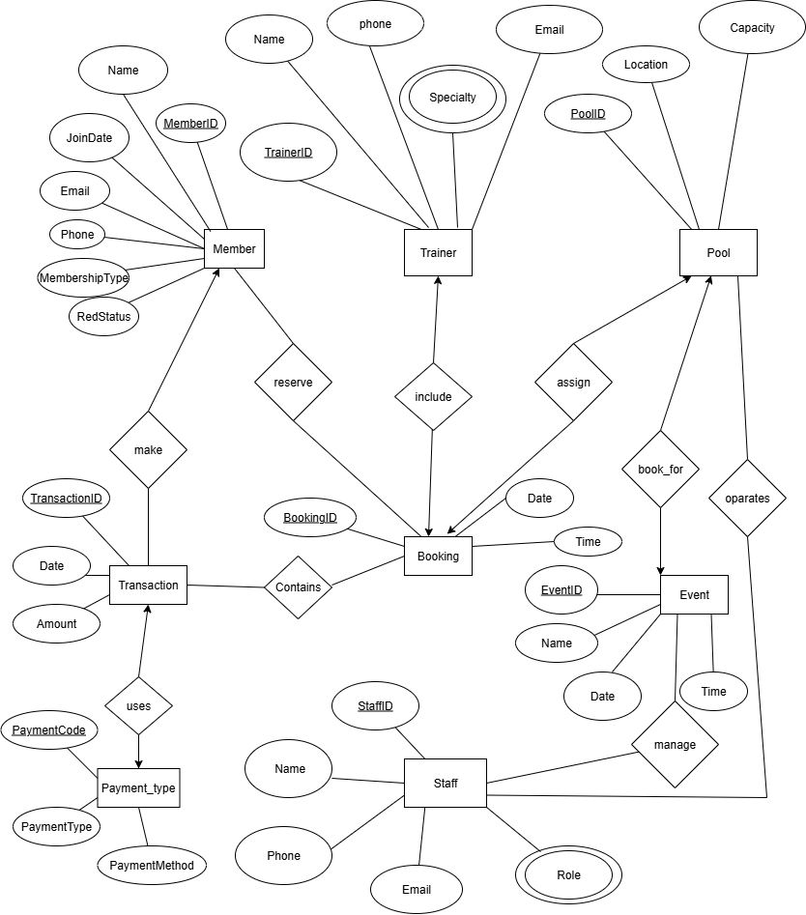**ER Diagram**

**Normalization**

**Relation: Reserve**

**UNF**

Reserve(MemberID, Name, Email, Phone, JoinDate, MembershipType, RedStatus, BookingID, BookingDate, BookingTime)

**1NF**

There is no multi-valued attribute. Relation already in 1NF.

1. MemberID, Name, Email, Phone, JoinDate, MembershipType, RedStatus, BookingID, BookingDate, BookingTime.

**2NF**

1. MemberID, Name, Email, Phone, JoinDate, MembershipType, RedStatus.
2. BookingID, BookingDate, BookingTime.

**3NF**

1. MemberID, Name, JoinDate.
2. Email, Phone, MembershipType, RedStatus.
3. BookingID, BookingDate, BookingTime.

**Table Creation**

1. MemberID, Name, JoinDate, **Email**.
2. Email, Phone, MembershipType, RedStatus.
3. BookingID, BookingDate, BookingTime.
4. **MemberID, BookingID.**

**Relation: Make**

**UNF**

Make(MemberID, Name, Email, Phone, JoinDate, MembershipType, RedStatus, TransactionID, TransactionDate, Amount)

**1NF**

There is no multi-valued attribute. Relation already in 1NF.

1. MemberID, Name, Email, Phone, JoinDate, MembershipType, RedStatus, TransactionID, TransactionDate, Amount.

**2NF**

1. MemberID, Name, Email, Phone, JoinDate, MembershipType, RedStatus.
2. TransactionID, TransactionDate, Amount.

**3NF**

1. MemberID, Name, JoinDate.
2. Email, Phone, MembershipType, RedStatus.
3. TransactionID, TransactionDate, Amount.

**Table Creation**

1. MemberID, Name, JoinDate, **Email**.
2. Email, Phone, MembershipType, RedStatus.
3. TransactionID, TransactionDate, Amount.
4. **MemberID,** **TransactionID.**

**Relation: Uses**

**UNF**

Uses(TransactionID, TransactionDate, Amount, PaymentCode, PaymentType, PaymentMethod)

**1NF**

There is no multi-valued attribute. Relation already in 1NF.

1. TransactionID, TransactionDate, Amount, PaymentCode, PaymentType, PaymentMethod.

**2NF**

1. TransactionID, TransactionDate, Amount.
2. PaymentCode, PaymentType, PaymentMethod.

**3NF**

1. TransactionID, TransactionDate, Amount.
2. PaymentCode, PaymentType, PaymentMethod.

**Table Creation**

1. TransactionID, TransactionDate, Amount.
2. PaymentCode, PaymentType, PaymentMethod.
3. **TransactionID**, **PaymentCode.**

**Relation: Include**

**UNF**

Include(TrainerID, Name, Email, Phone, Specialty, BookingID, BookingDate, BookingTime)

**1NF**

Specialty is a multi-valued attribute.

1. TrainerID, Name, Email, Phone, Specialty, BookingID, BookingDate, BookingTime.
2. **TrainerID**, Specialty.

**2NF**

1. TrainerID, Name, Email, Phone, Specialty.
2. **TrainerID**, Specialty.
3. BookingID, BookingDate, BookingTime.

**3NF**

1. TrainerID, Name, Specialty.
2. **TrainerID**, Specialty.
3. Email, Phone.
4. BookingID, BookingDate, BookingTime.

**Table Creation**

1. TrainerID, Name, **Email**.
2. **TrainerID**, Specialty.
3. Email, Phone.
4. BookingID, BookingDate, BookingTime.
5. **TrainerID**, **BookingID**.

**Relation: Assign**

**UNF**

Assign(PoolID, Location, Capacity, BookingID, BookingDate, BookingTime)

**1NF**

There is no multi-valued attribute. Relation already in 1NF.

1. PoolID, Location, Capacity, BookingID, BookingDate, BookingTime.

**2NF**

1. PoolID, Location, Capacity.
2. BookingID, BookingDate, BookingTime.

**3NF**

1. PoolID, Location, Capacity.
2. BookingID, BookingDate, BookingTime.

**Table Creation**

1. PoolID, Location, Capacity.
2. BookingID, BookingDate, BookingTime.
3. **PoolID**, **BookingID**.

**Relation: Book_for**

**UNF**

Book_for(PoolID, Location, Capacity, EventID, Name, EventDate, EventTime)

**1NF**

There is no multi-valued attribute. Relation already in 1NF.

1. PoolID, Location, Capacity, EventID, Name, EventDate, EventTime.

**2NF**

1. PoolID, Location, Capacity.
2. EventID, Name, EventDate, EventTime.

**3NF**

1. PoolID, Location, Capacity.
2. EventID, Name, EventDate, EventTime.

**Table Creation**

1. PoolID, Location, Capacity.
2. EventID, Name, EventDate, EventTime.
3. **PoolID,** **EventID.**

**Relation: Operates**

**UNF**

Operates(PoolID, Location, Capacity, StaffID, Name, Email, Phone, Role)

**1NF**

Role is a multi-valued attribute.

1. PoolID, Location, Capacity, StaffID, Name, Email, Phone.
2. **StaffID**, Role**.**

**2NF**

1. PoolID, Location, Capacity.
2. StaffID, Name, Email, Phone.
3. **StaffID**, Role.

**3NF**

1. PoolID, Location, Capacity.
2. StaffID, Name.
3. Email, Phone.
4. **StaffID**, Role.

**Table Creation**

1. PoolID, Location, Capacity.
2. StaffID, Name, **Email**.
3. Email, Phone.
4. **PoolID, StaffID.**
5. **StaffID**, Role

**Relation: Manage**

**UNF**

Manage(EventID, Name, EventDate, EventTime, StaffID, Name, Email, Phone, Role)

**1NF**

Role is a multi-valued attribute.

1. EventID, Name, EventDate, EventTime, StaffID, Name, Email, Phone.
2. **StaffID**, Role**.**

**2NF**

1. EventID, Name, EventDate, EventTime.
2. StaffID, Name, Email, Phone.
3. **StaffID**, Role.

**3NF**

1. EventID, Name, EventDate, EventTime.
2. StaffID, Name.
3. Email, Phone.
4. **StaffID**, Role.

**Table Creation**

1. EventID, Name, EventDate, EventTime.
2. StaffID, Name, **Email**.
3. Email, Phone.
4. **EventID, StaffID.**
5. **StaffID**, Role

**Relation: Contains**

**UNF**

Contains(BookingID, BookingDate, BookingTime, TransactionID, TransactionDate, Amount)

**1NF**

There is no multi-valued attribute. Relation already in 1NF.

1. BookingID, BookingDate, BookingTime, TransactionID, Date, Amount.

**2NF**

1. BookingID, BookingDate, BookingTime.
2. TransactionID, TransactionDate, Amount.

**3NF**

1. BookingID, BookingDate, BookingTime.
2. TransactionID, TransactionDate, Amount.

**Table Creation**

1. BookingID, BookingDate, BookingTime.
2. TransactionID, TransactionDate, Amount.
3. **BookingID,** **TransactionID.**

**Final Table Creation:**

1. **MemberInfo:** MemberID, Name, JoinDate, **Email**.
2. **MemberContactInfo:** Email, Phone, MembershipType, RedStatus.
3. **BookingInfo:** BookingID, BookingDate, BookingTime.
4. **MemberBookingInfo:** **BookingID, MemberID.**
5. **TransactionInfo:** TransactionID, **Transaction**Date, Amount.
6. **MemberTransactionInfo:**  **TransactionID, MemberID.**
7. **PaymentTypeInfo:** PaymentCode, PaymentType, PaymentMethod.
8. **TransactionPaymentInfo: TransactionID**, **PaymentCode.**
9. **TrainerInfo:** TrainerID, Name, **Email**.
10. **TrainerSpecialtyInfo: TrainerID**, Specialty.
11. **TrainerContactInfo:** Email, Phone.
12. **TrainerBookingInfo: TrainerID**, **BookingID**.
13. **PoolInfo:** PoolID, Location, Capacity.
14. **PoolBookingInfo:** **PoolID**, **BookingID**.
15. **EventInfo:** EventID, Name, EventDate, EventTime.
16. **PoolEventInfo: PoolID,** **EventID.**
17. **StaffInfo:** StaffID, Name, **Email**.
18. **StaffRoleInfo: StaffID**, Role.
19. **StaffContactInfo:** Email, Phone.
20. **PoolStaffInfo: PoolID, StaffID.**
21. **EventStaffInfo: EventID, StaffID.**
22. **BookingTransactionInfo: BookingID,** **TransactionID.**

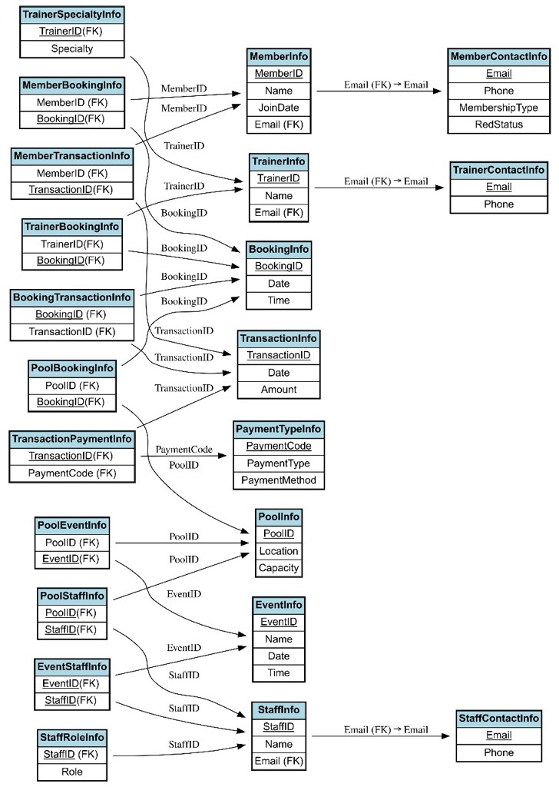**Schema Diagram**

**Table Creation Using SQL**

1. MemberInfo:

CREATE TABLE MemberInfo (

MemberID NUMBER NOT NULL,

Name VARCHAR2(50) NOT NULL,

JoinDate DATE DEFAULT SYSDATE NOT NULL,

Email VARCHAR2(50) NOT NULL,

CONSTRAINT pk_member PRIMARY KEY (MemberID)

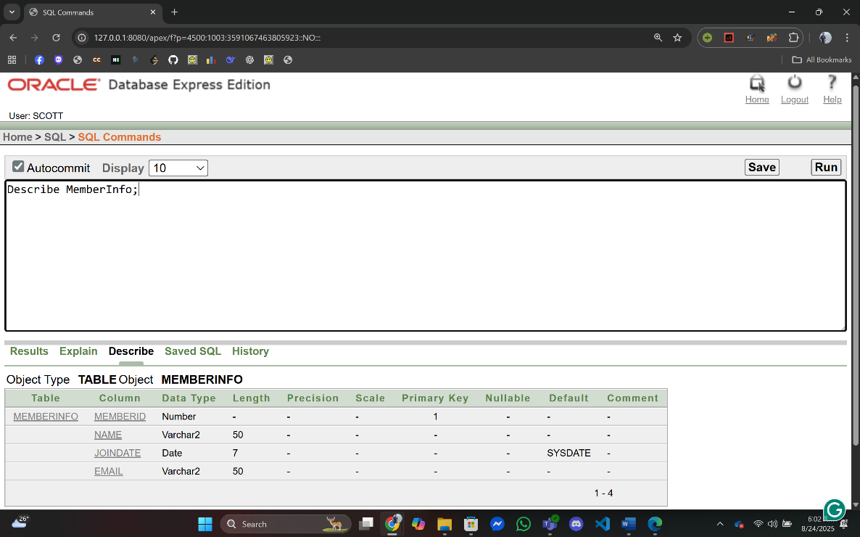);

1. MemberContactInfo:

CREATE TABLE MemberContactInfo (

Email VARCHAR2(50) NOT NULL,

Phone VARCHAR2(15) NOT NULL,

MembershipType VARCHAR2(20) NOT NULL,

RedStatus VARCHAR2(5) DEFAULT 'NO' NOT NULL,

CONSTRAINT pk_member_contact PRIMARY KEY (Email)

);

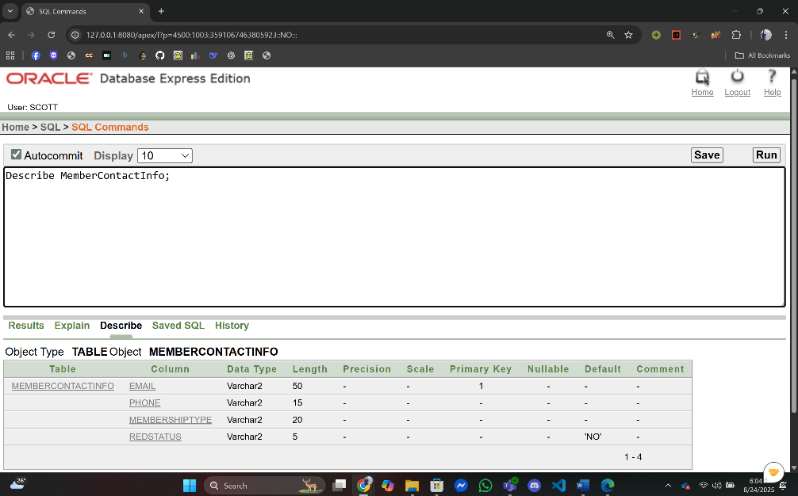

ALTER TABLE MemberInfo

ADD CONSTRAINT fk_member_email FOREIGN KEY (Email)

REFERENCES MemberContactInfo(Email);

1. BookingInfo

CREATE TABLE BookingInfo (

BookingID NUMBER NOT NULL,

BookingDate DATE DEFAULT SYSDATE NOT NULL,

BookingTime VARCHAR2(10) DEFAULT TO_CHAR(SYSDATE, 'HH24:MI:SS') NOT NULL,

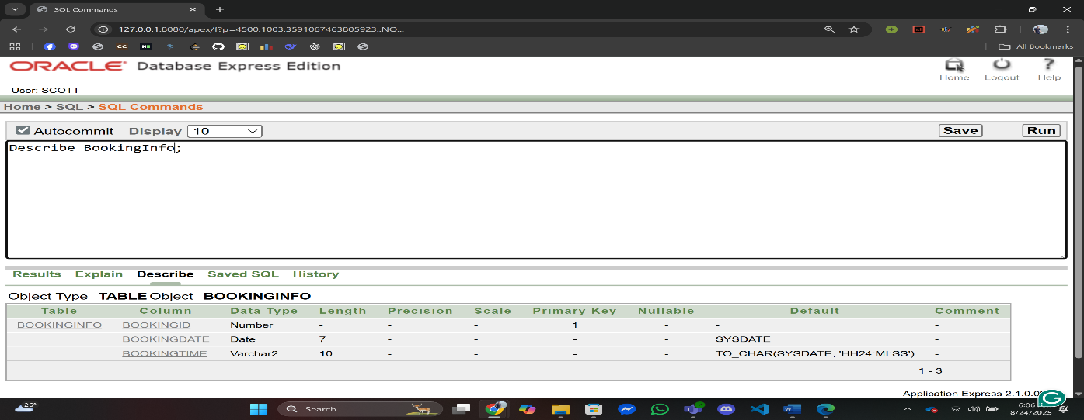 CONSTRAINT pk_booking PRIMARY KEY (BookingID));

1. MemberBookingInfo

CREATE TABLE MemberBookingInfo (

BookingID NUMBER NOT NULL,

MemberID NUMBER NOT NULL,

CONSTRAINT pk_member_booking PRIMARY KEY (BookingID),

CONSTRAINT fk_mbi_booking FOREIGN KEY (BookingID) REFERENCES BookingInfo(BookingID),

CONSTRAINT fk_mbi_member FOREIGN KEY (MemberID) REFERENCES MemberInfo(MemberID)

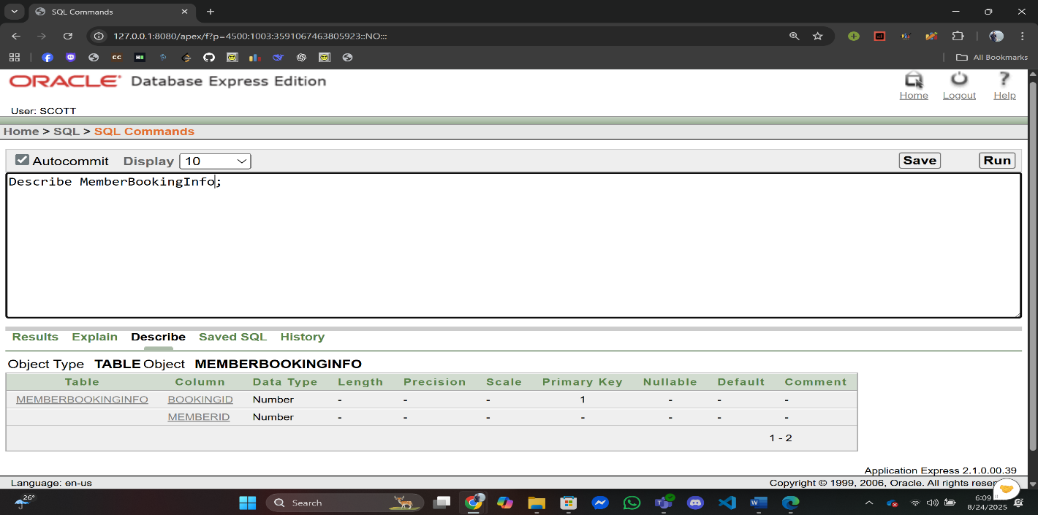);

1. TransactionInfo

CREATE TABLE TransactionInfo (

TransactionID NUMBER NOT NULL,

TransactionDate DATE DEFAULT SYSDATE NOT NULL,

Amount NUMBER(10,2) NOT NULL,

CONSTRAINT pk_transaction PRIMARY KEY (TransactionID)

);

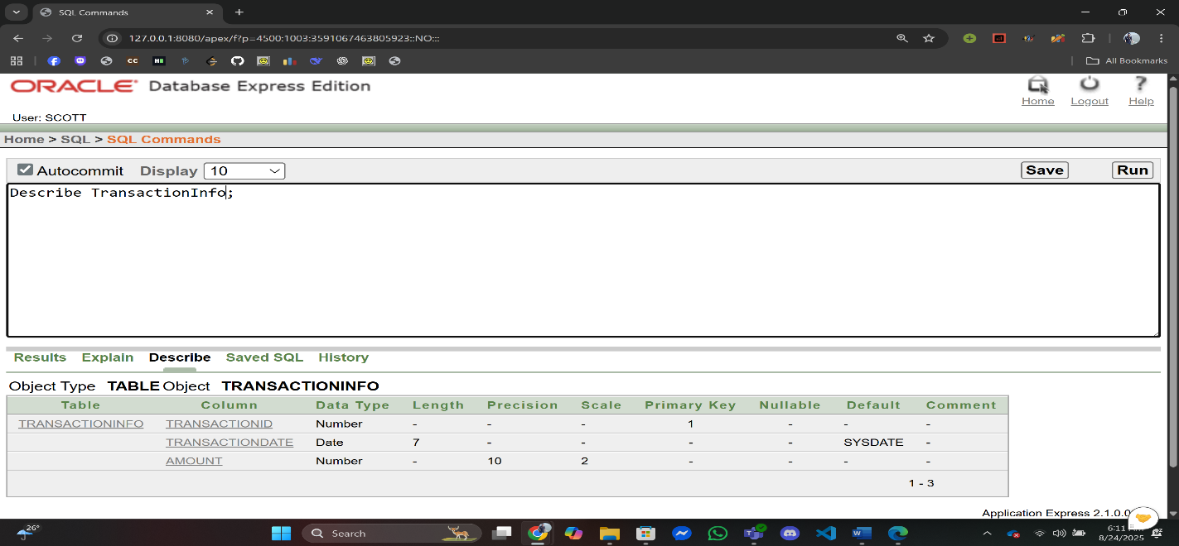

1. MemberTransactionInfo:

CREATE TABLE MemberTransactionInfo (

TransactionID NUMBER NOT NULL,

MemberID NUMBER NOT NULL,

CONSTRAINT pk_member_transaction PRIMARY KEY (TransactionID),

CONSTRAINT fk_mti_trans FOREIGN KEY (TransactionID) REFERENCES TransactionInfo(TransactionID),

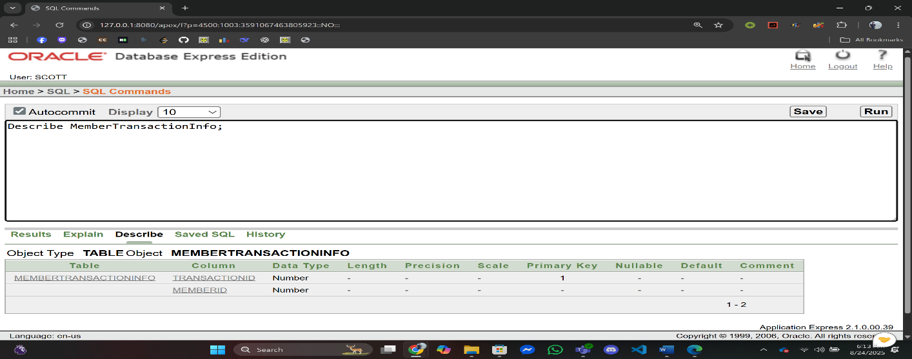 CONSTRAINT fk_mti_member FOREIGN KEY (MemberID) REFERENCES MemberInfo(MemberID));

1. PaymentTypeInfo:

CREATE TABLE PaymentTypeInfo (

PaymentCode NUMBER NOT NULL,

PaymentType VARCHAR2(20) NOT NULL,

PaymentMethod VARCHAR2(20) NOT NULL,

CONSTRAINT pk_payment PRIMARY KEY (PaymentCode)

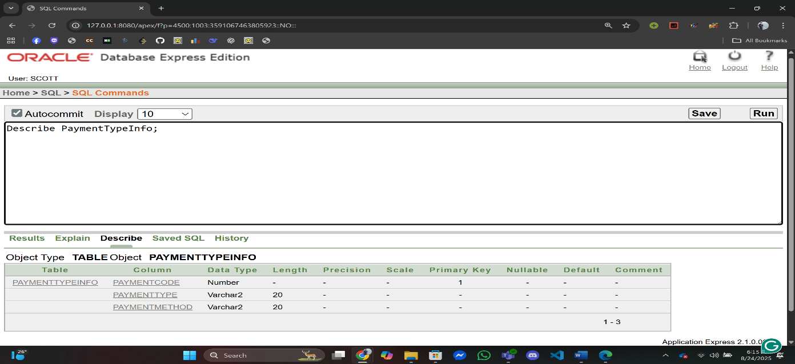);

1. TransactionPaymentInfo:

CREATE TABLE TransactionPaymentInfo (

TransactionID NUMBER NOT NULL,

PaymentCode NUMBER NOT NULL,

CONSTRAINT pk_transaction_payment PRIMARY KEY (TransactionID),

CONSTRAINT fk_tpi_trans FOREIGN KEY (TransactionID) REFERENCES TransactionInfo(TransactionID),

CONSTRAINT fk_tpi_pay FOREIGN KEY (PaymentCode) REFERENCES PaymentTypeInfo(PaymentCode)

);

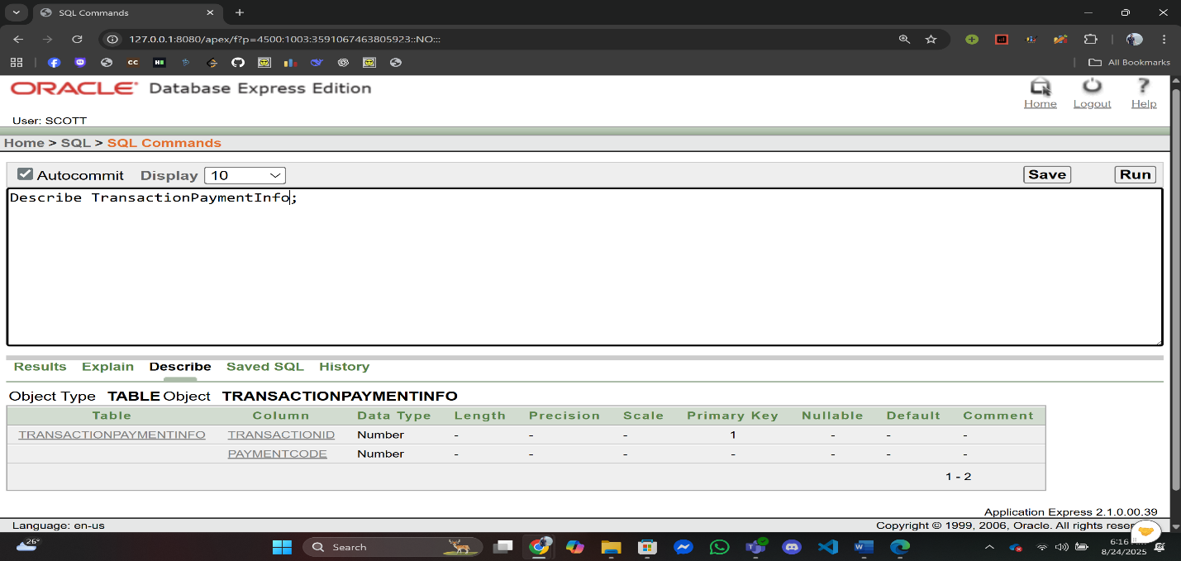

1. TrainerInfo:

CREATE TABLE TrainerInfo (

TrainerID NUMBER NOT NULL,

Name VARCHAR2(50) NOT NULL,

Email VARCHAR2(50) NOT NULL,

CONSTRAINT pk_trainer PRIMARY KEY (TrainerID)

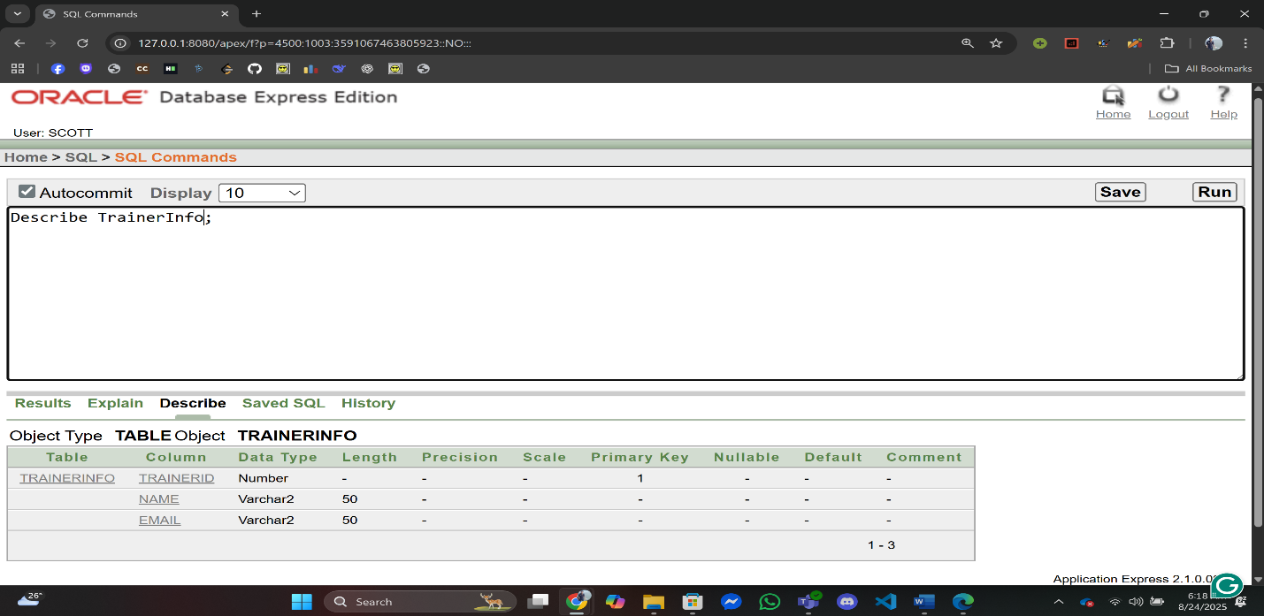);

1. TrainerSpecialtyInfo:

CREATE TABLE TrainerSpecialtyInfo (

TrainerID NUMBER NOT NULL,

Specialty VARCHAR2(50) NOT NULL,

CONSTRAINT pk_trainer_specialty PRIMARY KEY (TrainerID, Specialty),

CONSTRAINT fk_tsi_trainer FOREIGN KEY (TrainerID) REFERENCES TrainerInfo(TrainerID)

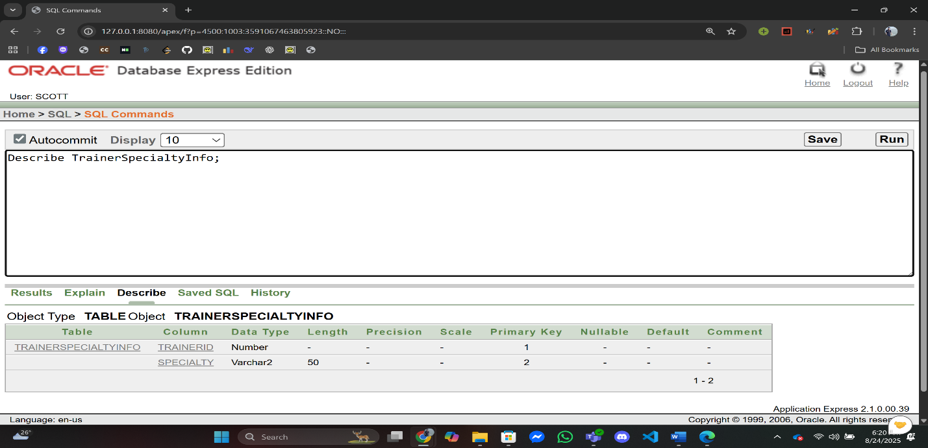);

1. TrainerContactInfo:

CREATE TABLE TrainerContactInfo (

Email VARCHAR2(50) NOT NULL,

Phone VARCHAR2(15) NOT NULL,

CONSTRAINT pk_trainer_contact PRIMARY KEY (Email)

);

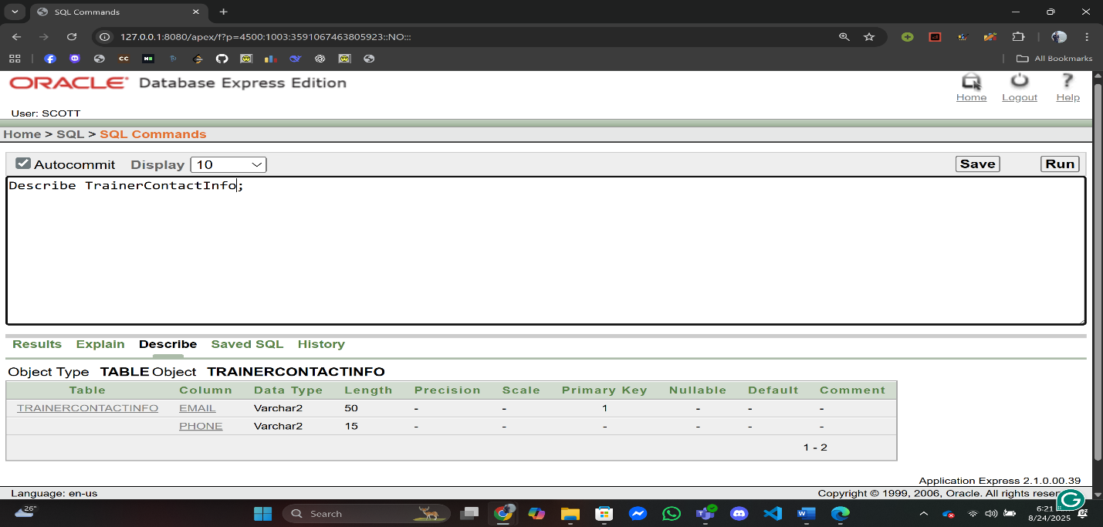

ALTER TABLE TrainerInfo

ADD CONSTRAINT fk_trainer_email FOREIGN KEY (Email)

REFERENCES TrainerContactInfo(Email);

1. TrainerBookingInfo:

CREATE TABLE TrainerBookingInfo (

BookingID NUMBER NOT NULL,

TrainerID NUMBER NOT NULL,

CONSTRAINT pk_trainer_booking PRIMARY KEY (BookingID),

CONSTRAINT fk_tbi_booking FOREIGN KEY (BookingID) REFERENCES BookingInfo(BookingID),

CONSTRAINT fk_tbi_trainer FOREIGN KEY (TrainerID) REFERENCES TrainerInfo(TrainerID)

);

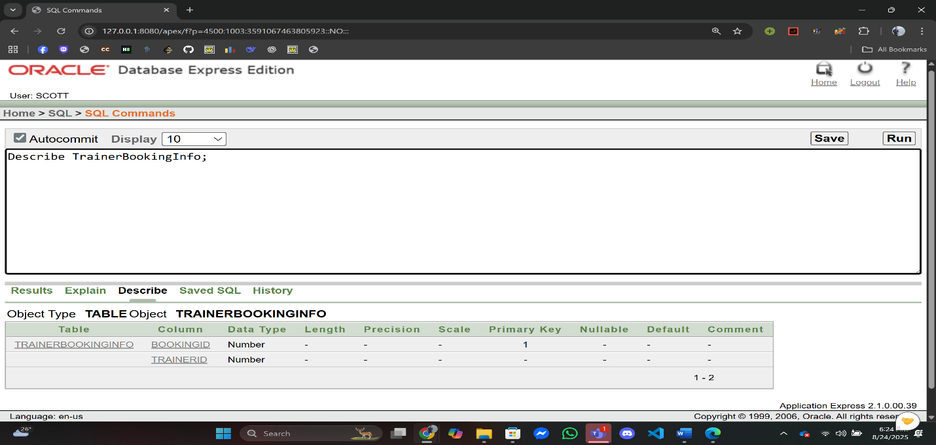

1. PoolInfo:

CREATE TABLE PoolInfo (

PoolID NUMBER NOT NULL,

Location VARCHAR2(50) NOT NULL,

Capacity NUMBER NOT NULL,

CONSTRAINT pk_pool PRIMARY KEY (PoolID)

);

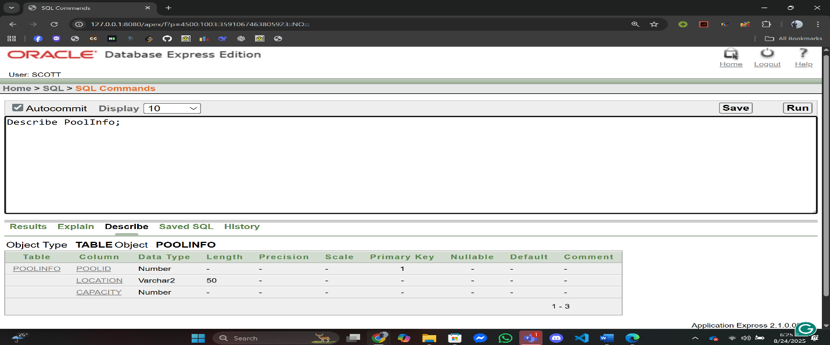

1. PoolBookingInfo:

CREATE TABLE PoolBookingInfo (

BookingID NUMBER NOT NULL,

PoolID NUMBER NOT NULL,

CONSTRAINT pk_pool_booking PRIMARY KEY (BookingID),

CONSTRAINT fk_pbi_booking FOREIGN KEY (BookingID) REFERENCES BookingInfo(BookingID),

CONSTRAINT fk_pbi_pool FOREIGN KEY (PoolID) REFERENCES PoolInfo(PoolID)

);

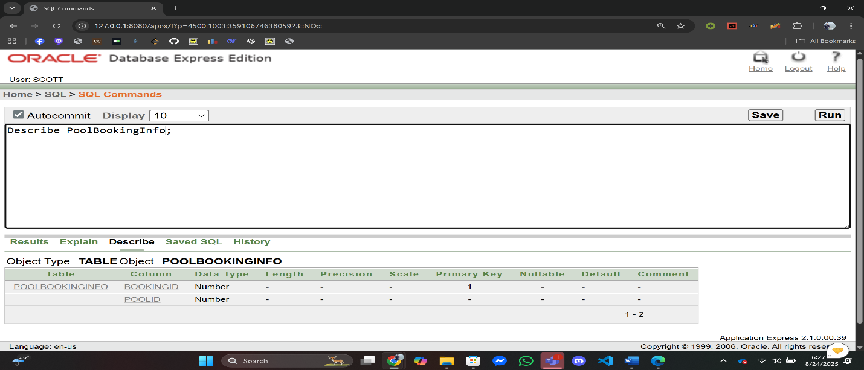

1. EventInfo:

CREATE TABLE EventInfo (

EventID NUMBER NOT NULL,

Name VARCHAR2(50) NOT NULL,

EventDate DATE NOT NULL,

EventTime VARCHAR2(10) NOT NULL,

CONSTRAINT pk_event PRIMARY KEY (EventID)

);

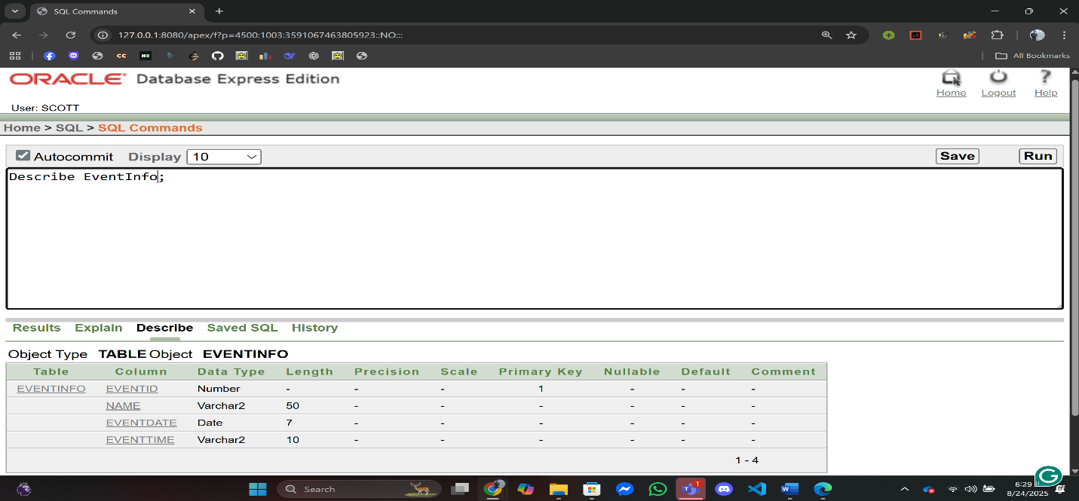

1. PoolEventInfo:

CREATE TABLE PoolEventInfo (

EventID NUMBER NOT NULL,

PoolID NUMBER NOT NULL,

CONSTRAINT pk_pool_event PRIMARY KEY (EventID),

CONSTRAINT fk_pei_event FOREIGN KEY (EventID) REFERENCES EventInfo(EventID),

CONSTRAINT fk_pei_pool FOREIGN KEY (PoolID) REFERENCES PoolInfo(PoolID)

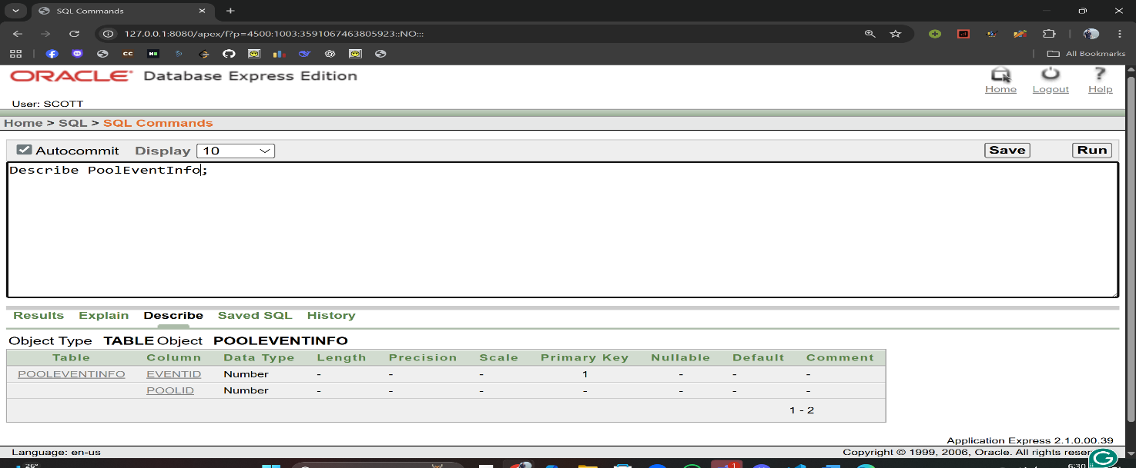);

1. StaffInfo:

CREATE TABLE StaffInfo (

StaffID NUMBER NOT NULL,

Name VARCHAR2(50) NOT NULL,

Email VARCHAR2(50) NOT NULL,

CONSTRAINT pk_staff PRIMARY KEY (StaffID)

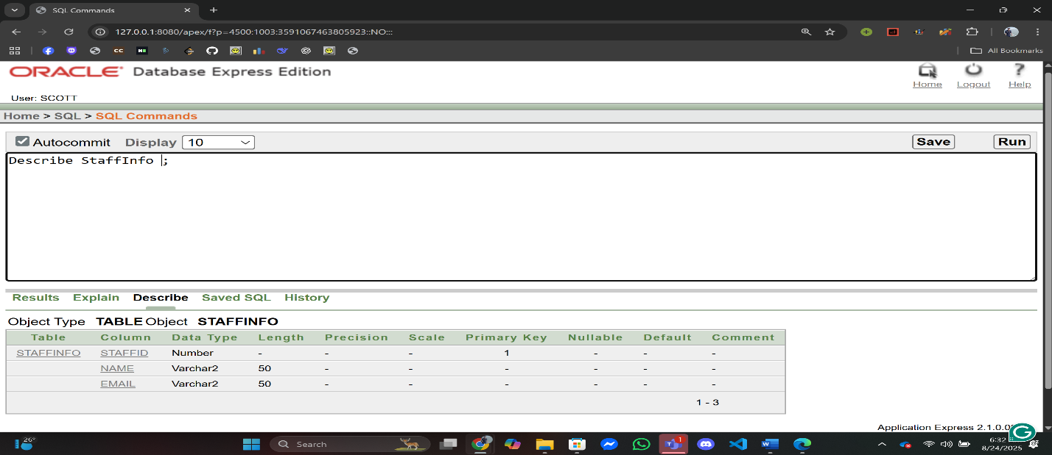);

1. StaffRoleInfo:

CREATE TABLE StaffRoleInfo (

StaffID NUMBER NOT NULL,

Role VARCHAR2(30) NOT NULL,

CONSTRAINT pk_staff_role PRIMARY KEY (StaffID, Role),

CONSTRAINT fk_sri_staff FOREIGN KEY (StaffID) REFERENCES StaffInfo(StaffID)

);

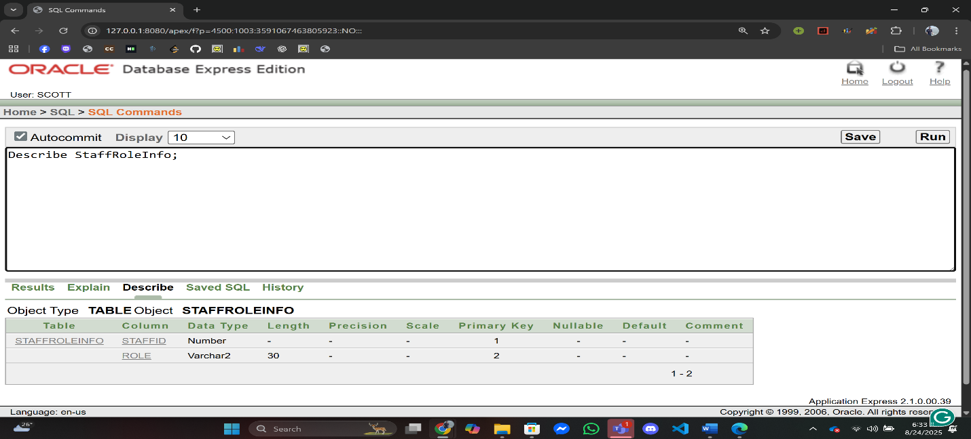

1. StaffContactInfo:

CREATE TABLE StaffContactInfo (

Email VARCHAR2(50) NOT NULL,

Phone VARCHAR2(15) NOT NULL,

CONSTRAINT pk_staff_contact PRIMARY KEY (Email)

);

ALTER TABLE StaffInfo

ADD CONSTRAINT fk_staff_email FOREIGN KEY (Email)

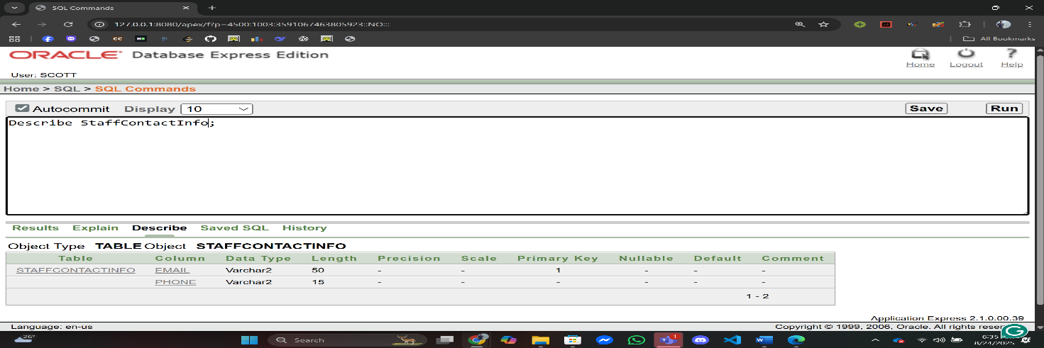REFERENCES StaffContactInfo(Email);

1. PoolStaffInfo:

CREATE TABLE PoolStaffInfo (

PoolID NUMBER NOT NULL,

StaffID NUMBER NOT NULL,

CONSTRAINT pk_poolstaff PRIMARY KEY (PoolID, StaffID),

CONSTRAINT fk_psi_pool FOREIGN KEY (PoolID) REFERENCES PoolInfo(PoolID),

CONSTRAINT fk_psi_staff FOREIGN KEY (StaffID) REFERENCES StaffInfo(StaffID)

);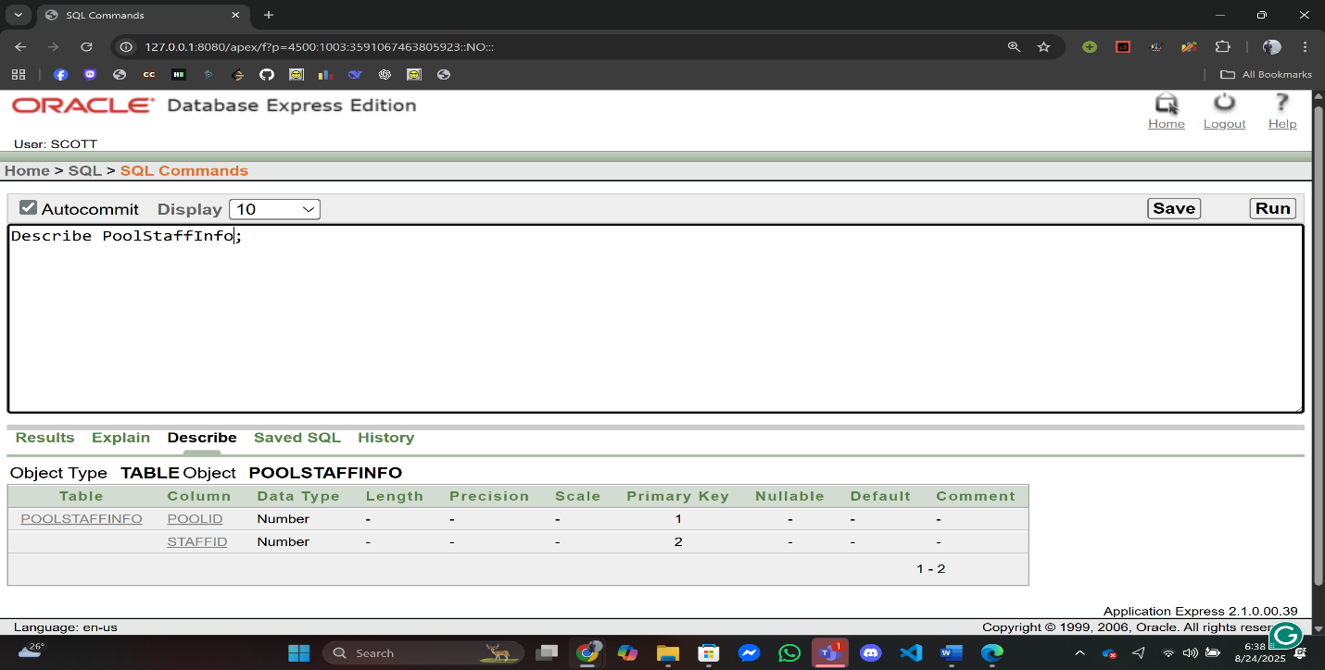

1. EventStaffInfo:

CREATE TABLE EventStaffInfo (

EventID NUMBER NOT NULL,

StaffID NUMBER NOT NULL,

CONSTRAINT pk_eventstaff PRIMARY KEY (EventID, StaffID),

CONSTRAINT fk_esi_event FOREIGN KEY (EventID) REFERENCES EventInfo(EventID),

CONSTRAINT fk_esi_staff FOREIGN KEY (StaffID) REFERENCES StaffInfo(StaffID)

);

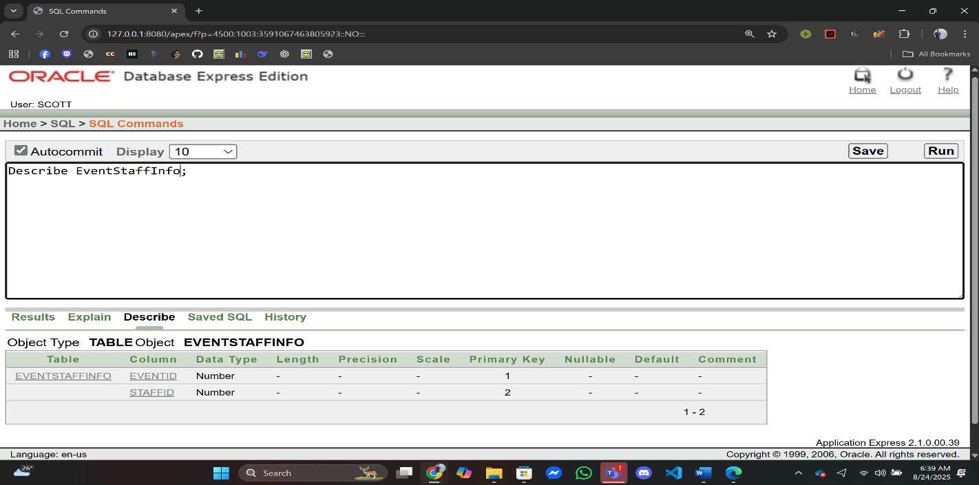

1. BookingTraInfo:

CREATE TABLE BookingTraInfo (

BookingID NUMBER NOT NULL,

TransactionID NUMBER NOT NULL,

CONSTRAINT pk_booking_transaction PRIMARY KEY (BookingID),

CONSTRAINT fk_bti_booking FOREIGN KEY (BookingID) REFERENCES BookingInfo(BookingID),

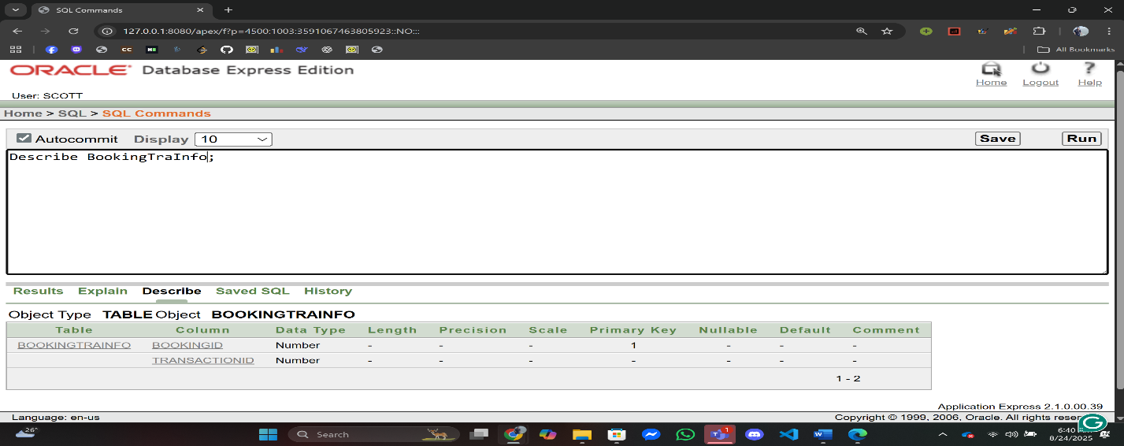 CONSTRAINT fk_bti_trans FOREIGN KEY (TransactionID) REFERENCES TransactionInfo(TransactionID)

**Data Insertion Using SQL**

1. MemberContactInfo:

INSERT INTO MemberContactInfo (Email, Phone, MembershipType, RedStatus)

VALUES ('sazzad@example.com', '01711000001', 'Gold', DEFAULT);

INSERT INTO MemberContactInfo (Email, Phone, MembershipType, RedStatus)

VALUES ('rahim@example.com', '01711000002', 'Silver', DEFAULT);

INSERT INTO MemberContactInfo (Email, Phone, MembershipType, RedStatus)

VALUES ('karim@example.com', '01711000003', 'Platinum', DEFAULT);

INSERT INTO MemberContactInfo (Email, Phone, MembershipType, RedStatus)

VALUES ('apu@example.com', '01711000004', 'Gold', DEFAULT);

INSERT INTO MemberContactInfo (Email, Phone, MembershipType, RedStatus)

VALUES ('mehedi@example.com', '01711000005', 'Silver', DEFAULT);

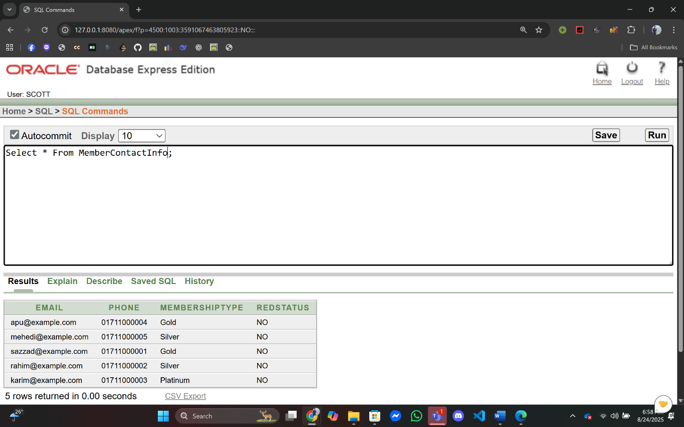

1. MemberInfo:

INSERT INTO MemberInfo (MemberID, Name, JoinDate, Email)

VALUES (1, 'Sazzad Khan', DEFAULT, 'sazzad@example.com');

INSERT INTO MemberInfo (MemberID, Name, JoinDate, Email)

VALUES (2, 'Rahim Uddin', DEFAULT, 'rahim@example.com');

INSERT INTO MemberInfo (MemberID, Name, JoinDate, Email)

VALUES (3, 'Karim Sheikh', DEFAULT, 'karim@example.com');

INSERT INTO MemberInfo (MemberID, Name, JoinDate, Email)

VALUES (4, 'Apu Rani', DEFAULT, 'apu@example.com');

INSERT INTO MemberInfo (MemberID, Name, JoinDate, Email)

VALUES (5, 'Mehedi Hasan', DEFAULT, 'mehedi@example.com');

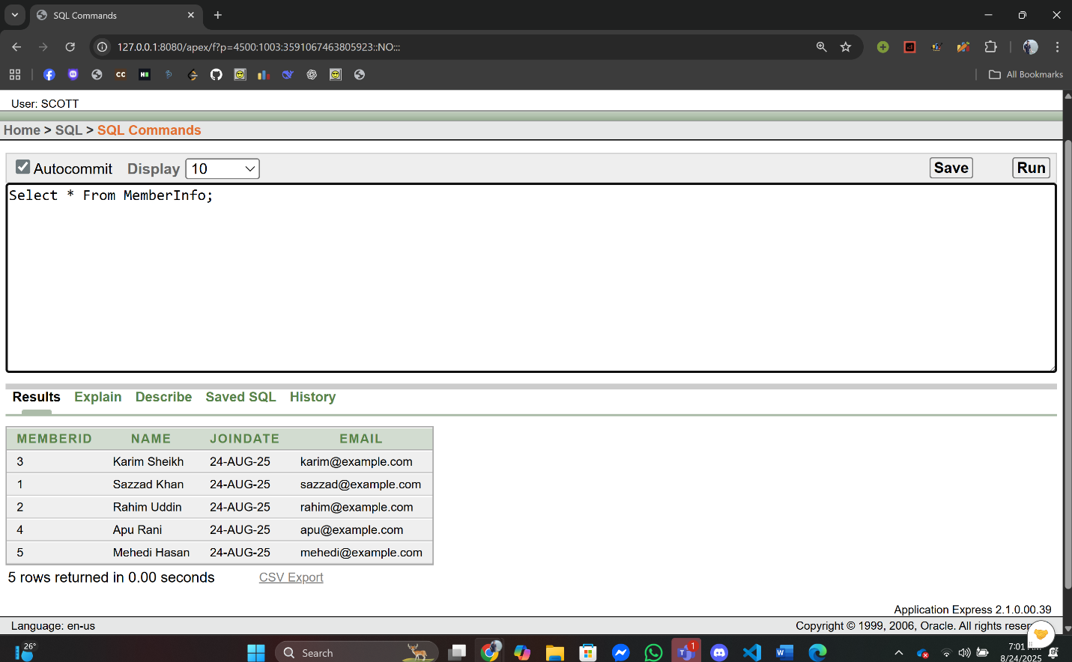

3. BookingInfo:

INSERT INTO BookingInfo (BookingID, BookingDate, BookingTime) VALUES (101, DEFAULT, DEFAULT);

INSERT INTO BookingInfo (BookingID, BookingDate, BookingTime) VALUES (102, DEFAULT, DEFAULT);

INSERT INTO BookingInfo (BookingID, BookingDate, BookingTime) VALUES (103, DEFAULT, DEFAULT);

INSERT INTO BookingInfo (BookingID, BookingDate, BookingTime) VALUES (104, DEFAULT, DEFAULT);

INSERT INTO BookingInfo (BookingID, BookingDate, BookingTime) VALUES (105, DEFAULT, DEFAULT);

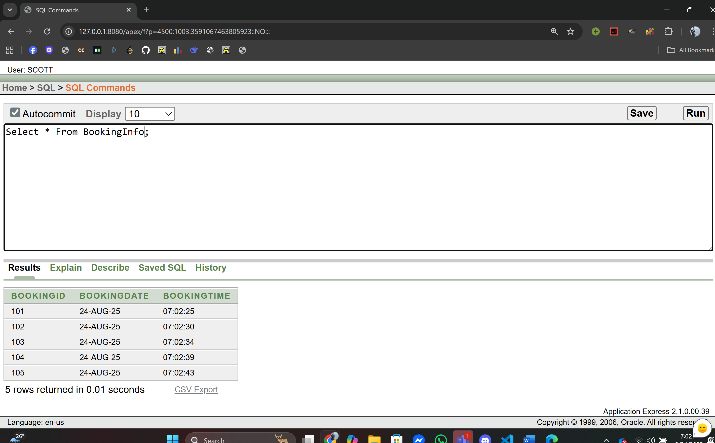

4. MemberBookingInfo:

INSERT INTO MemberBookingInfo (BookingID, MemberID) VALUES (101, 1);

INSERT INTO MemberBookingInfo (BookingID, MemberID) VALUES (102, 2);

INSERT INTO MemberBookingInfo (BookingID, MemberID) VALUES (103, 3);

INSERT INTO MemberBookingInfo (BookingID, MemberID) VALUES (104, 4);

INSERT INTO MemberBookingInfo (BookingID, MemberID) VALUES (105, 5);

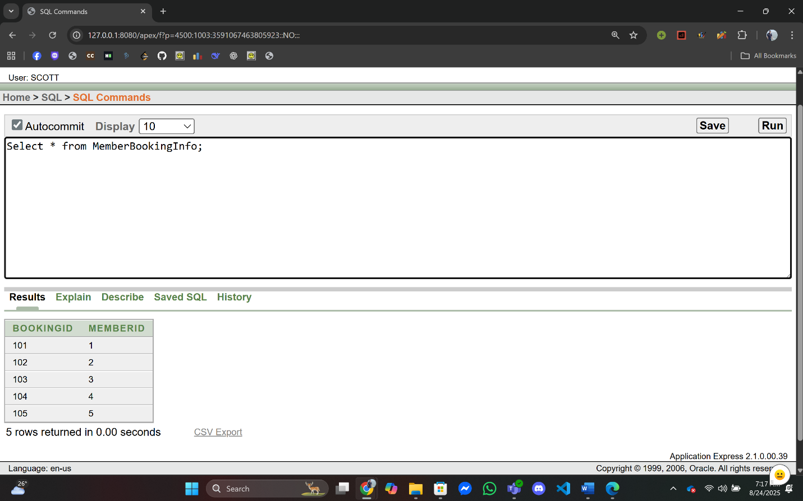

5. TransactionInfo:

INSERT INTO TransactionInfo (TransactionID, TransactionDate, Amount) VALUES (2001, DEFAULT, 1500.00);

INSERT INTO TransactionInfo (TransactionID, TransactionDate, Amount) VALUES (2002, DEFAULT, 3200.50);

INSERT INTO TransactionInfo (TransactionID, TransactionDate, Amount) VALUES (2003, DEFAULT, 875.75);

INSERT INTO TransactionInfo (TransactionID, TransactionDate, Amount) VALUES (2004, DEFAULT, 4999.99);

INSERT INTO TransactionInfo (TransactionID, TransactionDate, Amount) VALUES (2005, DEFAULT, 2210.25);

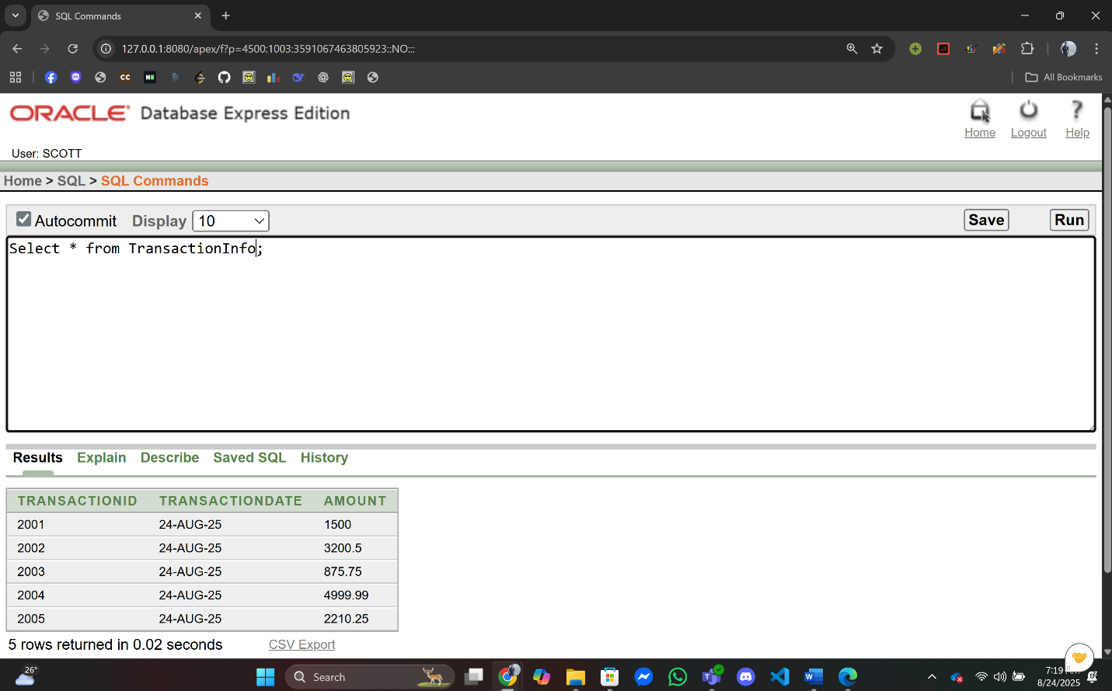

6. MemberTransactionInfo:

INSERT INTO MemberTransactionInfo (TransactionID, MemberID) VALUES (2001, 1);

INSERT INTO MemberTransactionInfo (TransactionID, MemberID) VALUES (2002, 2);

INSERT INTO MemberTransactionInfo (TransactionID, MemberID) VALUES (2003, 3);

INSERT INTO MemberTransactionInfo (TransactionID, MemberID) VALUES (2004, 4);

INSERT INTO MemberTransactionInfo (TransactionID, MemberID) VALUES (2005, 5);

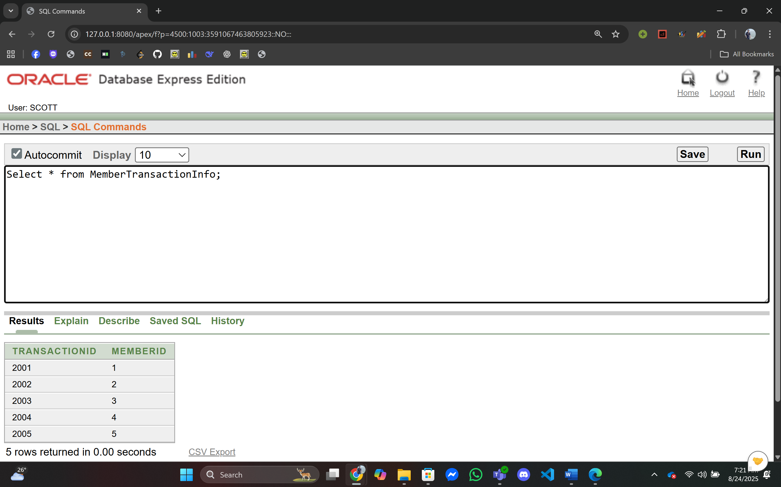

7. PaymentTypeInfo:

INSERT INTO PaymentTypeInfo (PaymentCode, PaymentType, PaymentMethod) VALUES (3001, 'Credit', 'Visa');

INSERT INTO PaymentTypeInfo (PaymentCode, PaymentType, PaymentMethod) VALUES (3002, 'Debit', 'MasterCard');

INSERT INTO PaymentTypeInfo (PaymentCode, PaymentType, PaymentMethod) VALUES (3003, 'Online', 'bKash');

INSERT INTO PaymentTypeInfo (PaymentCode, PaymentType, PaymentMethod) VALUES (3004, 'Mobile', 'Nagad');

INSERT INTO PaymentTypeInfo (PaymentCode, PaymentType, PaymentMethod) VALUES (3005, 'Cash', 'Cash');

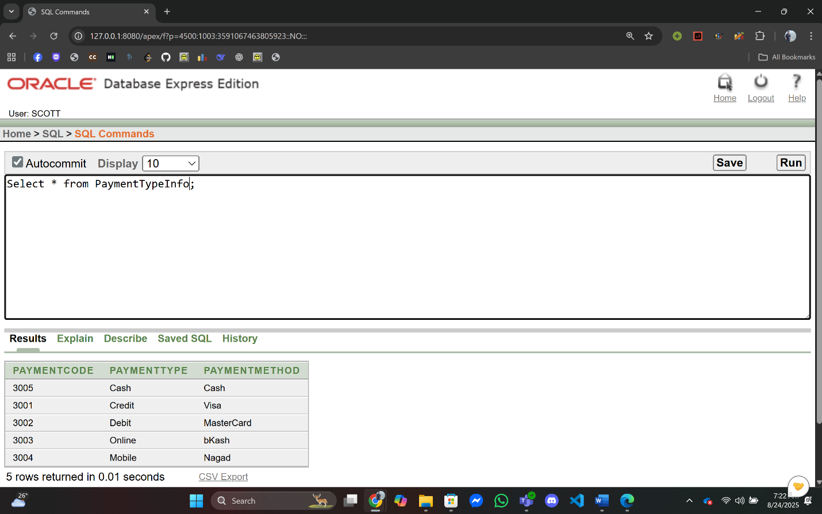

8. TransactionPaymentInfo:

INSERT INTO TransactionPaymentInfo (TransactionID, PaymentCode) VALUES (2001, 3001);

INSERT INTO TransactionPaymentInfo (TransactionID, PaymentCode) VALUES (2002, 3002);

INSERT INTO TransactionPaymentInfo (TransactionID, PaymentCode) VALUES (2003, 3003);

INSERT INTO TransactionPaymentInfo (TransactionID, PaymentCode) VALUES (2004, 3004);

INSERT INTO TransactionPaymentInfo (TransactionID, PaymentCode) VALUES (2005, 3005);

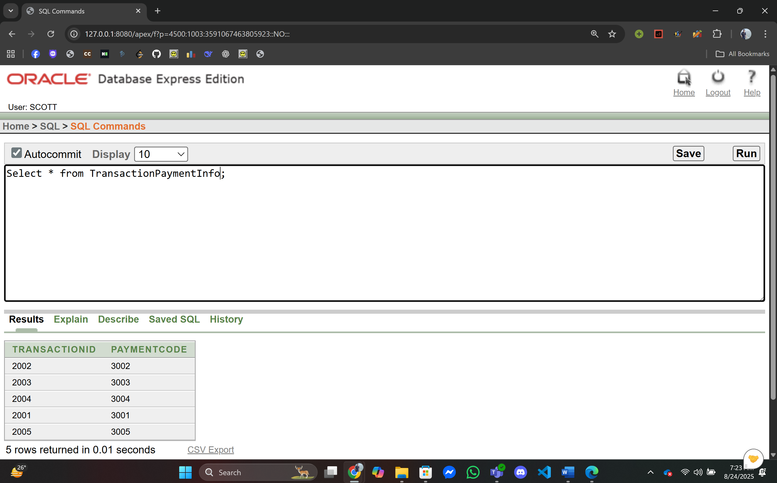

9. TrainerContactInfo:

INSERT INTO TrainerContactInfo (Email, Phone) VALUES ('rahim.trainer@club.com', '01712000001');

INSERT INTO TrainerContactInfo (Email, Phone) VALUES ('nazmul.trainer@club.com', '01712000002');

INSERT INTO TrainerContactInfo (Email, Phone) VALUES ('rupa.trainer@club.com', '01712000003');

INSERT INTO TrainerContactInfo (Email, Phone) VALUES ('tahsin.trainer@club.com', '01712000004');

INSERT INTO TrainerContactInfo (Email, Phone) VALUES ('mitu.trainer@club.com', '01712000005');

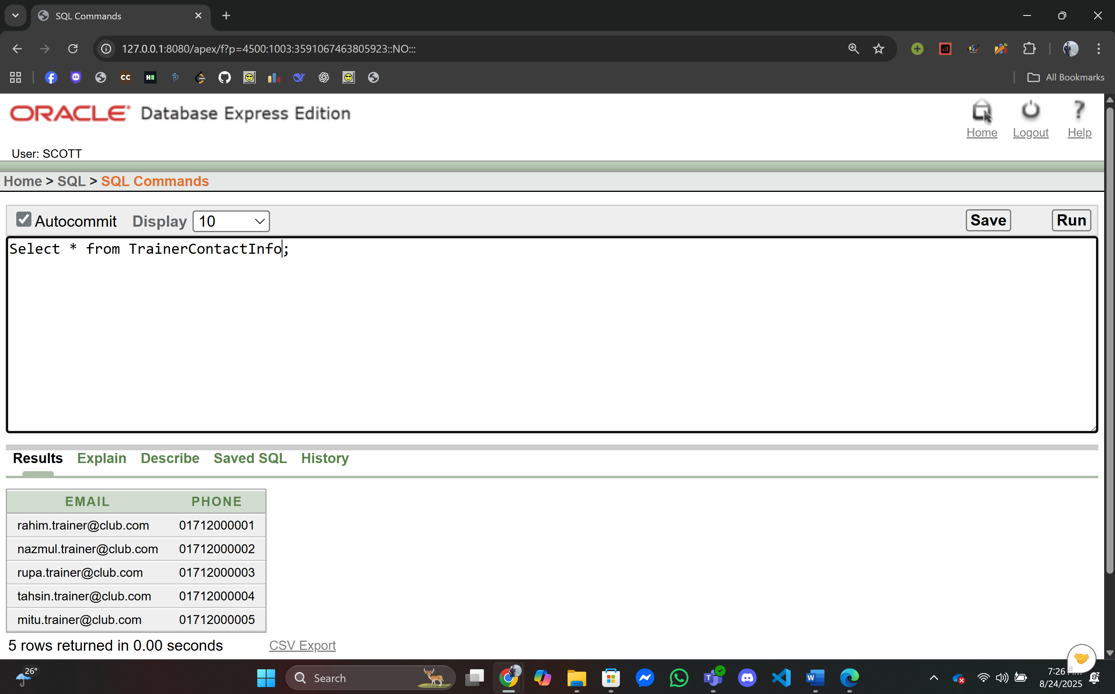

10. TrainerInfo:

INSERT INTO TrainerInfo (TrainerID, Name, Email) VALUES (4001, 'Abdul Rahim', 'rahim.trainer@club.com');

INSERT INTO TrainerInfo (TrainerID, Name, Email) VALUES (4002, 'Nazmul Huda', 'nazmul.trainer@club.com');

INSERT INTO TrainerInfo (TrainerID, Name, Email) VALUES (4003, 'Rupa Sultana', 'rupa.trainer@club.com');

INSERT INTO TrainerInfo (TrainerID, Name, Email) VALUES (4004, 'Md Tahsin', 'tahsin.trainer@club.com');

INSERT INTO TrainerInfo (TrainerID, Name, Email) VALUES (4005, 'Mitu Akter', 'mitu.trainer@club.com');

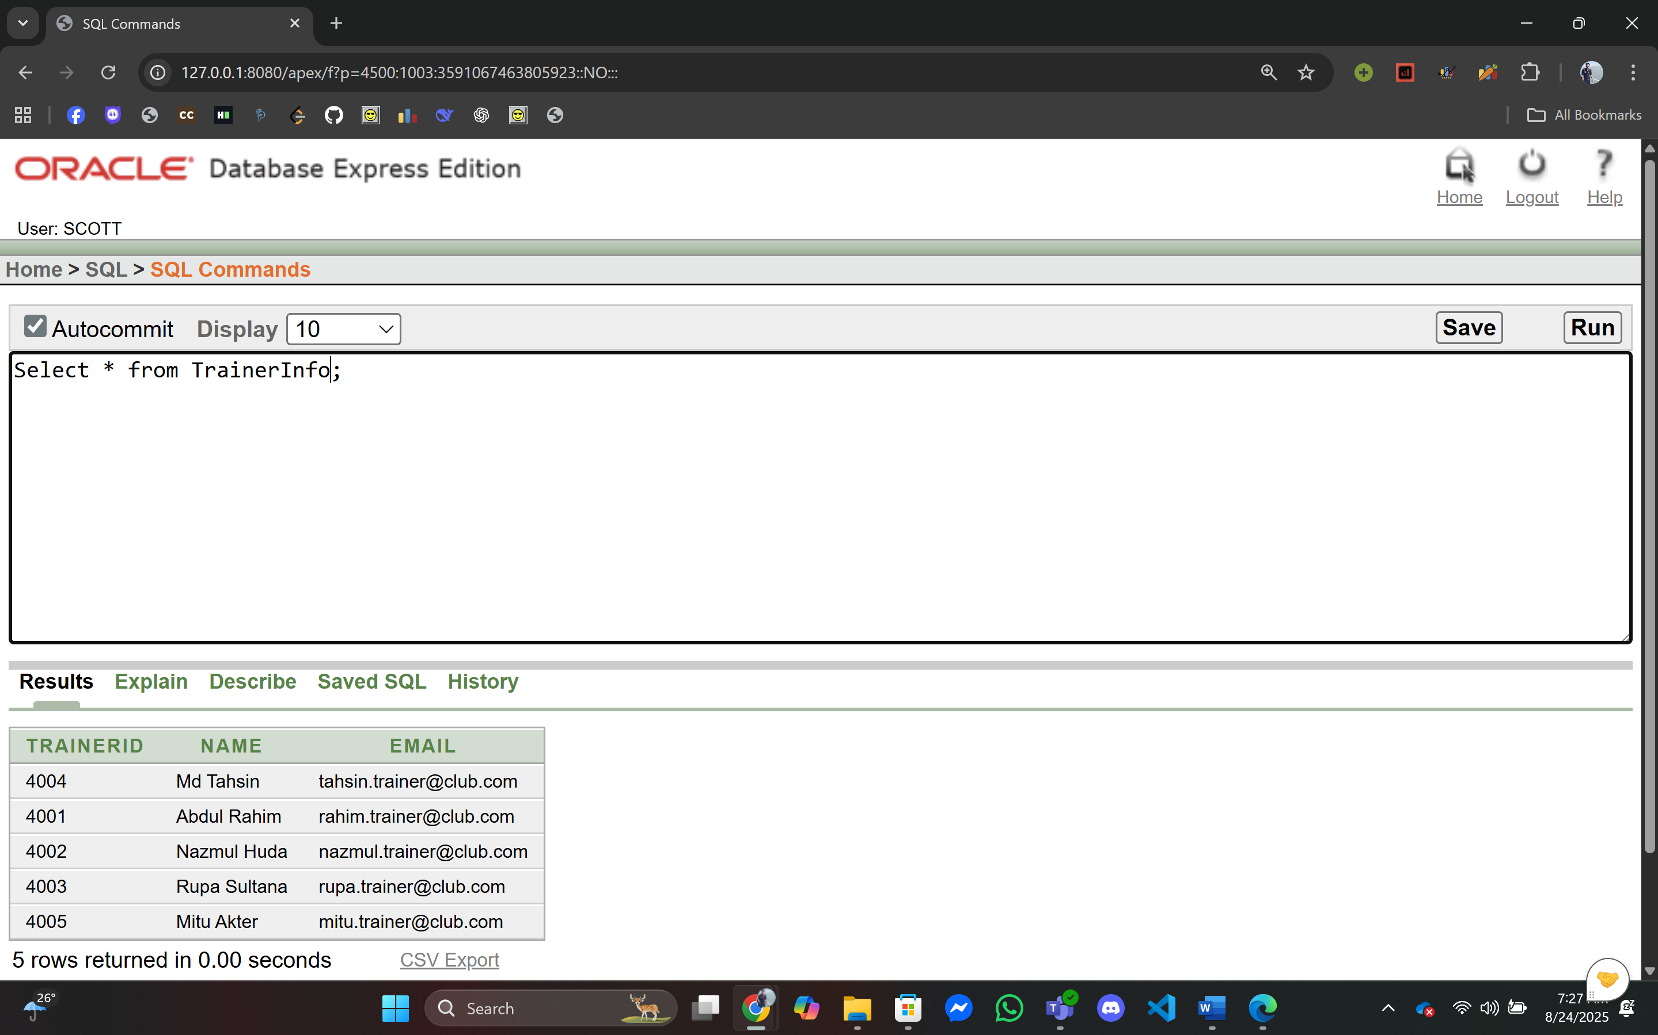

11. TrainerSpecialtyInfo:

INSERT INTO TrainerSpecialtyInfo (TrainerID, Specialty) VALUES (4001, 'Freestyle');

INSERT INTO TrainerSpecialtyInfo (TrainerID, Specialty) VALUES (4002, 'Backstroke');

INSERT INTO TrainerSpecialtyInfo (TrainerID, Specialty) VALUES (4003, 'Breaststroke');

INSERT INTO TrainerSpecialtyInfo (TrainerID, Specialty) VALUES (4004, 'Butterfly');

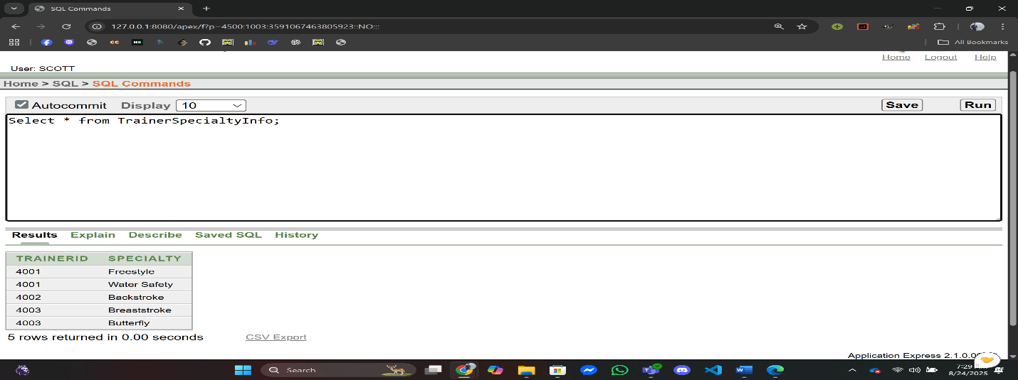INSERT INTO TrainerSpecialtyInfo (TrainerID, Specialty) VALUES (4005, 'Water Safety');

12. TrainerBookingInfo:

INSERT INTO TrainerBookingInfo (BookingID, TrainerID) VALUES (101, 4001);

INSERT INTO TrainerBookingInfo (BookingID, TrainerID) VALUES (102, 4002);

INSERT INTO TrainerBookingInfo (BookingID, TrainerID) VALUES (103, 4003);

INSERT INTO TrainerBookingInfo (BookingID, TrainerID) VALUES (104, 4004);

INSERT INTO TrainerBookingInfo (BookingID, TrainerID) VALUES (105, 4005);

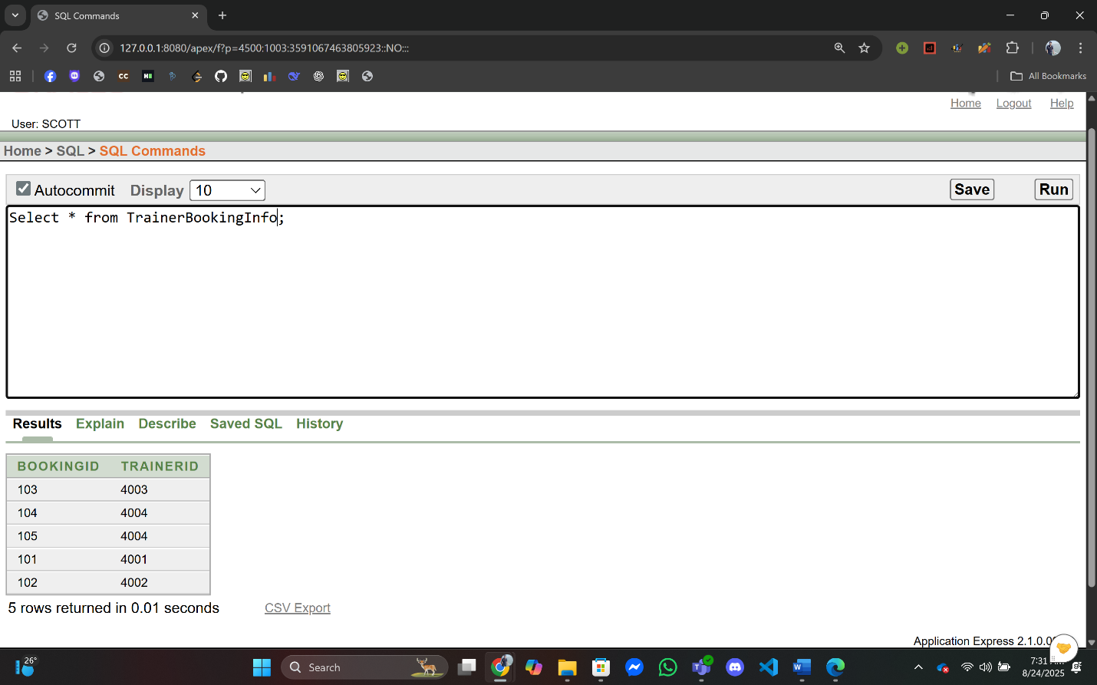

13. PoolInfo:

INSERT INTO PoolInfo (PoolID, Location, Capacity) VALUES (5001, 'Gulshan', 50);

INSERT INTO PoolInfo (PoolID, Location, Capacity) VALUES (5002, 'Banani', 40);

INSERT INTO PoolInfo (PoolID, Location, Capacity) VALUES (5003, 'Dhanmondi', 60);

INSERT INTO PoolInfo (PoolID, Location, Capacity) VALUES (5004, 'Uttara', 55);

INSERT INTO PoolInfo (PoolID, Location, Capacity) VALUES (5005, 'Mirpur', 45);

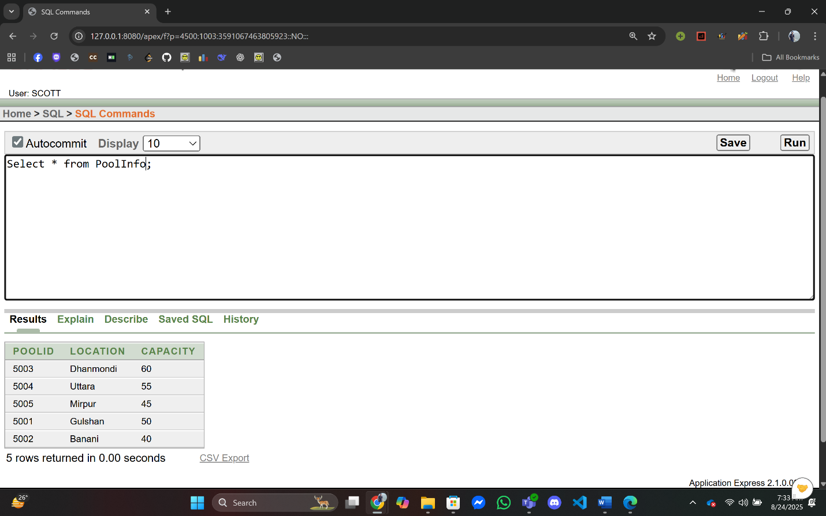

14. PoolBookingInfo:

INSERT INTO PoolBookingInfo (BookingID, PoolID) VALUES (101, 5001);

INSERT INTO PoolBookingInfo (BookingID, PoolID) VALUES (102, 5002);

INSERT INTO PoolBookingInfo (BookingID, PoolID) VALUES (103, 5003);

INSERT INTO PoolBookingInfo (BookingID, PoolID) VALUES (104, 5004);

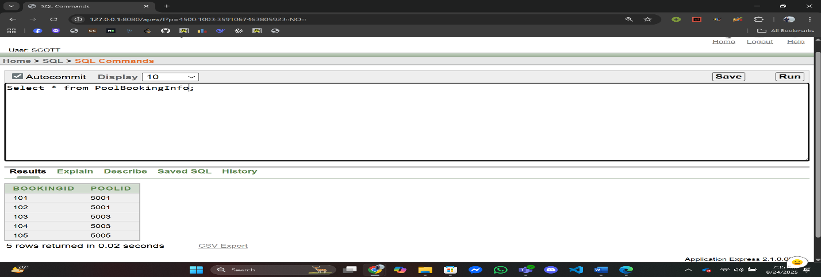INSERT INTO PoolBookingInfo (BookingID, PoolID) VALUES (105, 5005);

15. EventInfo:

INSERT INTO EventInfo (EventID, Name, EventDate, EventTime) VALUES (6001, 'Summer Swim Meet', TO_DATE('2025-09-05','YYYY-MM-DD'), '10:00:00');

INSERT INTO EventInfo (EventID, Name, EventDate, EventTime) VALUES (6002, 'Junior Championship', TO_DATE('2025-09-12','YYYY-MM-DD'), '11:30:00');

INSERT INTO EventInfo (EventID, Name, EventDate, EventTime) VALUES (6003, 'Water Safety Workshop', TO_DATE('2025-10-01','YYYY-MM-DD'), '09:00:00');

INSERT INTO EventInfo (EventID, Name, EventDate, EventTime) VALUES (6004, 'Barsha Utshab Swim', TO_DATE('2025-10-15','YYYY-MM-DD'), '15:00:00');

INSERT INTO EventInfo (EventID, Name, EventDate, EventTime) VALUES (6005, 'Family Fun Day', TO_DATE('2025-11-01','YYYY-MM-DD'), '14:30:00');

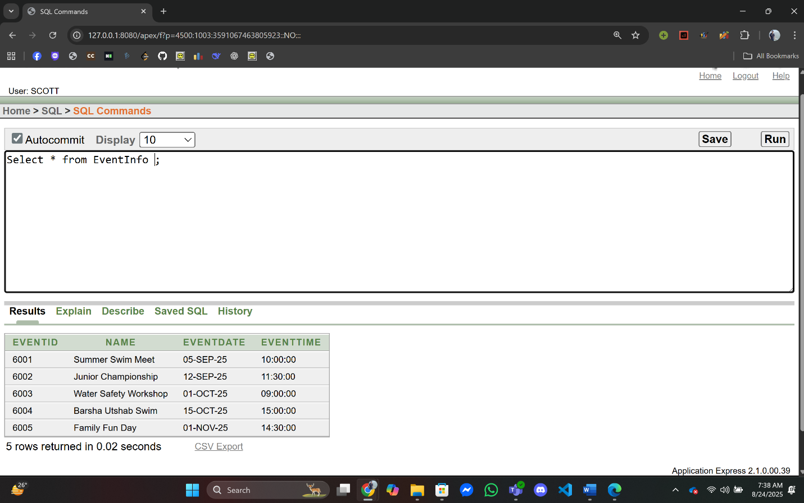

16. PoolEventInfo:

INSERT INTO PoolEventInfo (EventID, PoolID) VALUES (6001, 5001);

INSERT INTO PoolEventInfo (EventID, PoolID) VALUES (6002, 5002);

INSERT INTO PoolEventInfo (EventID, PoolID) VALUES (6003, 5003);

INSERT INTO PoolEventInfo (EventID, PoolID) VALUES (6004, 5004);

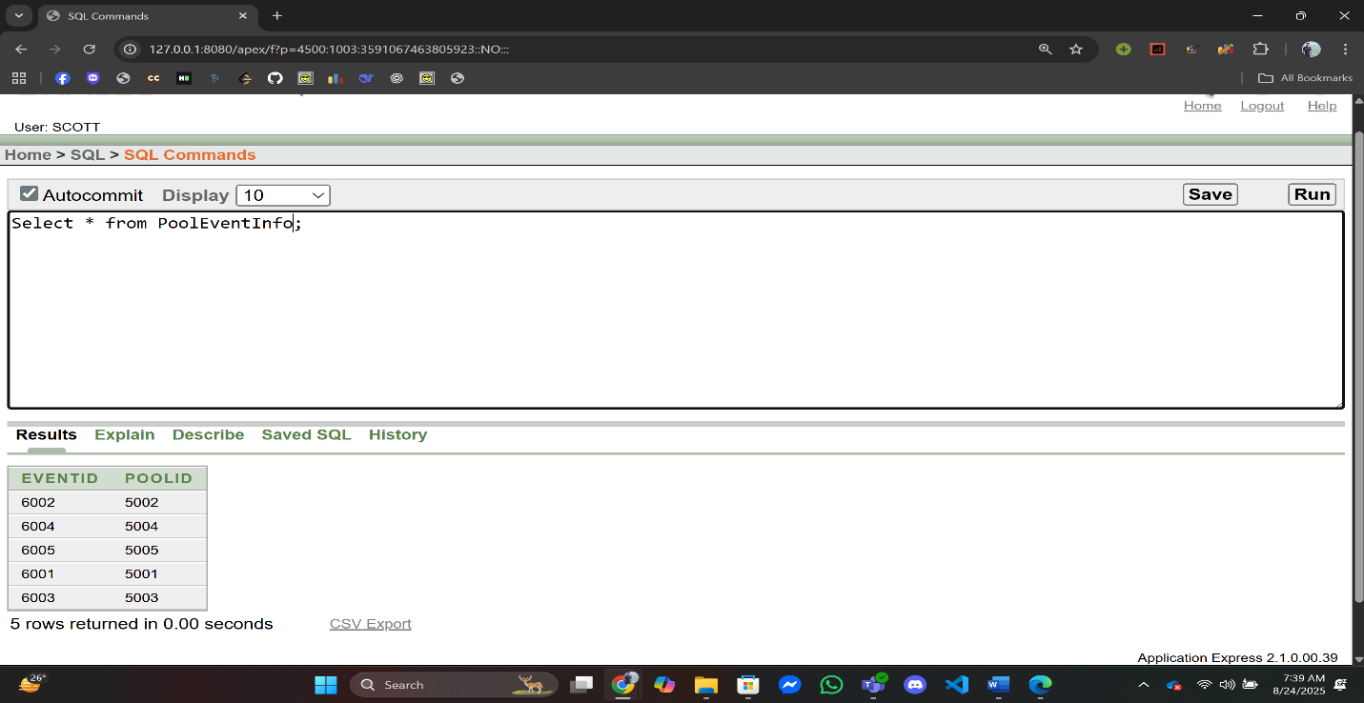INSERT INTO PoolEventInfo (EventID, PoolID) VALUES (6005, 5005);

17. StaffContactInfo:

INSERT INTO StaffContactInfo (Email, Phone) VALUES ('sazzad.staff@club.com', '01713000001');

INSERT INTO StaffContactInfo (Email, Phone) VALUES ('hasina.staff@club.com', '01713000002');

INSERT INTO StaffContactInfo (Email, Phone) VALUES ('rashed.staff@club.com', '01713000003');

INSERT INTO StaffContactInfo (Email, Phone) VALUES ('farzana.staff@club.com', '01713000004');

INSERT INTO StaffContactInfo (Email, Phone) VALUES ('bappa.staff@club.com', '01713000005');

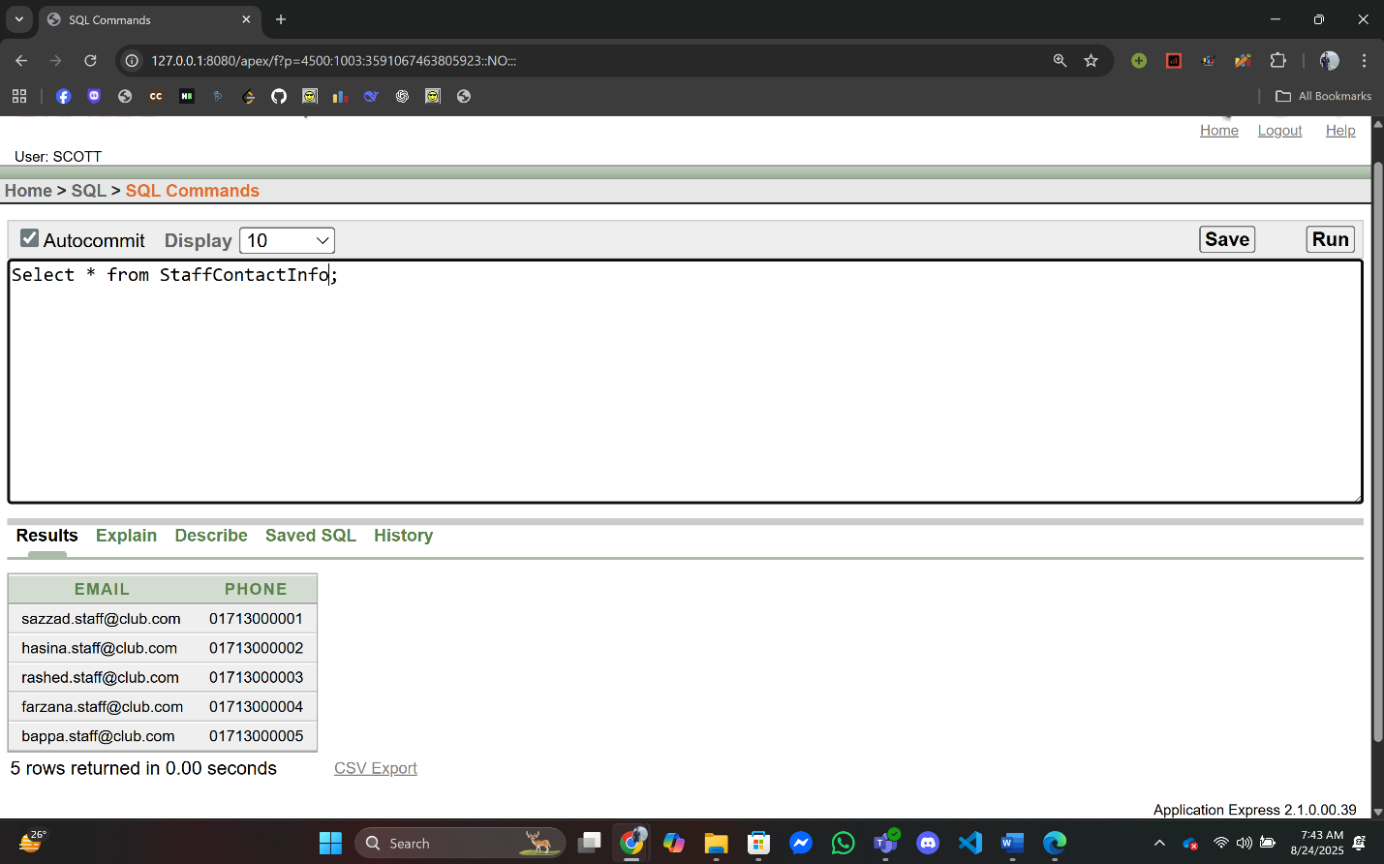

18. StaffInfo:

INSERT INTO StaffInfo (StaffID, Name, Email) VALUES (7001, 'Sazzad Khan', 'sazzad.staff@club.com');

INSERT INTO StaffInfo (StaffID, Name, Email) VALUES (7002, 'Hasina Akter', 'hasina.staff@club.com');

INSERT INTO StaffInfo (StaffID, Name, Email) VALUES (7003, 'Rashedul Islam', 'rashed.staff@club.com');

INSERT INTO StaffInfo (StaffID, Name, Email) VALUES (7004, 'Farzana Yasmin', 'farzana.staff@club.com');

INSERT INTO StaffInfo (StaffID, Name, Email) VALUES (7005, 'Bappa Raj', 'bappa.staff@club.com');

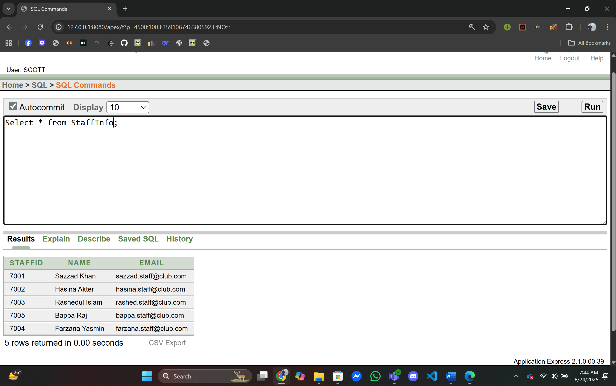

19. StaffRoleInfo:

INSERT INTO StaffRoleInfo (StaffID, Role) VALUES (7001, 'Manager');

INSERT INTO StaffRoleInfo (StaffID, Role) VALUES (7002, 'Receptionist');

INSERT INTO StaffRoleInfo (StaffID, Role) VALUES (7003, 'Lifeguard');

INSERT INTO StaffRoleInfo (StaffID, Role) VALUES (7004, 'Accountant');

INSERT INTO StaffRoleInfo (StaffID, Role) VALUES (7005, 'Cleaner');

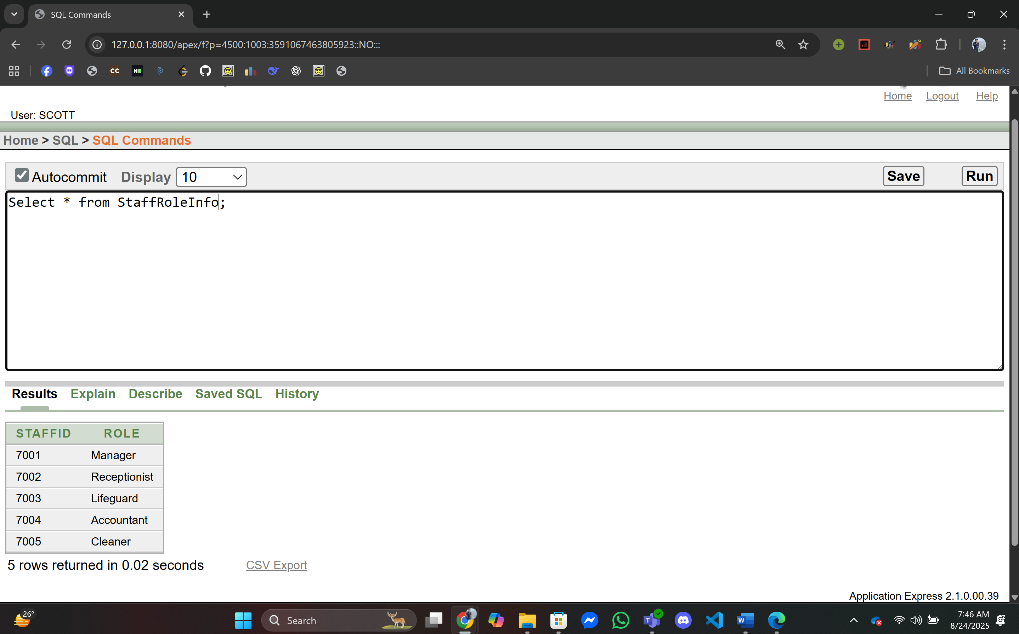

20. PoolStaffInfo:

INSERT INTO PoolStaffInfo (PoolID, StaffID) VALUES (5001, 7001);

INSERT INTO PoolStaffInfo (PoolID, StaffID) VALUES (5002, 7002);

INSERT INTO PoolStaffInfo (PoolID, StaffID) VALUES (5003, 7003);

INSERT INTO PoolStaffInfo (PoolID, StaffID) VALUES (5004, 7004);

INSERT INTO PoolStaffInfo (PoolID, StaffID) VALUES (5005, 7005);

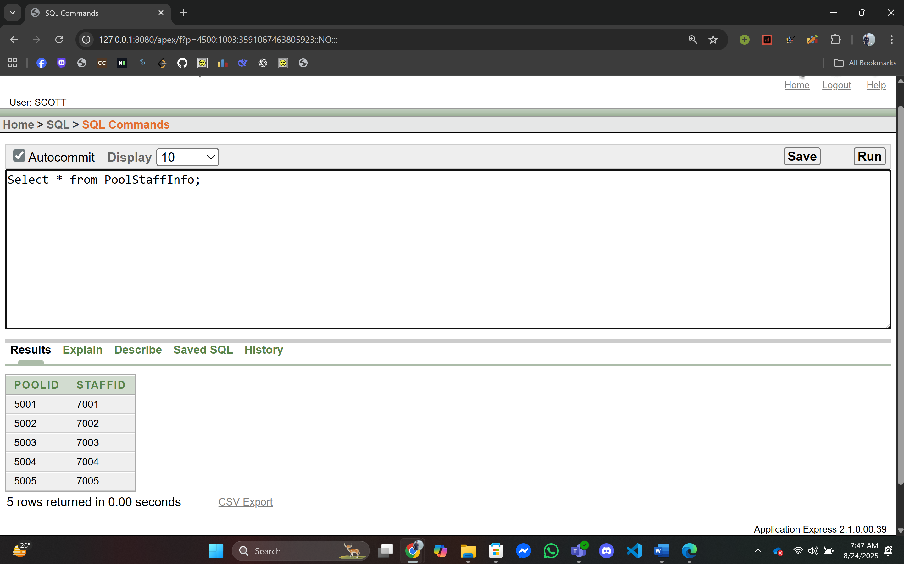

21. EventStaffInfo:

INSERT INTO EventStaffInfo (EventID, StaffID) VALUES (6001, 7001);

INSERT INTO EventStaffInfo (EventID, StaffID) VALUES (6002, 7002);

INSERT INTO EventStaffInfo (EventID, StaffID) VALUES (6003, 7003);

INSERT INTO EventStaffInfo (EventID, StaffID) VALUES (6004, 7004);

INSERT INTO EventStaffInfo (EventID, StaffID) VALUES (6005, 7005);

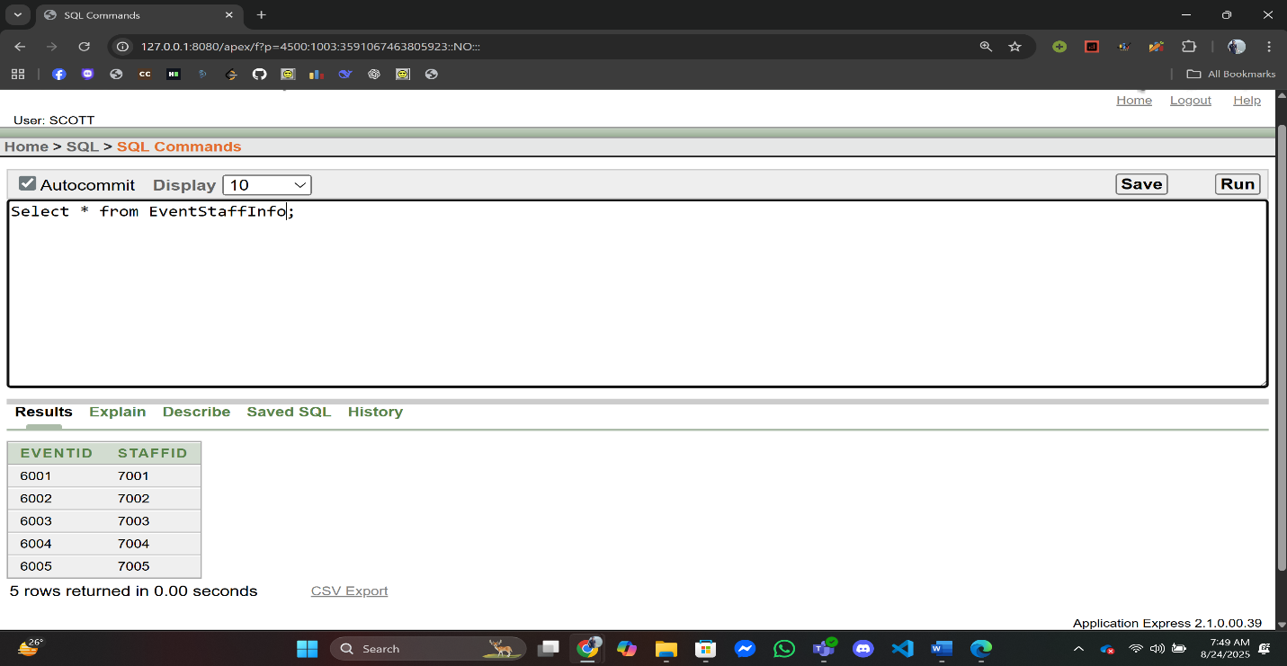

22. BookingTransactionInfo:

INSERT INTO BookingTransactionInfo (BookingID, TransactionID) VALUES (101, 2001);

INSERT INTO BookingTransactionInfo (BookingID, TransactionID) VALUES (102, 2002);

INSERT INTO BookingTransactionInfo (BookingID, TransactionID) VALUES (103, 2003);

INSERT INTO BookingTransactionInfo (BookingID, TransactionID) VALUES (104, 2004);

INSERT INTO BookingTransactionInfo (BookingID, TransactionID) VALUES (105, 2005);

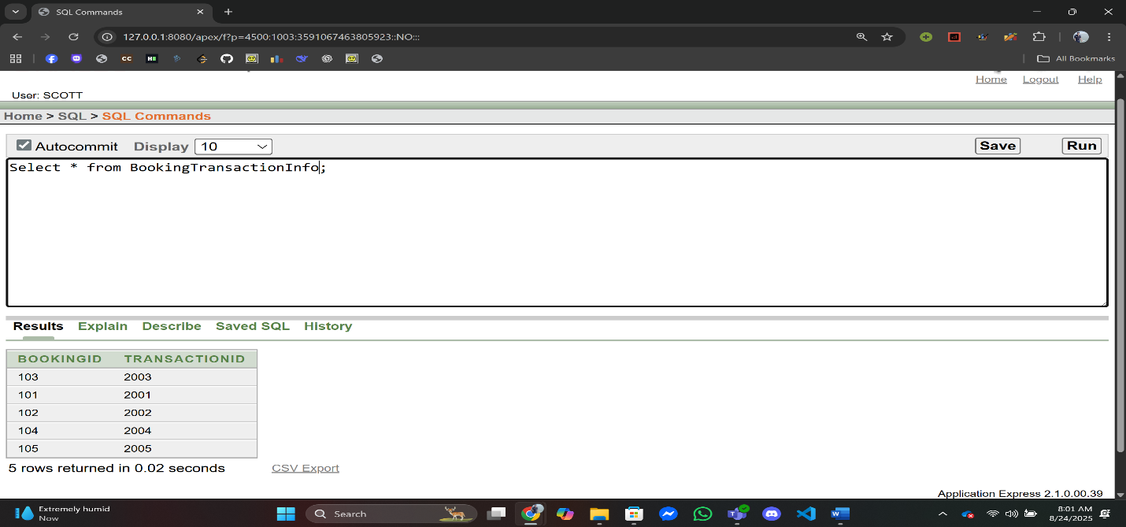

**Basic PL/SQL**

1. **Variable:**

**Q1:** Display The Member Name for MemberID = 1

**Answer:**

--Swimming Pool Management System,Summer,Advance Database Management System,A

DECLARE

name VARCHAR2(50);

BEGIN

SELECT Name INTO name

FROM MemberInfo

WHERE MemberID = 1;

DBMS_OUTPUT.PUT_LINE('Member Name: ' || name);

END;

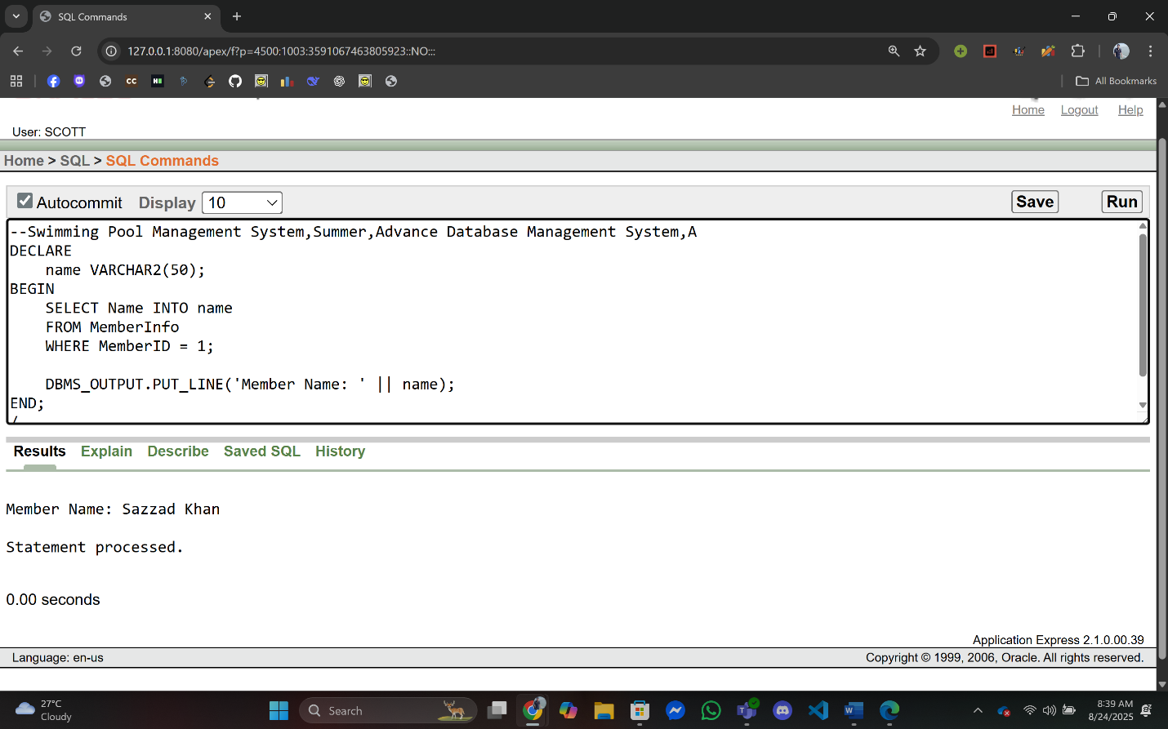/

**Q2:** Display the Staff Email for Staff Id = 7003.

**Answer:**

--Swimming Pool Management System,Summer,Advance Database Management System,A

DECLARE

email varchar(50);

BEGIN

SELECT Email INTO email FROM StaffInfo WHERE StaffID= 7003;

DBMS_OUTPUT.PUT_LINE('Staff Email Address with Staff Id = 7003 ' || email);

END;

/

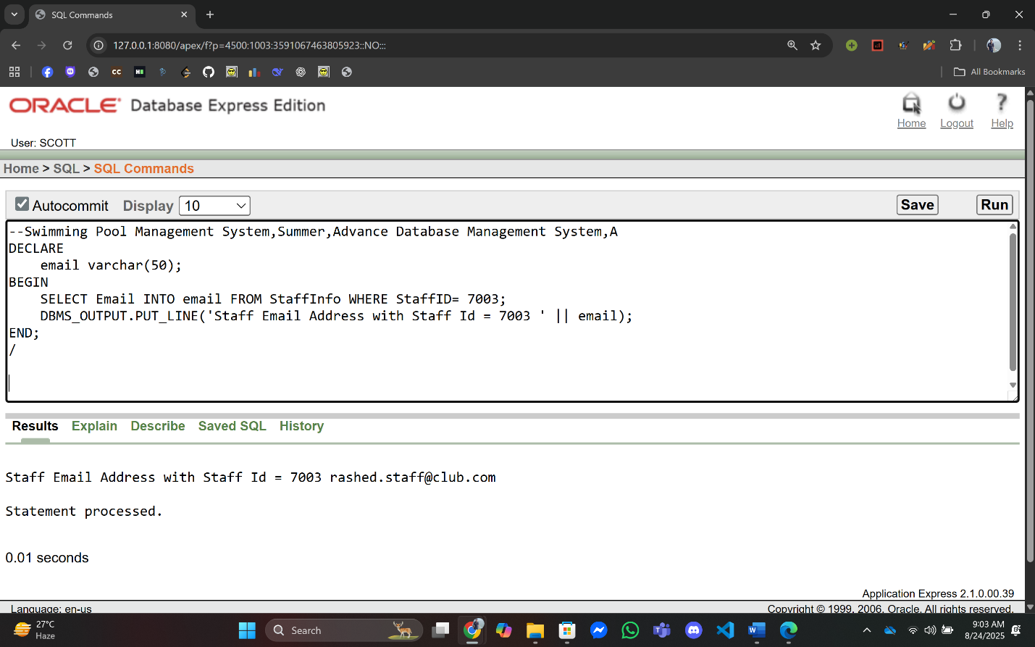

1. **Operator:**

**Q1:** Calculate the total amount after adding 15% tax for Transaction ID = 2001.

**Answer:**

--Swimming Pool Management System,Summer,Advance Database Management System,A

DECLARE

amount NUMBER;

total NUMBER;

BEGIN

SELECT Amount INTO amount FROM TransactionInfo WHERE TransactionID = 2001;

total := amount + (amount * 0.15);

DBMS_OUTPUT.PUT_LINE('Total Amount with 15% Tax: ' || total);

END;

/

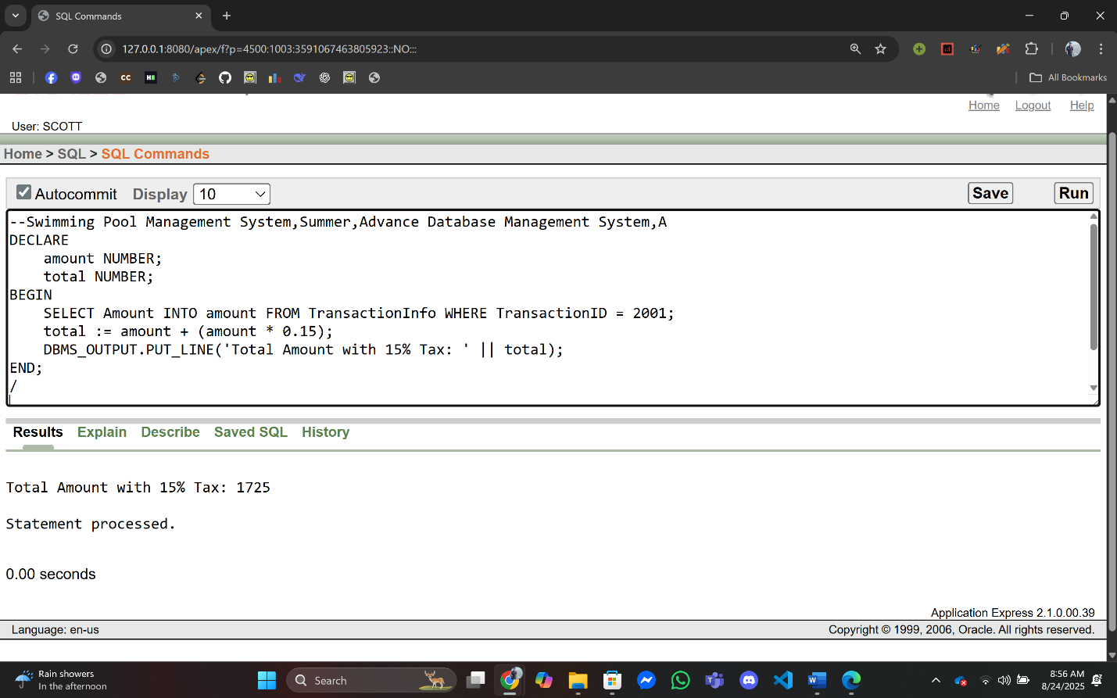

**Q2:** Add the Pool Capacity 100 for Pool ID = 5004 and Display the New Capacity.

**Answer:**

--Swimming Pool Management System,Summer,Advance Database Management System,A

DECLARE

newCapacity Number;

BEGIN

SELECT Capacity INTO newCapacity FROM PoolInfo WHERE PoolID = 5004;

newCapacity := newCapacity + 100;

DBMS_OUTPUT.PUT_LINE('New Capacity of the Pool Number 4 is: ' || newCapacity);

END;

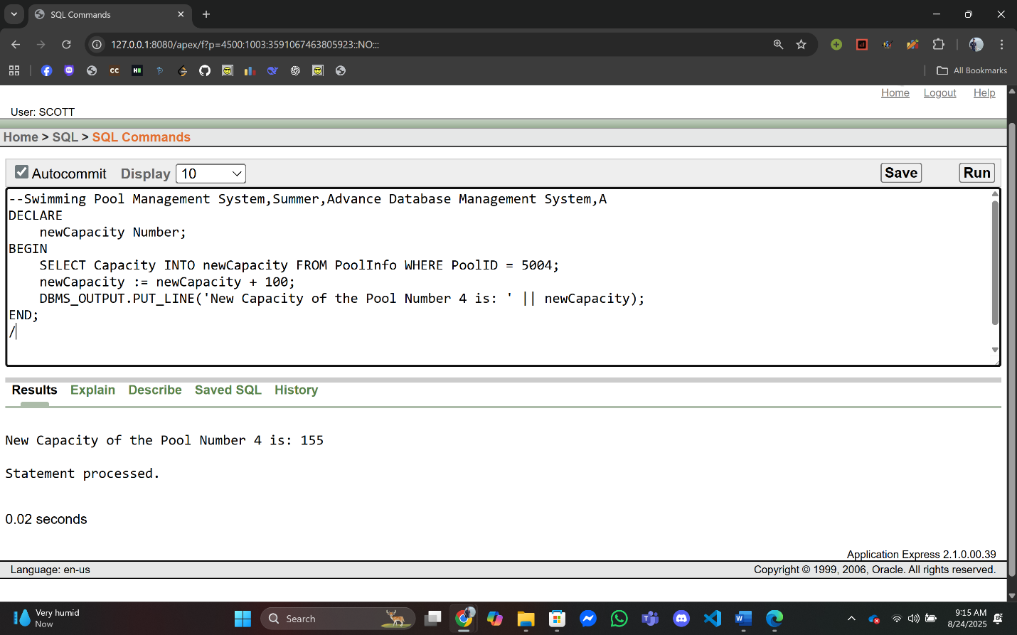/

1. **Single-row Function:**

**Q1:** Display a member’s name in uppercase for MemberID = 4.

**Answer:**

--Swimming Pool Management System,Summer,Advance Database Management System,A

DECLARE

name varchar(50);

BEGIN

SELECT Upper(Name) INTO name FROM MemberInfo WHERE MemberID = 4;

DBMS_OUTPUT.PUT_LINE('Name of Member Id 4 in Upper Case: ' || name);

END;

/

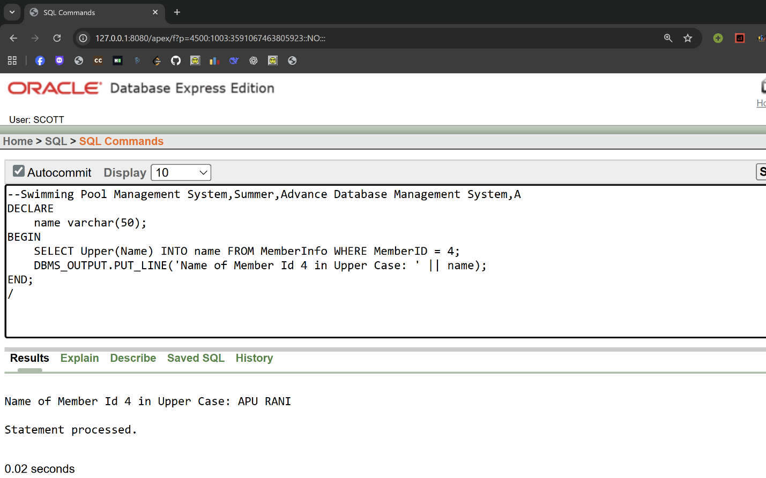

**Q2:** Display the Booking Date in DD-Month-YYYY format for BookingID = 103.

**Answer:**

--Swimming Pool Management System,Summer,Advance Database Management System,A

DECLARE

bookingDate varchar(50);

BEGIN

SELECT to_Char(BookingDate,'DD-Month-YYYY') Into bookingDate FROM BookingInfo WHERE BookingID= 103;

DBMS_OUTPUT.PUT_LINE('Booking Date ' || bookingDate);

END;

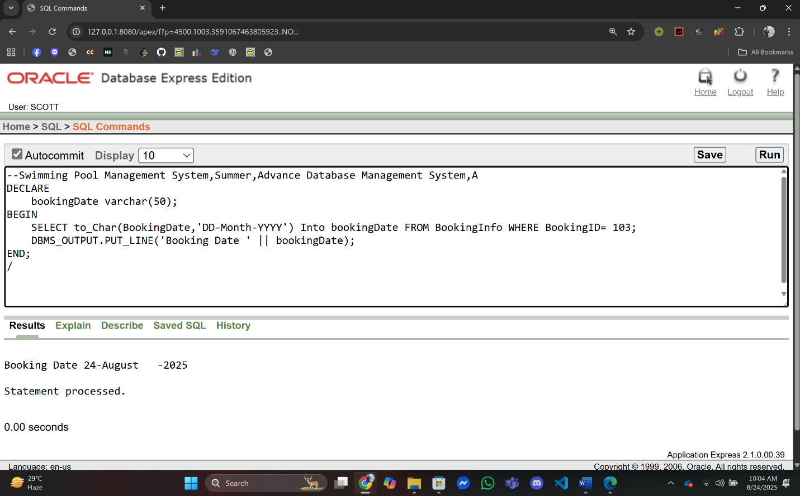/

1. **Group Function:**

**Q1:** Find the total number of bookings.

**Answer:**

--Swimming Pool Management System,Summer,Advance Database Management System,A

DECLARE

countNum Number;

BEGIN

SELECT count(*) Into countNum FROM BookingInfo;

DBMS_OUTPUT.PUT_LINE('Number of All Bookings is ' || countNum);

END;

/

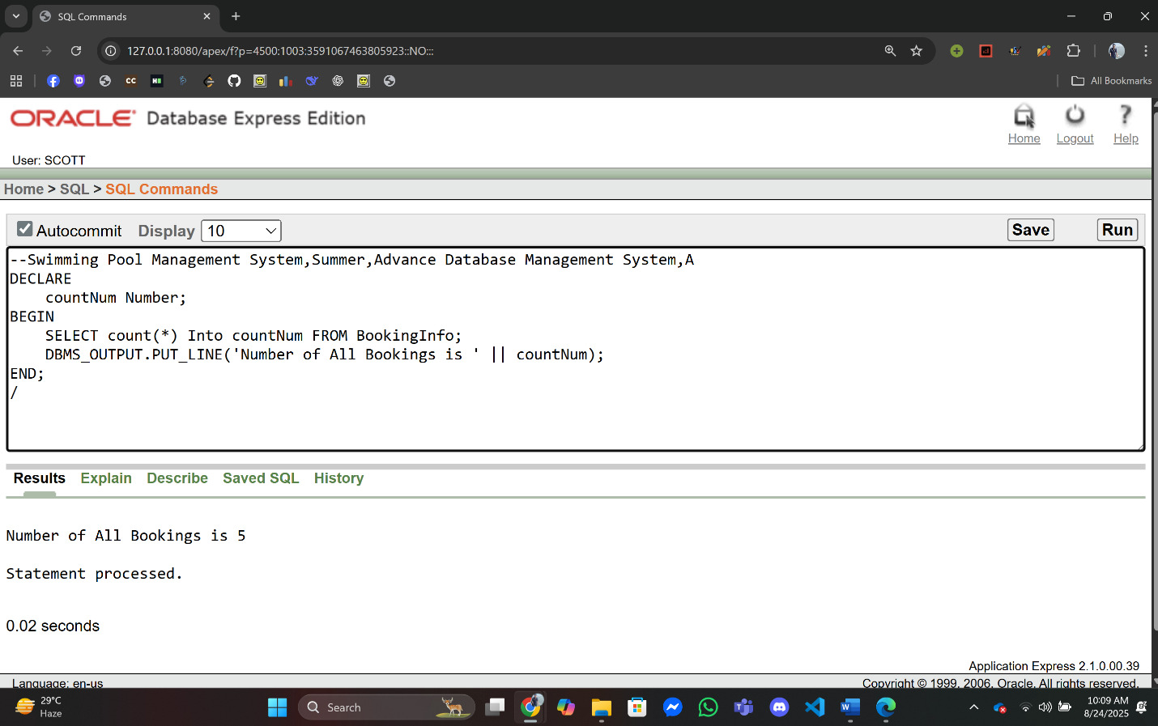

**Q2:** Find the highest transaction amount.

**Answer:**

--Swimming Pool Management System,Summer,Advance Database Management System,A

DECLARE

maxTransaction Number;

BEGIN

SELECT MAX(Amount) Into maxTransaction FROM TransactionInfo;

DBMS_OUTPUT.PUT_LINE('HighestTransaction is ' || maxTransaction);

END;

/

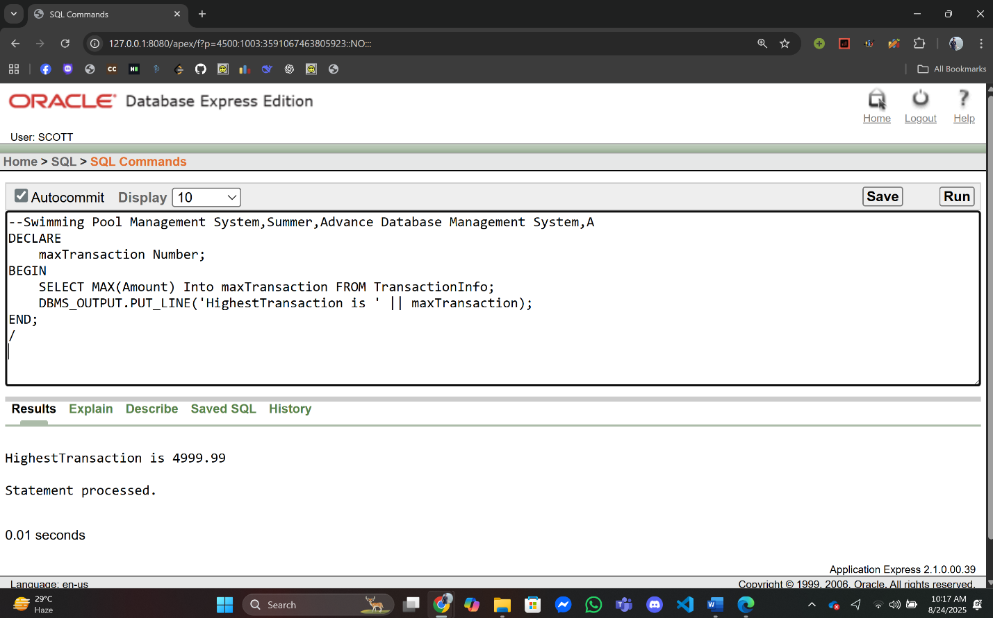

1. **Loop:**

**Q1:** Print all Member’s Id & Email address.

**Answer:**

--Swimming Pool Management System,Summer,Advance Database Management System,A

DECLARE

BEGIN

For rec In(Select MemberID,Email from MemberInfo) LOOP

Exit When rec.MemberID is NULL;

DBMS_OUTPUT.PUT_LINE('Email Address For Member ID' || rec.MemberID ||' is ' || rec.Email);

End Loop;

END;

/

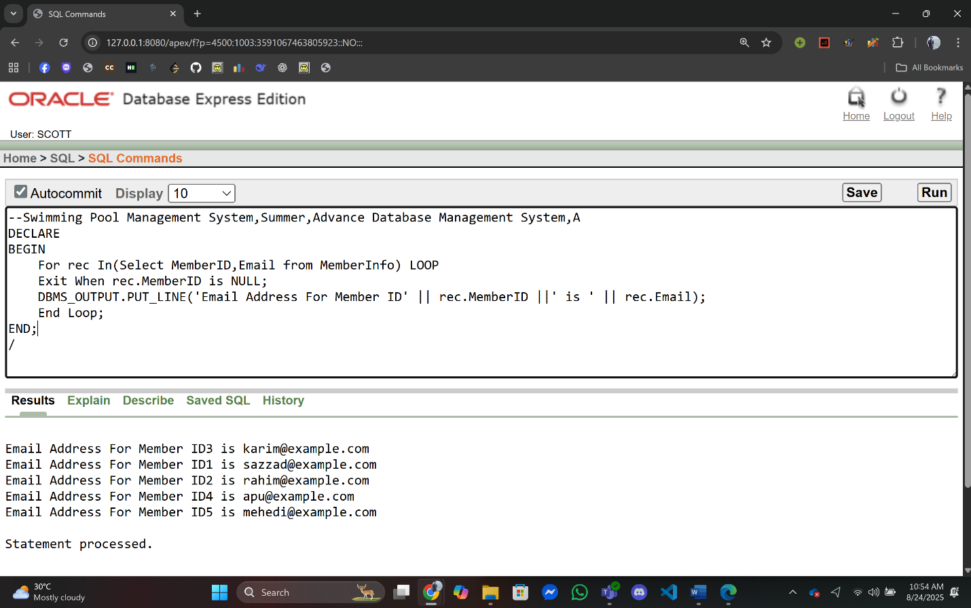

**Q2:** Print First 3 Transaction Information.

**Answer:**

--Swimming Pool Management System,Summer,Advance Database Management System,A

DECLARE

a Number(2) := 0;

BEGIN

DBMS_OUTPUT.PUT_LINE('Transaction Information----------------------');

For rec In(Select * from TransactionInfo) LOOP

Exit When a = 3;

DBMS_OUTPUT.PUT_LINE('Transaction ID '|| rec.TransactionID ||' Transaction Date ' || rec.TransactionDate || ' Transaction Amount '|| rec.Amount);

a := a+1;

End Loop;

END;

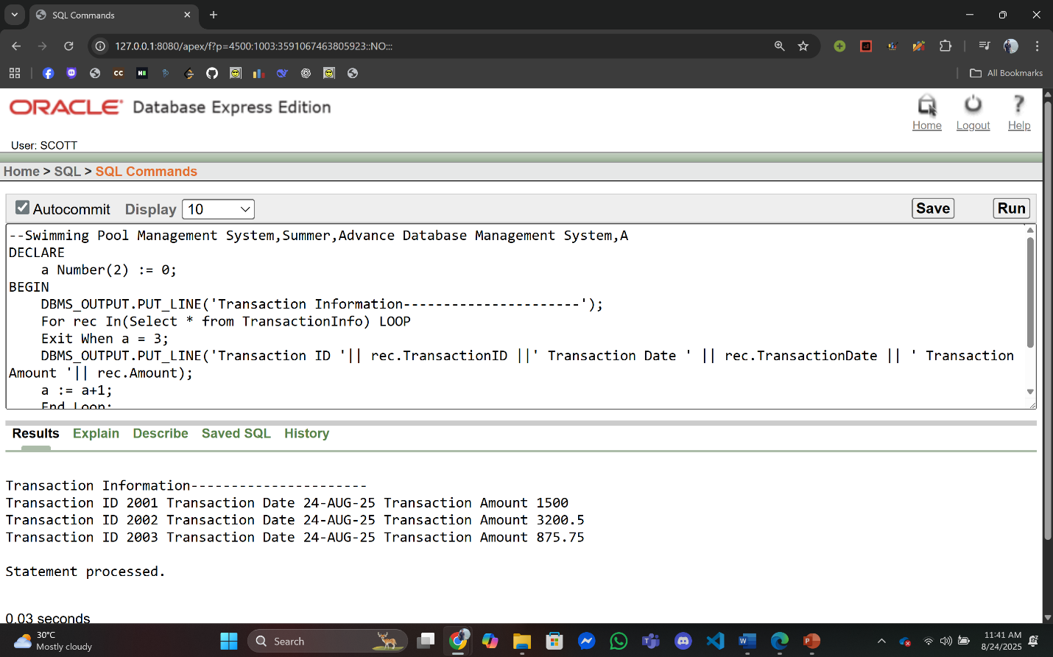/

1. **Conditional Statements:**

**Q1:** Check if a member is Premium or Gold Platinum or Silver or Regular.

**Answer:**

--Swimming Pool Management System,Summer,Advance Database Management System,A

DECLARE

memberType varchar2(20);

BEGIN

Select MembershipType Into memberType From MemberContactInfo Where Email = 'sazzad@example.com';

If (memberType = 'Premium') Then

DBMS_OUTPUT.PUT_LINE('Member is Premium');

ElsIf(memberType = 'Gold') Then

DBMS_OUTPUT.PUT_LINE('Member is Gold');

ElsIf(memberType = 'Platinum') Then

DBMS_OUTPUT.PUT_LINE('Member is Platinum');

ElsIf(memberType = 'Silver') Then

DBMS_OUTPUT.PUT_LINE('Member is Silver');

Else

DBMS_OUTPUT.PUT_LINE('Member is Regular');

End If;

END;

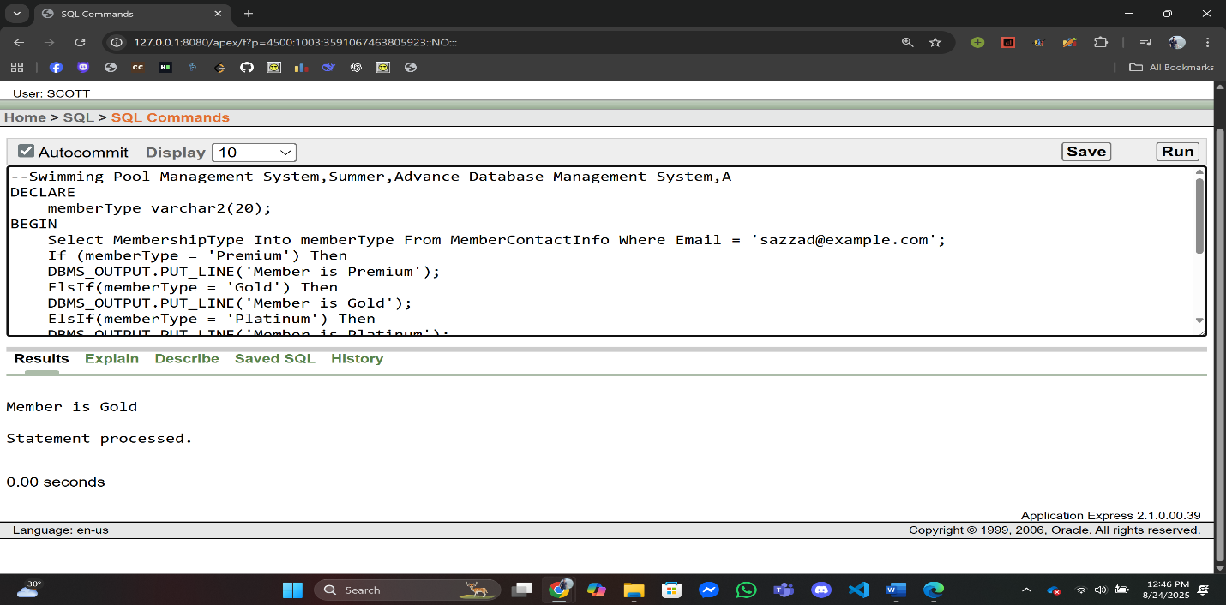/

**Q2:** Check if a transaction amount is greater than 2000 for TransactionID = 2002.

**Answer:**

--Swimming Pool Management System,Summer,Advance Database Management System,A

DECLARE

amount Number;

BEGIN

Select Amount Into amount From TransactionInfo Where TransactionID = 2002;

If (amount > 2000) Then

DBMS_OUTPUT.PUT_LINE('Amount is Greater than 2000');

Else

DBMS_OUTPUT.PUT_LINE('Amount is Less than 2000');

End If;

END;

/

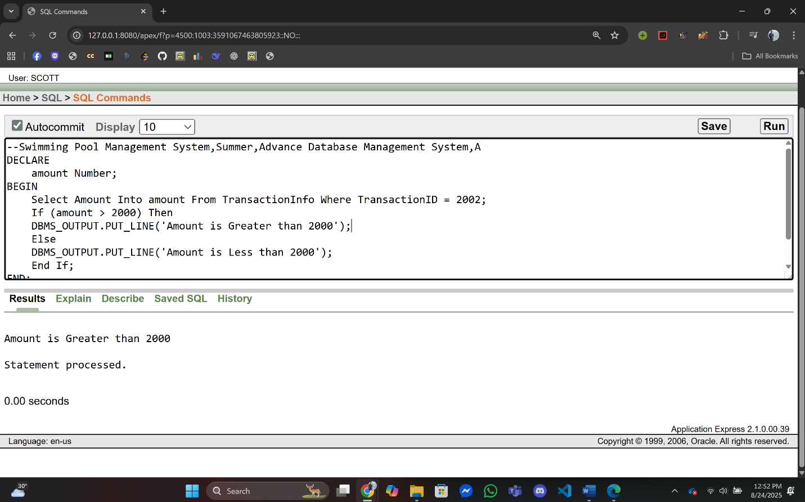

1. **Subquery:**

**Q1:** Find the member who made the earliest booking..

**Answer:**

--Swimming Pool Management System,Summer,Advance Database Management System,A

DECLARE

name varchar2(50);

BEGIN

Select Name Into name From MemberInfo

Where MemberID = (Select MemberID From MemberBookingInfo

Where BookingID = (Select BookingID From BookingInfo

Where BookingDate = (Select min(BookingDate) from BookingInfo)));

DBMS_OUTPUT.PUT_LINE('Earliest Booking By ' || name);

END;

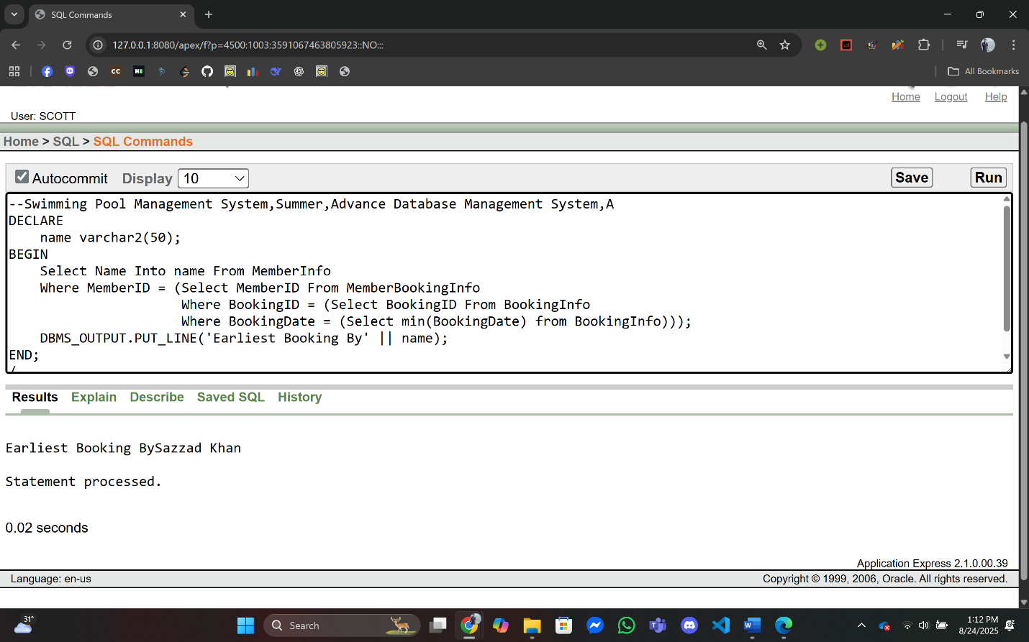/

**Q2:** Find the member with the highest transaction amount

**Answer:**

--Swimming Pool Management System,Summer,Advance Database Management System,A

DECLARE

name varchar2(50);

BEGIN

Select Name Into name From MemberInfo

Where MemberID = (Select MemberID From MemberTransactionInfo

Where TransactionID = (Select TransactionID From TransactionInfo

Where Amount = (Select max(Amount) from TransactionInfo)));

DBMS_OUTPUT.PUT_LINE('Highest Transaction Paid By ' || name);

END;

/

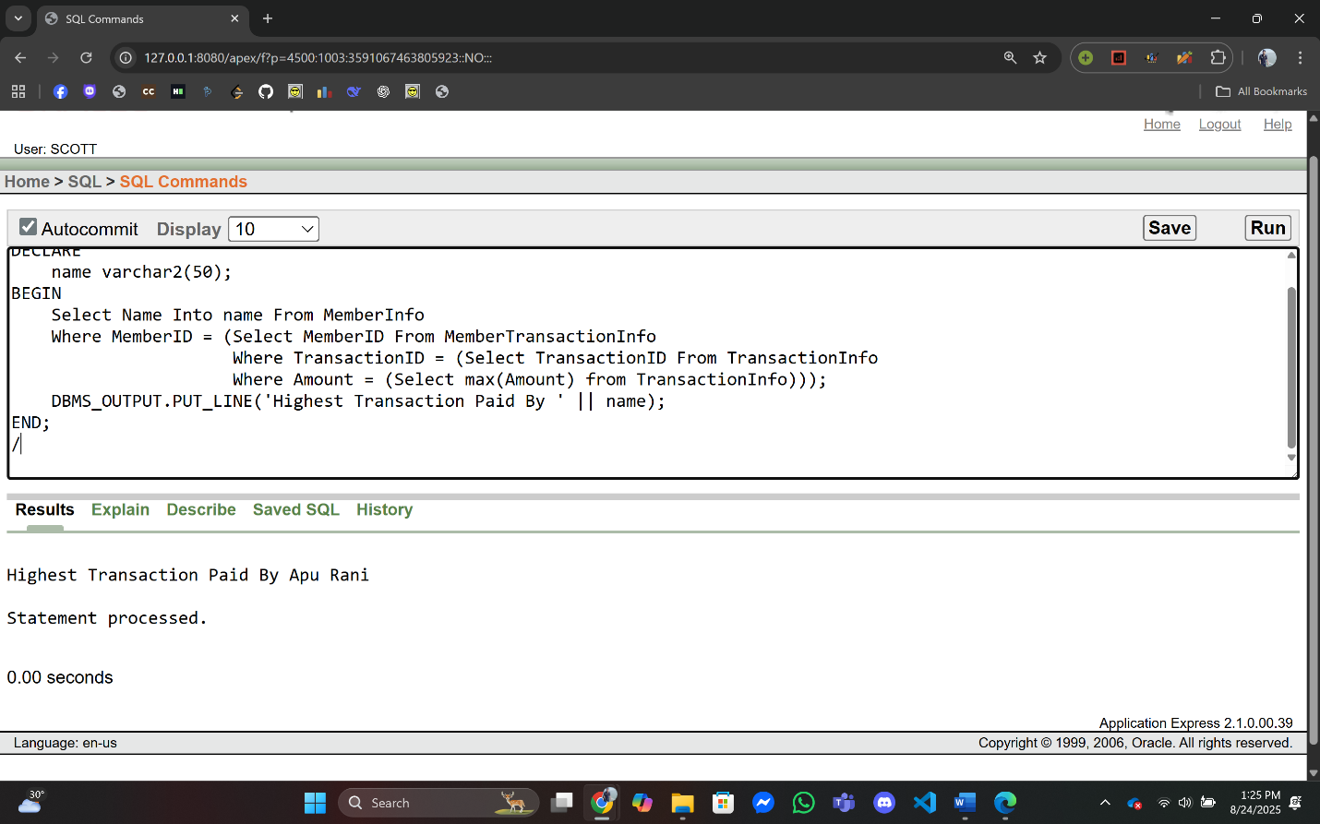

1. **Joining:**

**Q1:** Display the Member Name, Booking ID, and Booking Date for all members who have made bookings.

**Answer:**

--Swimming Pool Management System,Summer,Advance Database Management System,A

DECLARE

memberName varchar2(50);

bookingID Number;

bookingDate Date;

BEGIN

For rec IN (Select m.Name,b.BookingID,b.BookingDate

From MemberInfo m

INNER JOIN MemberBookingInfo mb

ON m.MemberID = mb.MemberID

INNER JOIN BookingInfo b

ON mb.BookingID = b.BookingID) LOOP

Exit When rec.BookingID is NULL;

DBMS_OUTPUT.PUT_LINE('Name - ' || rec.Name || ' Booking ID - ' || rec.BookingID || ' Booking Date - '|| rec.BookingDate);

END LOOP;

END;

/

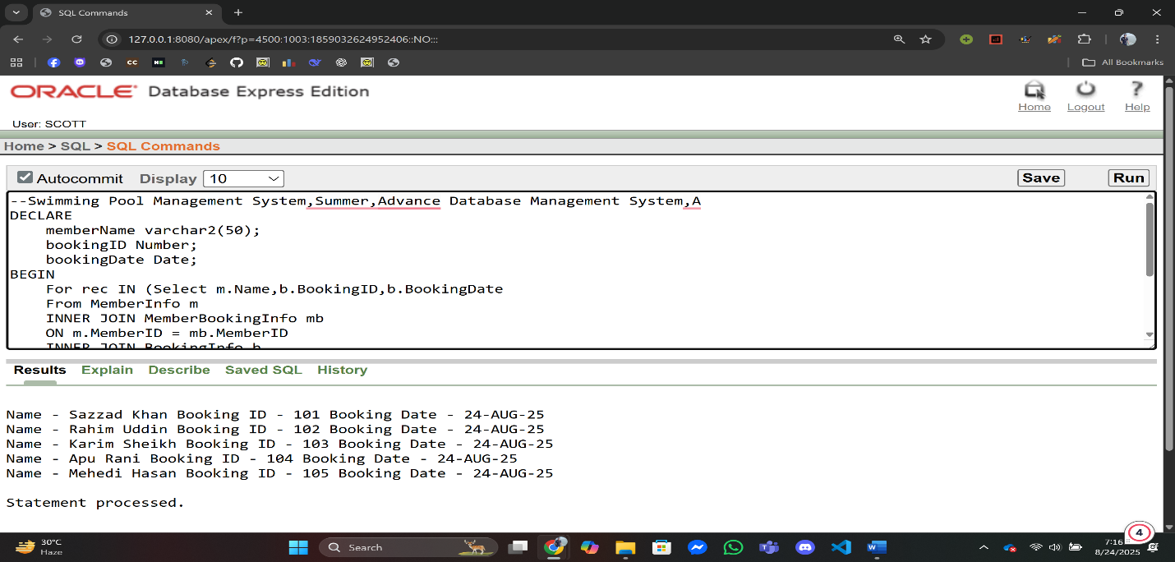

**Q2:** Display the Member Name, Booking Date, and Transaction Amount for all completed bookings.

**Answer:**

--Swimming Pool Management System,Summer,Advance Database Management System,A

DECLARE

BEGIN

For rec IN(Select m.Name,b.BookingDate,t.Amount

From MemberInfo m

INNER JOIN MemberBookingInfo mb

ON m.MemberID = mb.MemberID

INNER JOIN BookingInfo b

ON mb.BookingID = b.BookingID

INNER JOIN MemberTransactionInfo mt

ON m.MemberID = mt.MemberID

INNER JOIN TransactionInfo t

ON mt.TransactionID = t.TransactionID) LOOP

Exit When rec.Name is NULL;

DBMS_OUTPUT.PUT_LINE('Name - ' || rec.Name || ' Booking Date - ' || rec.BookingDate || ' Transaction Amount - '|| rec.Amount);

END LOOP;

END;

/

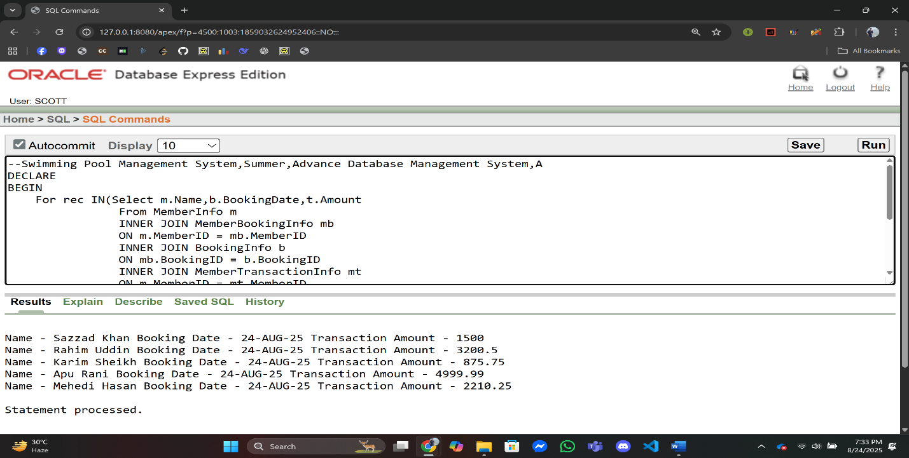

**Advance PL/SQL**

1. **Stored Function:**

**Q1:** Write a function that returns the total number of bookings.

**Answer:**

**Function Creation:**

Create OR Replace Function total_Booking_for_Member

Return Number AS

totalBooking Number;

Begin

Select count(*)

Into totalBooking

From MemberBookingInfo;

Return totalBooking;

End total_Booking_for_Member;

**Query:**

--Swimming Pool Management System,Summer,Advance Database Management System,A

DECLARE

result Number;

BEGIN

result := total_Booking_for_Member;

DBMS_OUTPUT.PUT_LINE('Total Booking ' || result);

END;

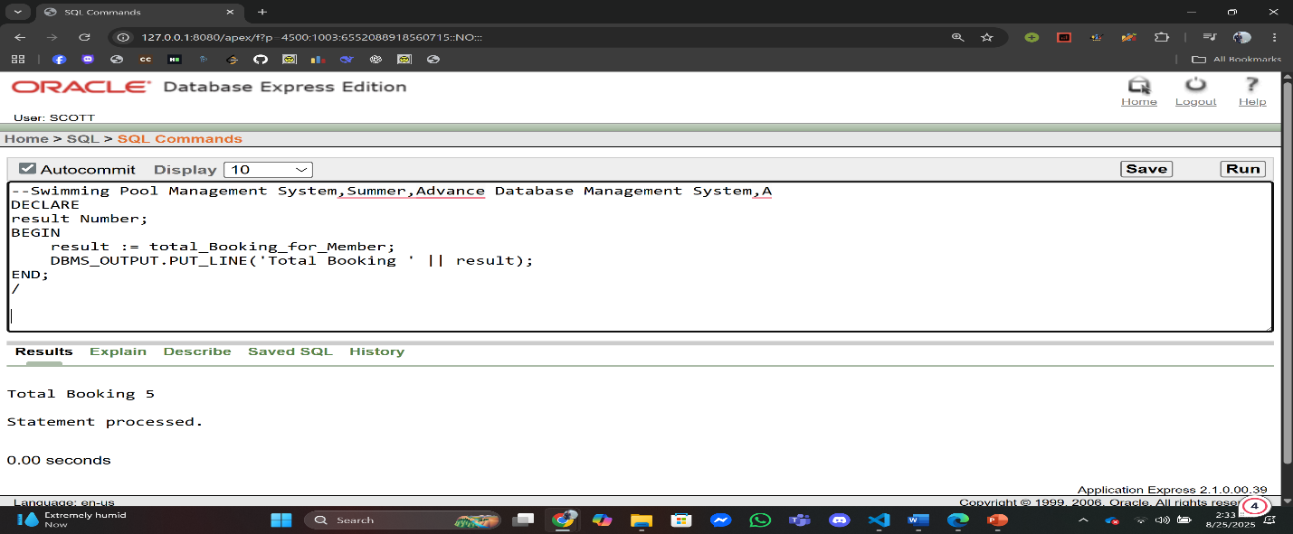/

**Q2:** Write a stored function that takes a TransactionID as input and returns the payment method used for that transaction.

**Answer:**

**Function Creation:**

Create OR Replace Function get_Payment_Method(transactionId IN Number)

Return PaymentTypeInfo.PaymentMethod%Type As

paymentMethod PaymentTypeInfo.PaymentMethod%Type;

Begin

Select PaymentMethod Into paymentMethod

From PaymentTypeInfo

Where PaymentCode = (Select MIN(PaymentCode) From TransactionPaymentInfo Where TransactionID = transactionId);

Return paymentMethod;

End get_Payment_Method;

**Query:**

--Swimming Pool Management System,Summer,Advance Database Management System,A

DECLARE

result varchar(50);

BEGIN

result := get_Payment_Method(2004);

DBMS_OUTPUT.PUT_LINE('Payment Method is ' || result);

END;

/

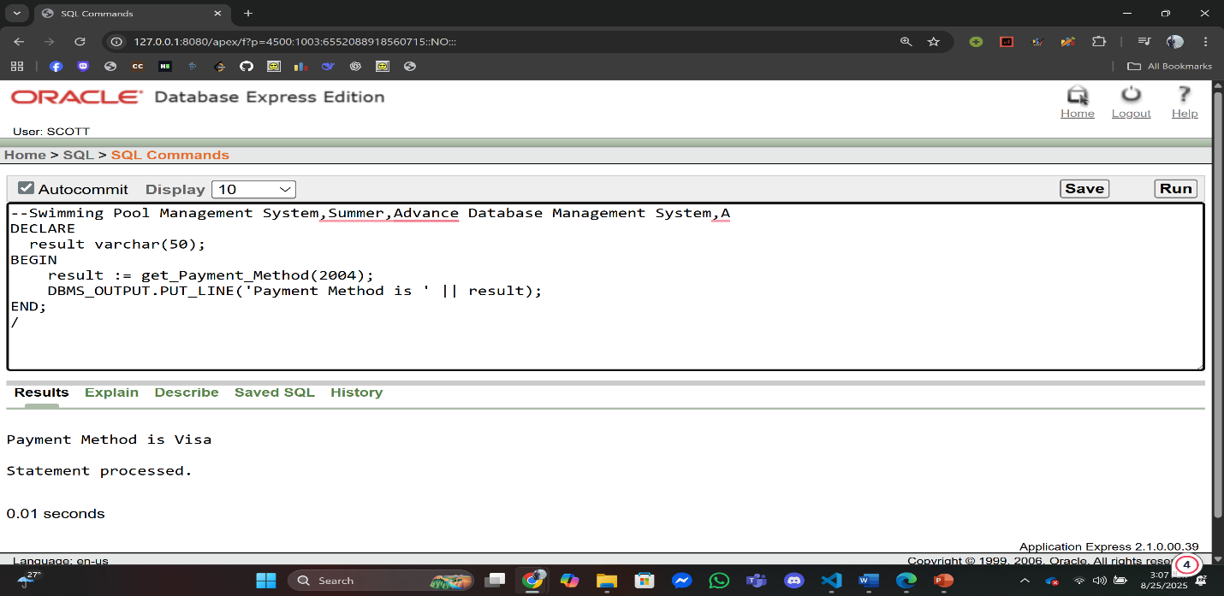

1. **Stored Procedure:**

**Q1:** Write a procedure that displays all staff names working in a specific pool.

**Answer:**

**Procedure Creation:**

CREATE OR REPLACE PROCEDURE show_staff_in_pool(p_pool_id NUMBER) IS

BEGIN

FOR rec IN (

SELECT s.Name

FROM StaffInfo s

INNER JOIN PoolStaffInfo ps ON s.StaffID = ps.StaffID

WHERE ps.PoolID = p_pool_id

) LOOP

DBMS_OUTPUT.PUT_LINE('Staff: ' || rec.Name);

END LOOP;

END;

/

**Query:**

--Swimming Pool Management System,Summer,Advance Database Management System,A

DECLARE

BEGIN

show_staff_in_pool(5002);

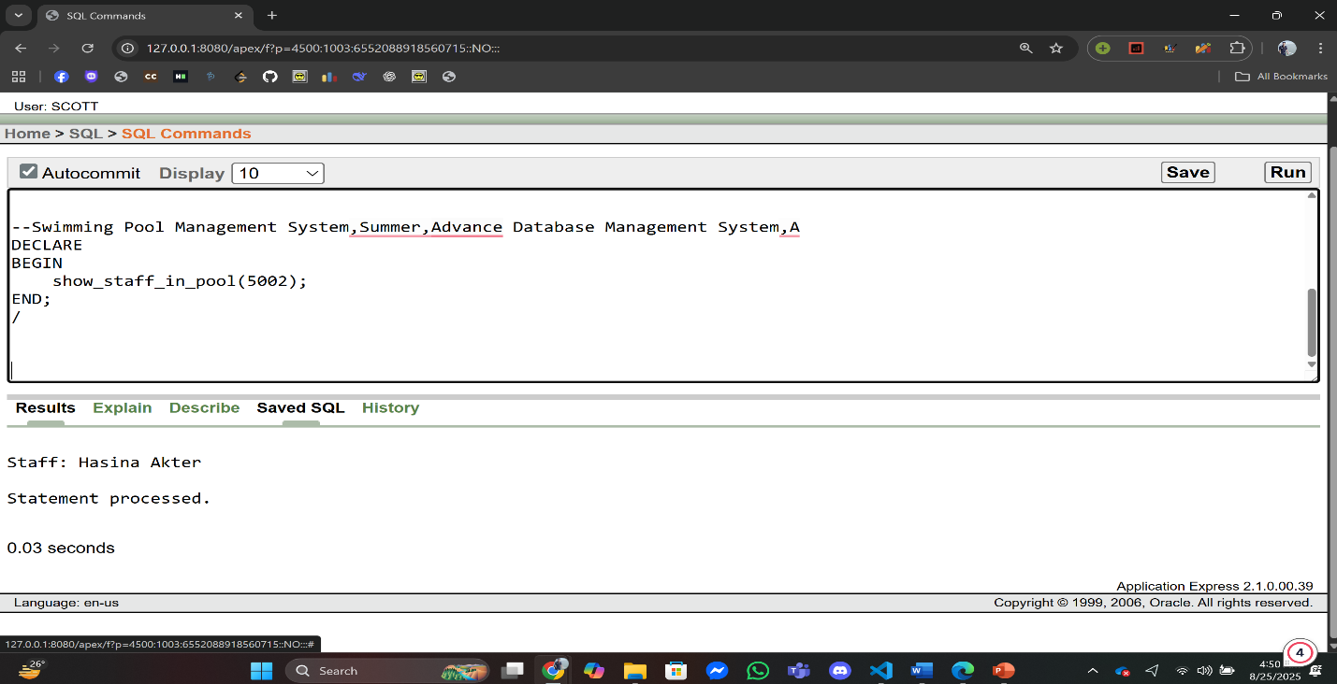END;

**Q2:** Create a procedure that checks how many bookings a member has. If more than 5, update their RedStatus to 'YES'.

**Answer:**

**Procedure Creation:**

CREATE OR REPLACE PROCEDURE update_redstatus(p_member_id NUMBER) IS

v_count NUMBER;

BEGIN

SELECT COUNT(*) INTO v_count

FROM MemberBookingInfo

WHERE MemberID = p_member_id;

IF v_count > 5 THEN

UPDATE MemberContactInfo

SET RedStatus = 'YES'

WHERE Email = (

SELECT Email FROM MemberInfo WHERE MemberID = p_member_id

);

DBMS_OUTPUT.PUT_LINE('Update Successfully Done');

Else

DBMS_OUTPUT.PUT_LINE('Red Status not change');

END IF;

END;

/

**Query:**

--Swimming Pool Management System,Summer,Advance Database Management System,A

DECLARE

BEGIN

update_redstatus(1);

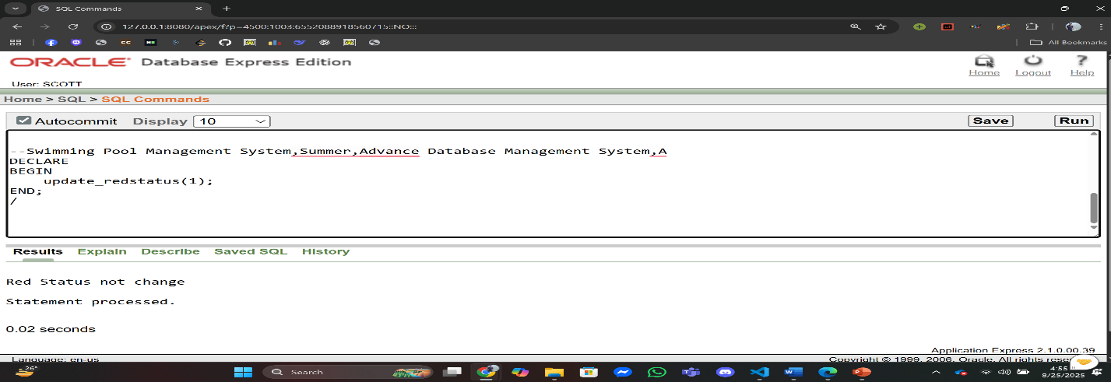END;

1. **Table-based Record:**

**Q1:** Store one row of MemberInfo in a record and display it.

**Answer:**

--Swimming Pool Management System,Summer,Advance Database Management System,A

DECLARE

member_rec MemberInfo%ROWTYPE;

BEGIN

SELECT * INTO member_rec

FROM MemberInfo

WHERE MemberID = 1;

DBMS_OUTPUT.PUT_LINE('Member: ' || member_rec.Name || ', Email: ' || member_rec.Email);

END;

/

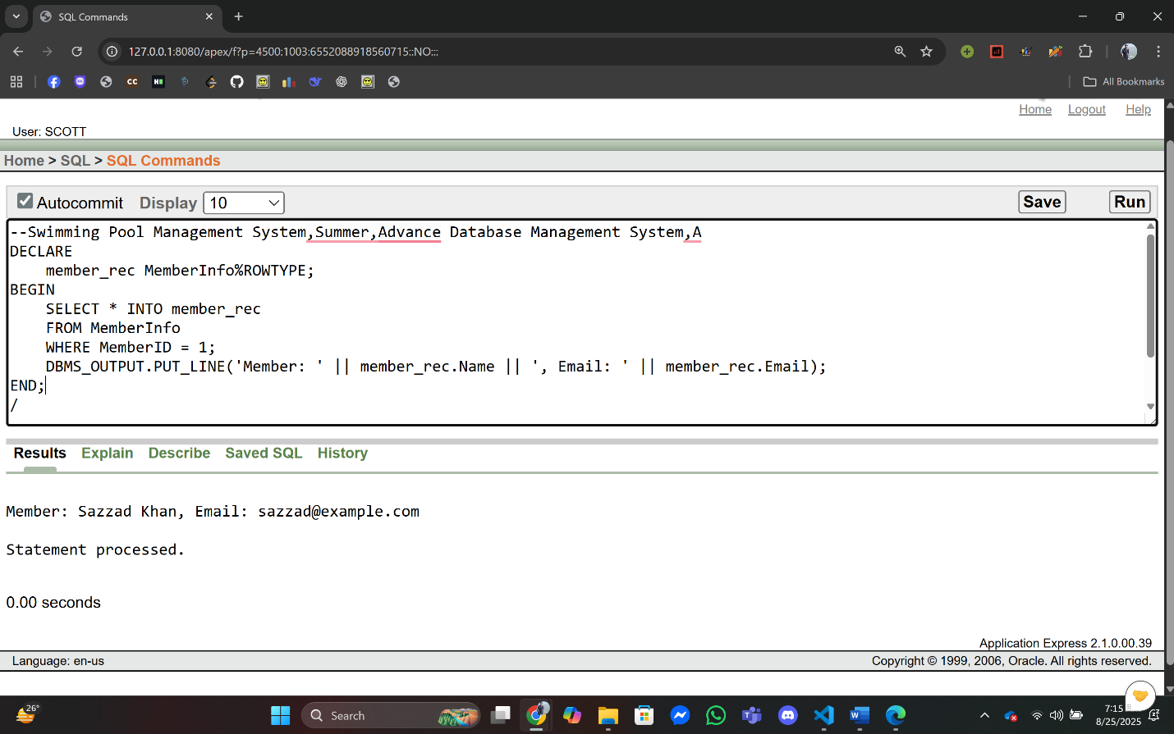

**Q2:** Fetch one TransactionInfo row into a record and print.

**Answer:**

--Swimming Pool Management System,Summer,Advance Database Management System,A

DECLARE

trans_rec TransactionInfo%ROWTYPE;

BEGIN

SELECT * INTO trans_rec

FROM TransactionInfo

WHERE TransactionID = 2002;

DBMS_OUTPUT.PUT_LINE('Transaction ' || trans_rec.TransactionID || ': ' || trans_rec.Amount);

END;

/

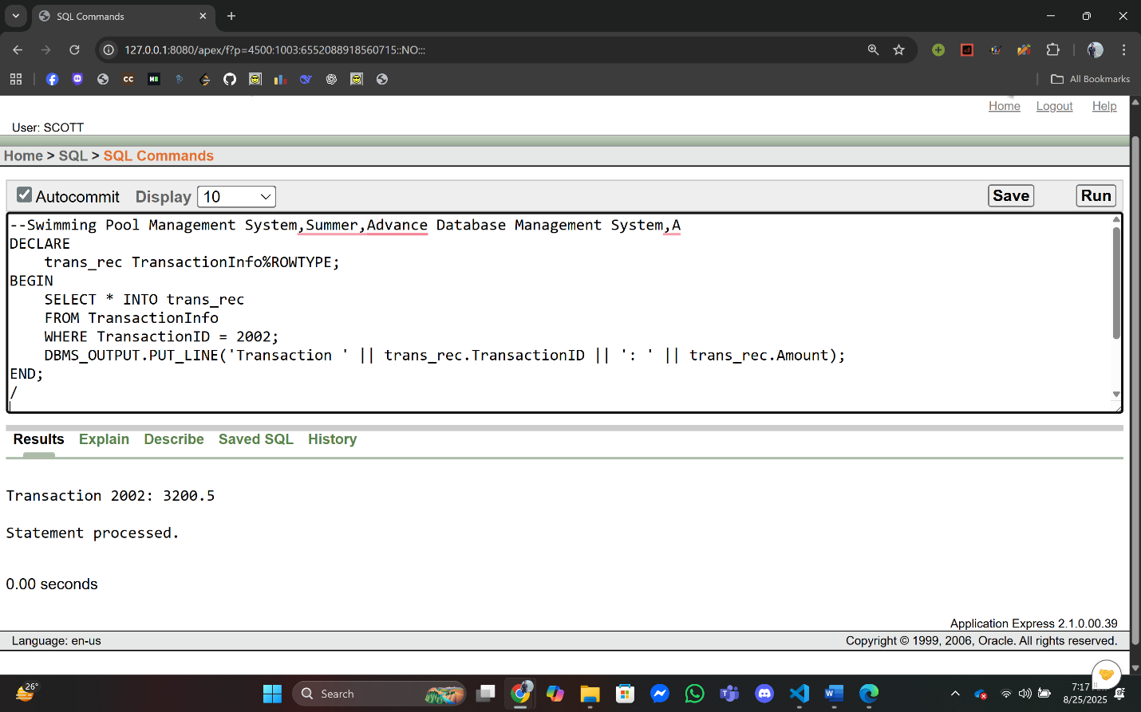

1. **Cursor-based Record:**

**Q1:** Write a PL/SQL program using a cursor-based record to fetch all bookings of a given MemberID and display BookingID and BookingDate.

**Answer:**

--Swimming Pool Management System,Summer,Advance Database Management DECLARE

CURSOR cur_bookings IS

SELECT b.BookingID, b.BookingDate

FROM BookingInfo b

JOIN MemberBookingInfo mb ON b.BookingID = mb.BookingID

WHERE mb.MemberID = 1;

rec_booking cur_bookings%ROWTYPE;

BEGIN

OPEN cur_bookings;

LOOP

FETCH cur_bookings INTO rec_booking;

EXIT WHEN cur_bookings%NOTFOUND;

DBMS_OUTPUT.PUT_LINE('BookingID: ' || rec_booking.BookingID ||

', BookingDate: ' || rec_booking.BookingDate);

END LOOP;

CLOSE cur_bookings;

END;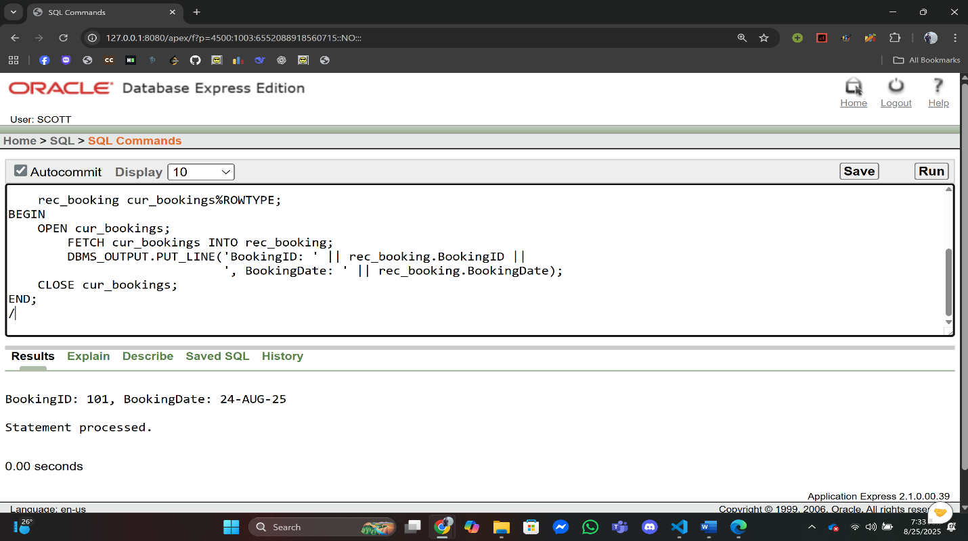

**Q2:** Write a PL/SQL program to fetch each member’s total transaction amount using cursor-based record.

**Answer:**

--Swimming Pool Management System,Summer,Advance Database Management System,A

DECLARE

CURSOR cur_trans IS

SELECT m.MemberID, m.Name, SUM(t.Amount) AS TotalAmount

FROM MemberInfo m

JOIN MemberTransactionInfo mt

ON m.MemberID = mt.MemberID

JOIN TransactionInfo t

ON mt.TransactionID = t.TransactionID

GROUP BY m.MemberID, m.Name;

rec_trans cur_trans%ROWTYPE;

BEGIN

OPEN cur_trans;

LOOP

FETCH cur_trans INTO rec_trans;

EXIT WHEN cur_trans%NOTFOUND;

DBMS_OUTPUT.PUT_LINE('Member: ' || rec_trans.Name ||

', Total Transaction: ' || rec_trans.TotalAmount);

END LOOP;

CLOSE cur_trans;

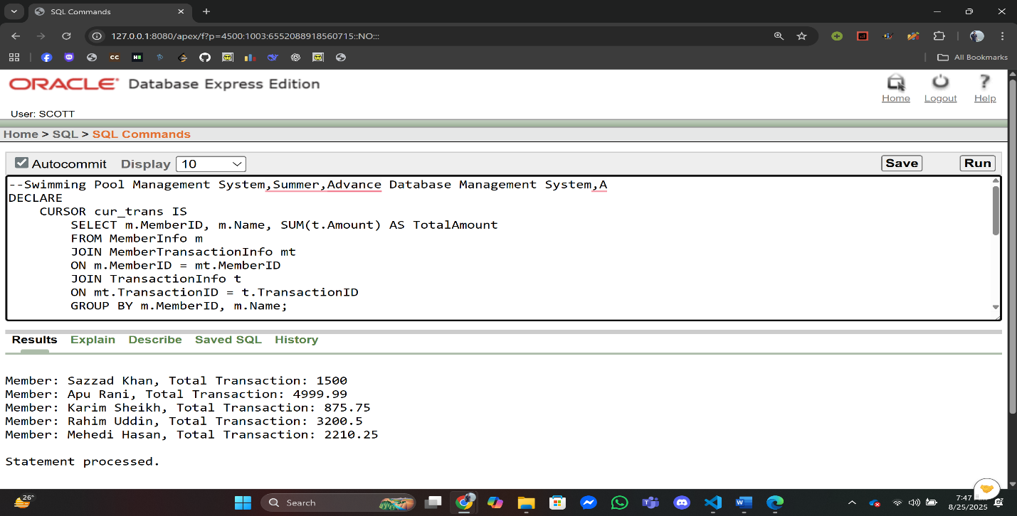END;

1. **Explicit Cursor:**

**Q1:** Print all Member names using a cursor.

**Answer:**

--Swimming Pool Management System,Summer,Advance Database Management System,A

DECLARE

CURSOR c1 IS SELECT Name FROM MemberInfo;

v_name MemberInfo.Name%TYPE;

BEGIN

OPEN c1;

LOOP

FETCH c1 INTO v_name;

EXIT WHEN c1%NOTFOUND;

DBMS_OUTPUT.PUT_LINE('Member: ' || v_name);

END LOOP;

CLOSE c1;

END;

/

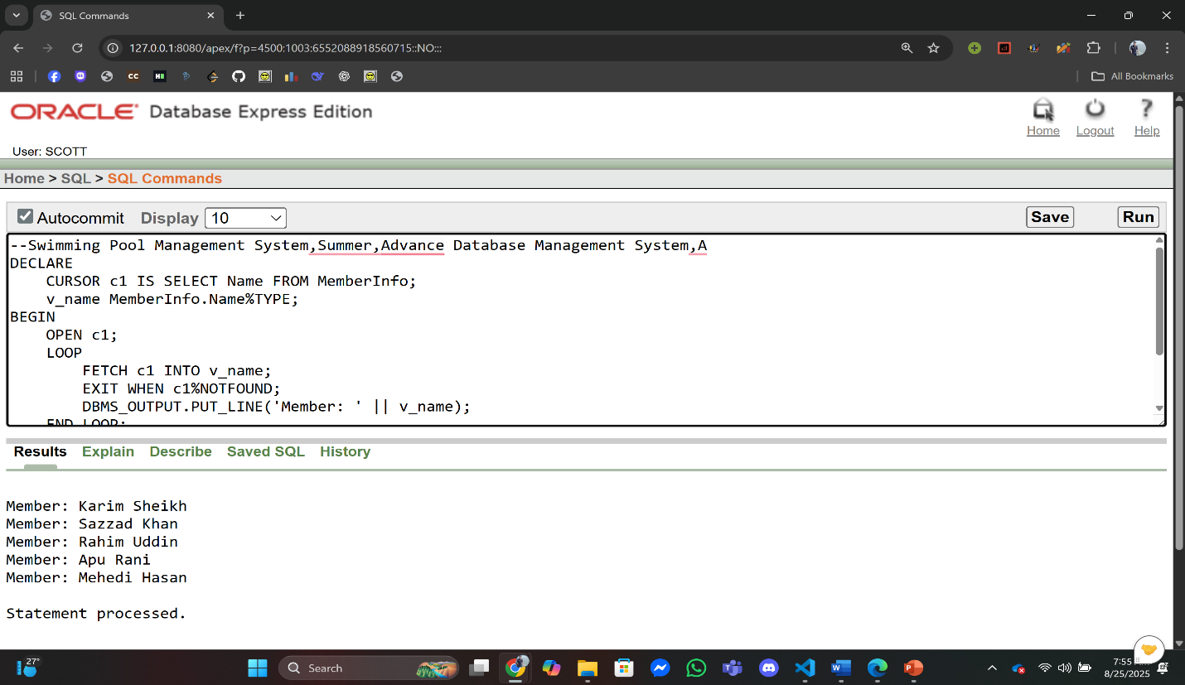

**Q2:** Print all booking dates using a cursor.

**Answer:**

--Swimming Pool Management System,Summer,Advance Database Management System,A

DECLARE

CURSOR c2 IS SELECT BookingID, BookingDate FROM BookingInfo;

v_id BookingInfo.BookingID%TYPE;

v_date BookingInfo.BookingDate%TYPE;

BEGIN

OPEN c2;

LOOP

FETCH c2 INTO v_id, v_date;

EXIT WHEN c2%NOTFOUND;

DBMS_OUTPUT.PUT_LINE('Booking ' || v_id || ' on ' || v_date);

END LOOP;

CLOSE c2;

END;

/

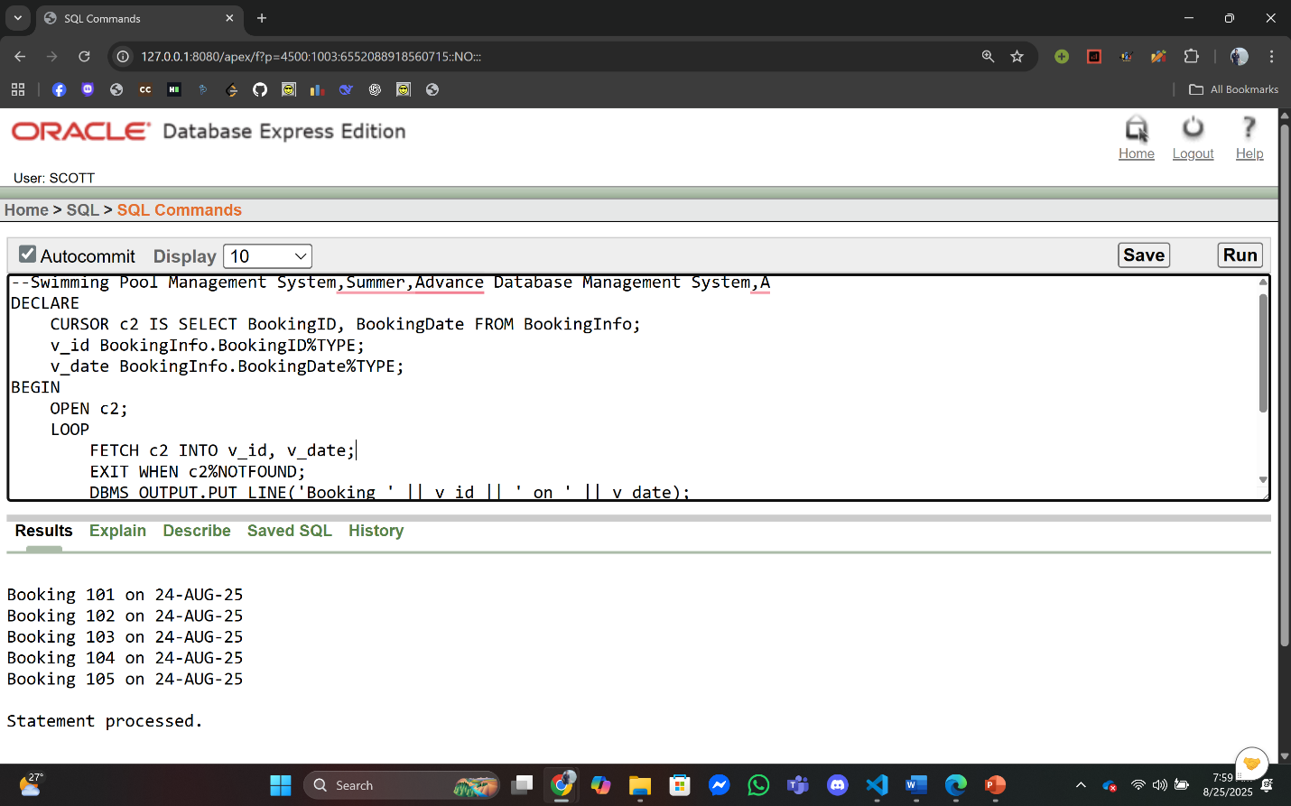

1. **Row Level Trigger:**

**Q1:** Create a row-level trigger that prevents adding a booking if the pool capacity is already full.

**Answer:**

**Trigger Creation:**

--Swimming Pool Management System,Summer,Advance Database Management System,A

CREATE OR REPLACE TRIGGER trg_check_pool_capacity

BEFORE INSERT ON PoolBookingInfo

FOR EACH ROW

DECLARE

cap NUMBER;

totalBooking NUMBER;

BEGIN

SELECT Capacity INTO cap

FROM PoolInfo

WHERE PoolID = :NEW.PoolID;

SELECT COUNT(*) INTO totalBooking

FROM PoolBookingInfo

WHERE PoolID = :NEW.PoolID;

IF totalBooking >= cap THEN

RAISE_APPLICATION_ERROR(-20002, 'Booking failed. Pool is full.');

END IF;

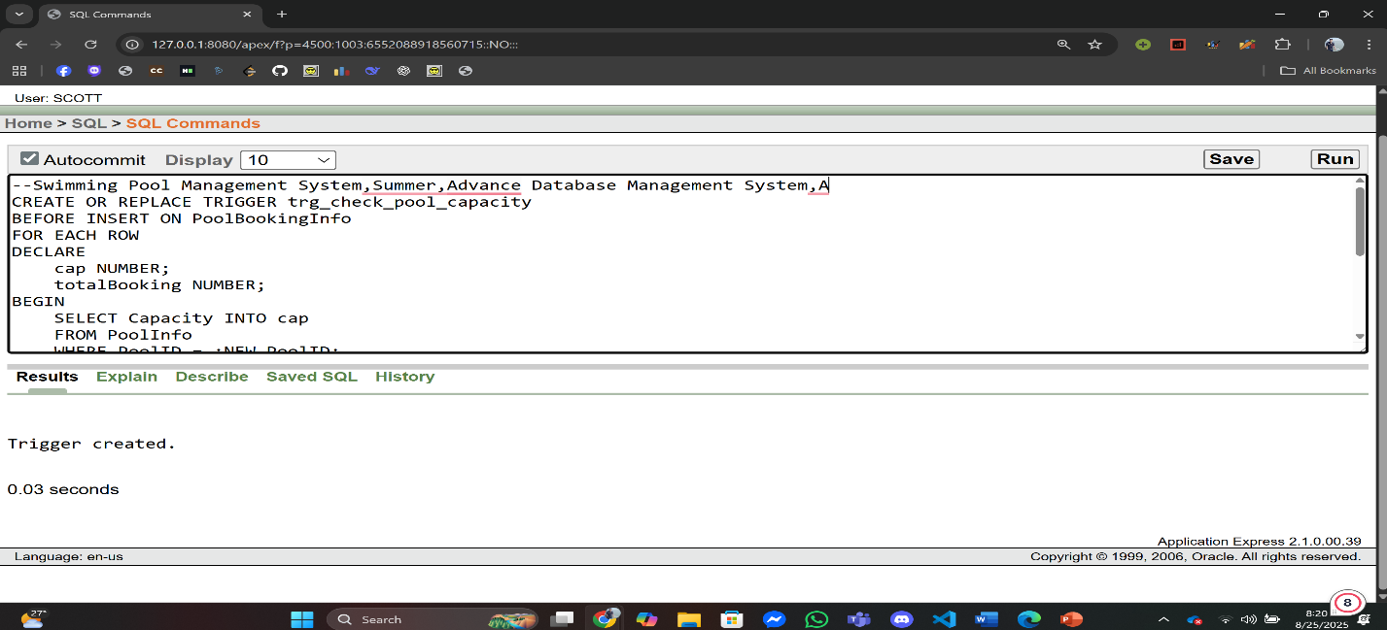END;

**Q2:** Create a row-level trigger that shows a message whenever a booking record is updated in BookingInfo.

**Answer:**

**Trigger Creation:**

--Swimming Pool Management System,Summer,Advance Database Management System,A

CREATE OR REPLACE TRIGGER trg_booking_update

AFTER UPDATE ON BookingInfo

FOR EACH ROW

When (NEW.BookingID > 0)

BEGIN

DBMS_OUTPUT.PUT_LINE('A booking record was updated.');

END;

/

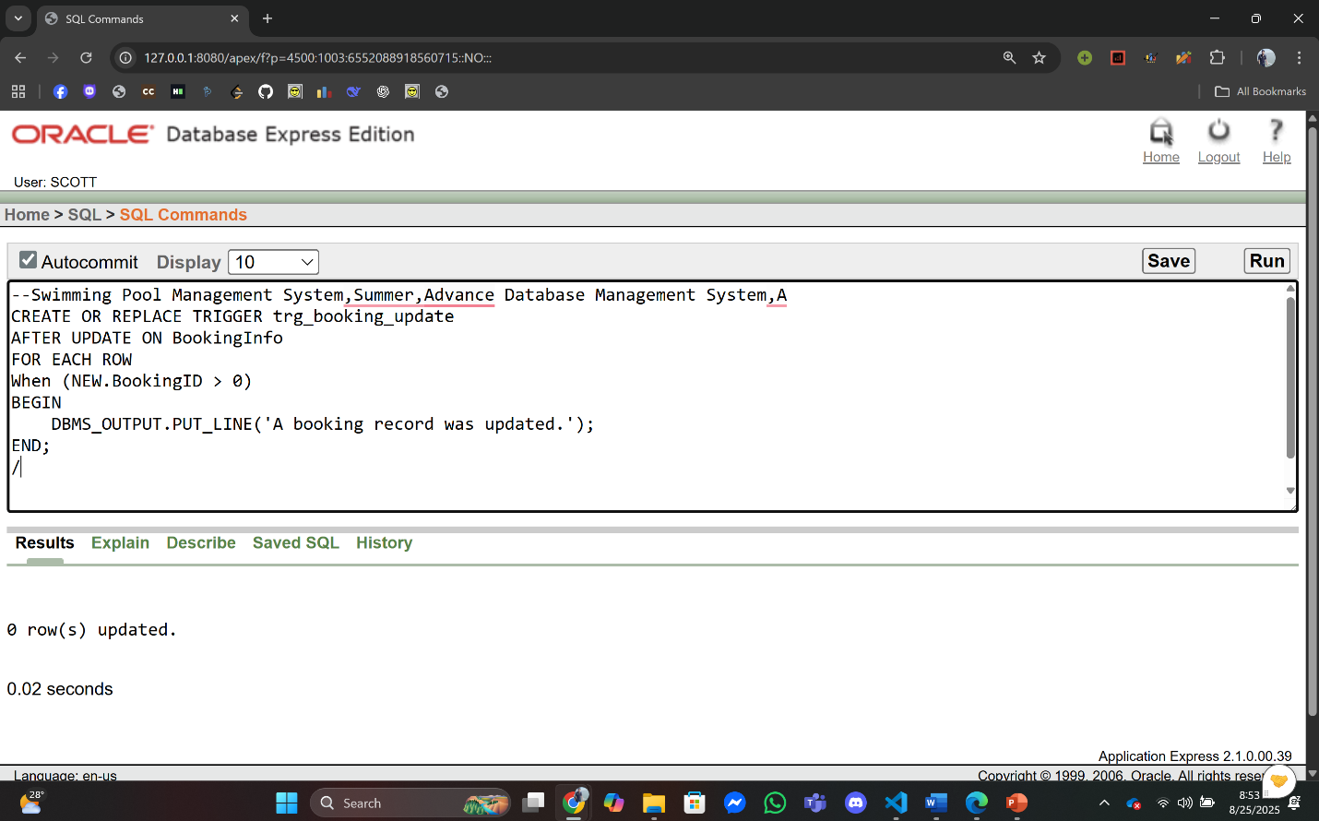

1. **Statement Level Trigger:**

**Q1:** Log whenever a booking is inserted.

**Answer:**

**Trigger Creation:**

--Swimming Pool Management System,Summer,Advance Database Management System,A

CREATE OR REPLACE TRIGGER trg_booking_log

AFTER INSERT ON BookingInfo

BEGIN

DBMS_OUTPUT.PUT_LINE('A new booking has been added.');

END;

/

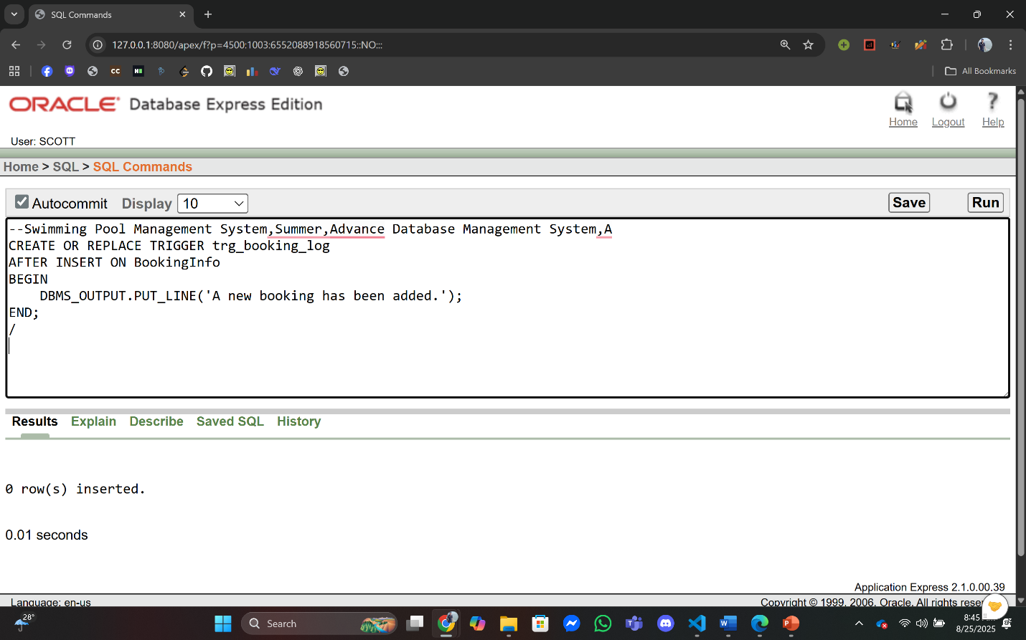

**Q2:** Log whenever a trainer is deleted.

**Answer:**

**Trigger Creation:**

--Swimming Pool Management System,Summer,Advance Database Management System,A

CREATE OR REPLACE TRIGGER trg_trainer_delete

AFTER DELETE ON TrainerInfo

BEGIN

DBMS_OUTPUT.PUT_LINE('A trainer record has been deleted.');

END;

/

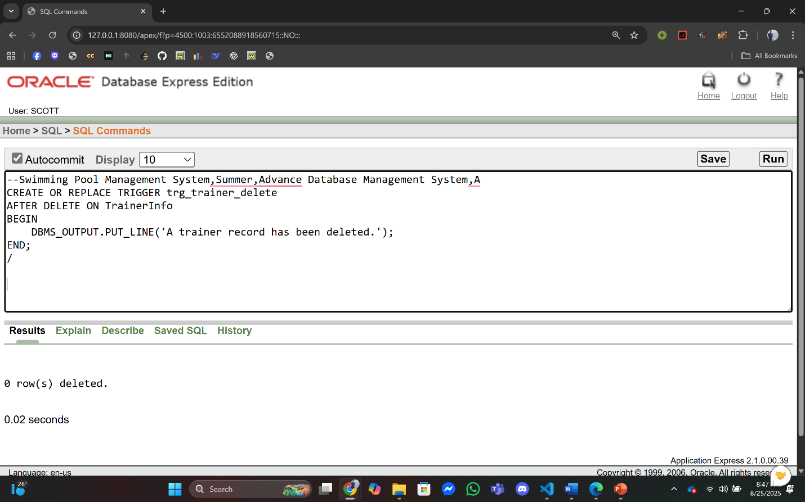

1. **Package:**

**Q1:** Create a package for **Reporting**, showing total bookings per pool and member details.

**Answer:**

**Package Specification:**

--Swimming Pool Management System,Summer,Advance Database Management System,A

CREATE OR REPLACE PACKAGE pkg_report AS

PROCEDURE pool_report(p_poolid NUMBER);

PROCEDURE member_report(p_memberid NUMBER);

END pkg_report;

/

**Package Body:**

--Swimming Pool Management System,Summer,Advance Database Management System,A

CREATE OR REPLACE PACKAGE BODY pkg_report AS

PROCEDURE pool_report(p_poolid NUMBER) IS

total NUMBER;

BEGIN

SELECT COUNT(*) INTO total FROM PoolBookingInfo WHERE PoolID = p_poolid;

DBMS_OUTPUT.PUT_LINE('Total Bookings for Pool ' || p_poolid || ' = ' || total);

END;

PROCEDURE member_report(p_memberid NUMBER) IS

name MemberInfo.Name%TYPE;

total NUMBER;

BEGIN

SELECT Name INTO name FROM MemberInfo WHERE MemberID = p_memberid;

SELECT COUNT(*) INTO total FROM MemberBookingInfo WHERE MemberID = p_memberid;

DBMS_OUTPUT.PUT_LINE('Member: ' || name || ' | Total Bookings: ' || total);

END;

END pkg_report;

/

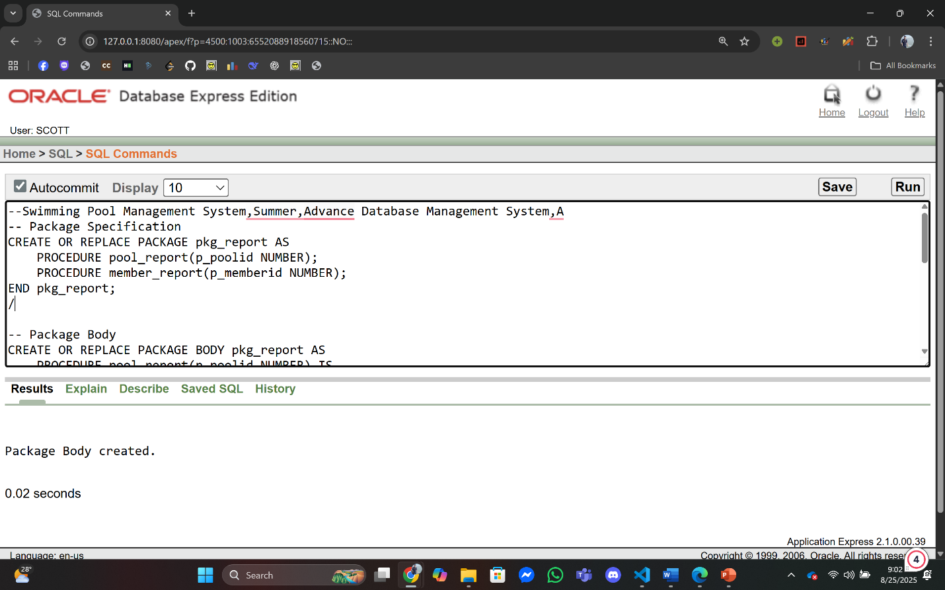

**Q2:** Create a package with two procedures show_total_bookings – Display total bookings for a member.show_member_email – Display the email of a member.

**Answer:**

**Package Specification:**

--Swimming Pool Management System,Summer,Advance Database Management System,A

CREATE OR REPLACE PACKAGE pkg_member AS

PROCEDURE show_total_bookings(p_member_id NUMBER);

PROCEDURE show_member_email(p_member_id NUMBER);

END pkg_member;

**Package Body:**

--Swimming Pool Management System,Summer,Advance Database Management System,A

CREATE OR REPLACE PACKAGE BODY pkg_member AS

PROCEDURE show_total_bookings(p_member_id NUMBER) IS

v_count NUMBER;

BEGIN

SELECT COUNT(*) INTO v_count

FROM MemberBookingInfo

WHERE MemberID = p_member_id;

DBMS_OUTPUT.PUT_LINE('Total Bookings for Member ID ' || p_member_id || ' = ' || v_count);

END;

PROCEDURE show_member_email(p_member_id NUMBER) IS

v_email MemberInfo.Email%TYPE;

BEGIN

SELECT Email INTO v_email

FROM MemberInfo

WHERE MemberID = p_member_id;

DBMS_OUTPUT.PUT_LINE('Email of Member ID ' || p_member_id || ' = ' || v_email);

END;

END pkg_member;

/

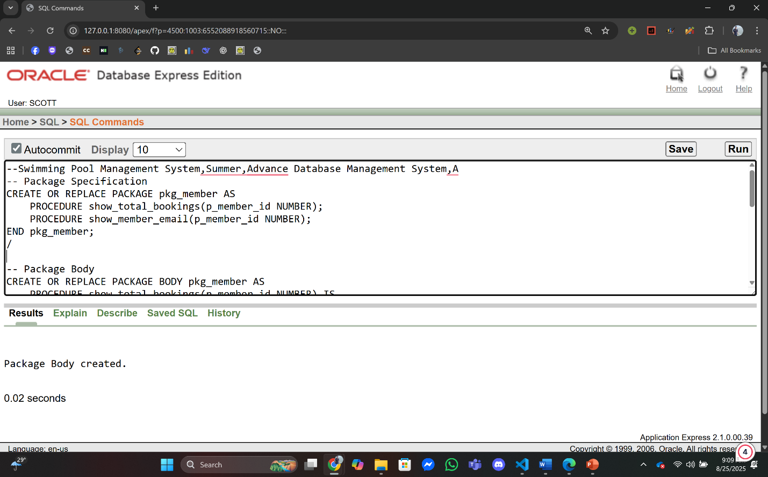

**Conclusion**

The unique management requirements of a swimming pool facility have been successfully transformed into an organized and effective relational database model through the development of the Swimming Pool Management System (SPMS). We created a detailed scenario that included all important entities by following an orderly system—Members, Trainers, Staff, Pools, Bookings, Events, and Transactions. An ER Diagram was used to show this, and it was then carefully normalized into a schema, which followed the Third Normal Form (3NF). With clearly specified primary and foreign key dependencies, the resulting database structure—shown in the Schema Diagram -- successfully reduces unnecessary data and assures reference reliability. This basic structure creates a dependable backend system that is ready for data insertion and accurate querying by displaying a strong and useful use of advanced database processes.

**Proposed Future Work:**  
Even though the current SPMS provides a strong and standardized data base, more work is needed to maximize its future benefits:

1. **Graphical User Interface (GUI) Development:** Creating a user-friendly desktop application (for example, in Java or C#) is the important next step. This front-end will allow ordinary employees to perform all operations—such as adding members, creating bookings, and processing payments— easily without any knowledge of SQL, significantly improving usability and adoption.
2. **Advanced Reporting Dashboard:** Creating a unique GUI module that will help with making important decisions through creating useful data and visual analytics on revenue, attendance patterns, peak booking periods, and inventory status.
3. **Online Member Portal:** Extending the system's reach by developing a web-based portal where members can view their profiles, check pool schedules, book sessions, and make online payments, significantly improving customer service.
4. **Integration of Additional Features:** Incorporating functionality for inventory management of pool equipment (e.g., goggles, towels) and chemical tracking with automated low-stock alerts.
5. **Mobile Application/Notification system for Staff:** Developing a lightweight mobile app or a mail notification to allow floor staff and lifeguards to check bookings and record attendance in real-time, directly from the poolside.

**THE END**